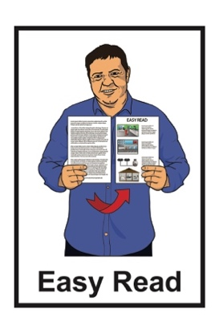


Summary of findings –
Monitoring of My Experiences
My Rights: Disability Supports and Services


Report 2:
Consultation and Engagement
Published: May 2025

What you will find in here

Page number:


What this document is about 2
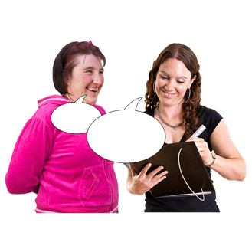

What was the research about? 6




What the research found out 12

What are the recommendations? 23


More information 26

What this document is about

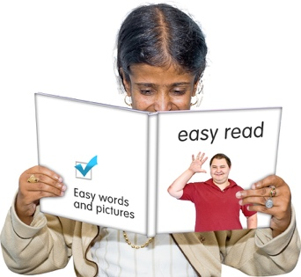
This Easy Read is a summary of findings from research done by the Donald Beasley Institute.


A summary is:
- shorter than the main document
- tells you the main ideas.

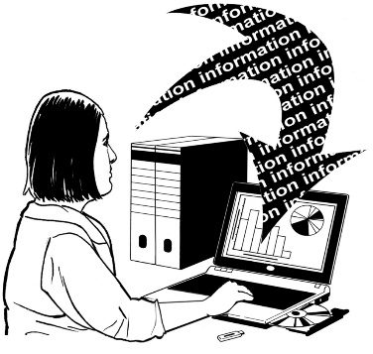
Research is when a lot of information about something is put together to learn about it.


The Donald Beasley Institute is a place that researches things to do with disability.

It is based in Dunedin in Aotearoa New Zealand.


In this document the Donald Beasley Institute will be called the DBI.

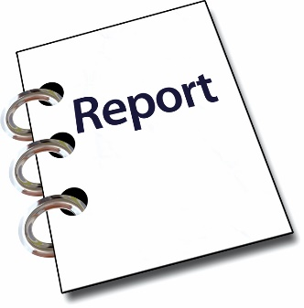
2
This is the second report of what the DBI found out.

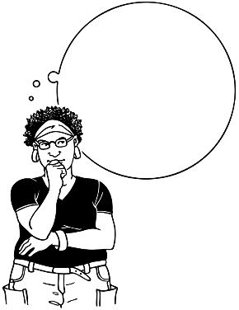
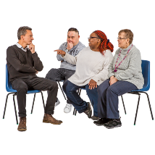
This report is about what people thought about how the Government does:
consultation with disabled people
engagement with disabled people.
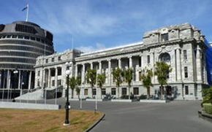
Here consultation is when the Government asks people what they think about things the Government is planning to do.


Here engagement is all the ways the Government tells people:
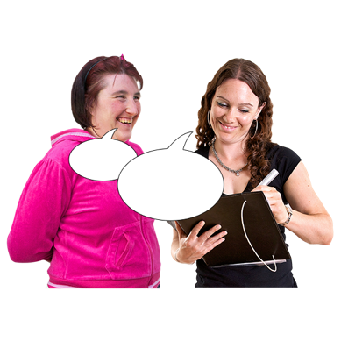
what it is doing
how to have their say about what the Government does.


This Easy Read talks a lot about Whaikaha – Ministry of Disabled People.


In this Easy Read Whaikaha – Ministry of Disabled People will be called Whaikaha.

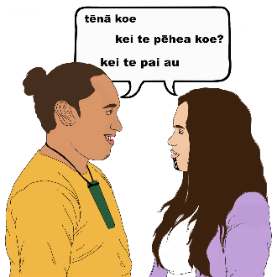
In this report the DBI uses the Kāi Tahu way of speaking te reo
Māori / the Māori language.

Kāi Tahu is an iwi / tribe in
Te Waipounamu / the South Island.

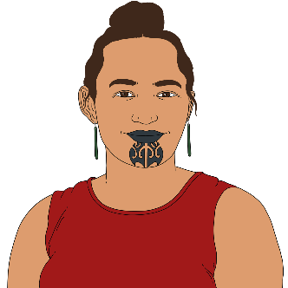
Kāi Tahu words use the letter k instead of the letters ng.

Tākata whaikaha
Māori

For example tākata whaikaha Māori is said to mean Māori disabled people instead of tāngata whaikaha Māori.

What was the research about?

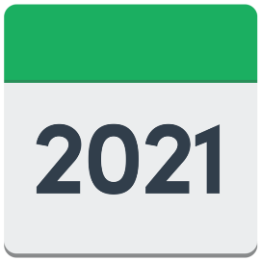
The Disabled People’s
Organisations Coalition / DPO asked the DBI to start doing research in 2021.

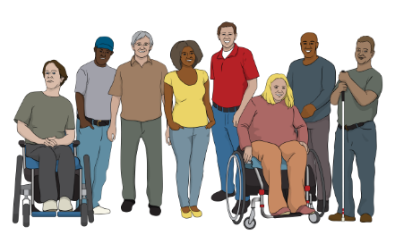
The Disabled People’s Organisations Coalition / DPO Coalition is a group of people who come from different disability organisations.


A coalition is a group of organisations that work towards shared goals.

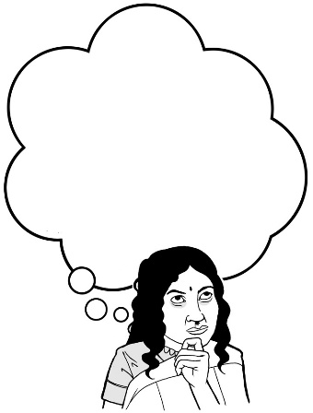
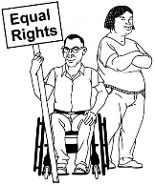
The DPO Coalition wanted to know how well the Aotearoa New Zealand Government was making the United Nations Convention on the Rights of Persons with Disabilities work in this country.

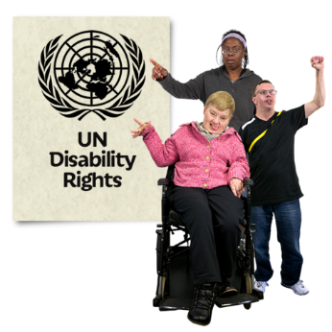
The United Nations Convention on the Rights of Persons with Disabilities / UNCRPD is a law lots of countries have agreed to.

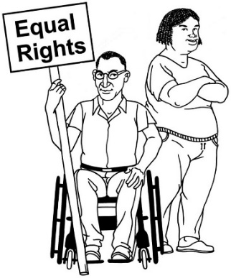
It says what governments must do to make sure disabled people get the same rights as everybody else.

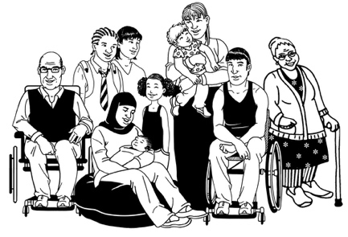
Rights are things everyone should:
have
be able to do.

Rights are things like:
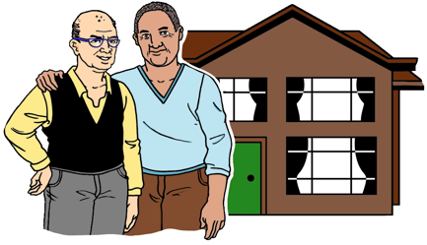
having a safe place to live
being able to get married.


The DPO Coalition asked the DBI to research what disability supports and services are like in Aotearoa New Zealand.


Many big changes started happening to disability supports and services when DBI was doing the research.


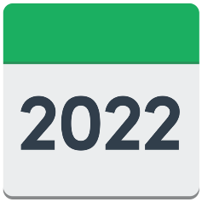
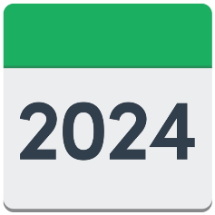
These changes included:
- Whaikaha starting in 2022
- changes to disability support services in March 2024
- changes to what Whaikaha can do in August 2024.

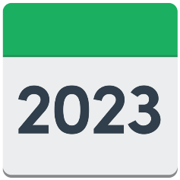
The research for this report happened between:
- late 2022
and
- the middle of 2023.


The research was done through:
interviews / talking to people
- focus groups
- questionnaires.


A focus group is a group of people who come together to talk about a thing they have in common.

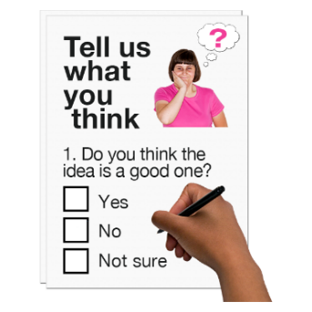
A questionnaire is a type of survey where someone answers questions.

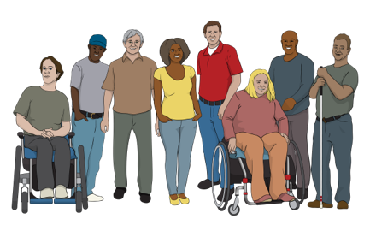
The people who were part of the research were:
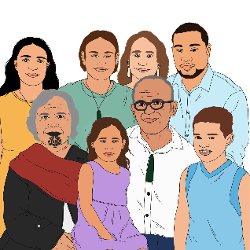
leaders in the disability sector
- disabled people
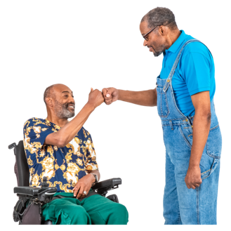
- whānau / aiga / family of disabled people
- support people.

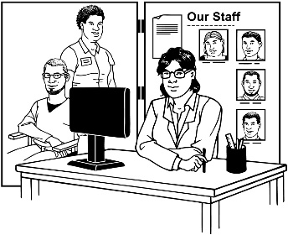
The disability sector includes:
- disability support services
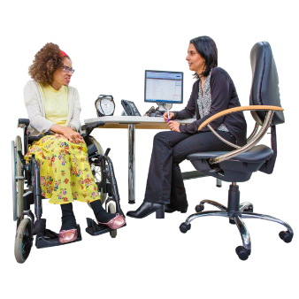
- health services
government departments.


In this Easy Read people who took part in the research are called participants.

What the research found out

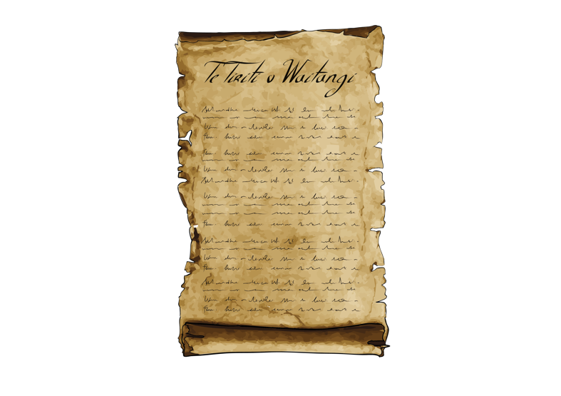
Te Tiriti o Waitangi / The Treaty of Waitangi says the Government has to consult with Māori about the decisions it makes.

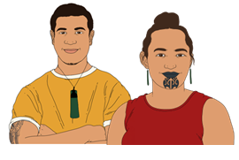
Te Tiriti o Waitangi / The Treaty of Waitangi is an important agreement between:
Māori
and
the Crown.

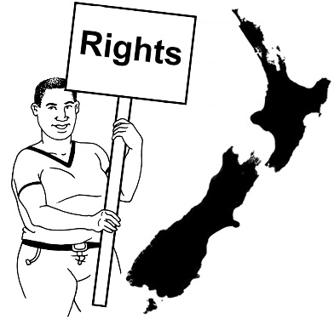
The purpose of Te Tiriti is to:
protect Māori:
- rights
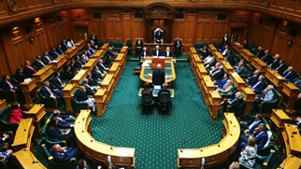
- taonga
keep peace and order
set up government.


Taonga means treasures such as:
- land / rivers
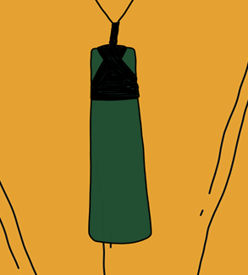
te reo Māori / the Māori language
objects like
pounamu / greenstone
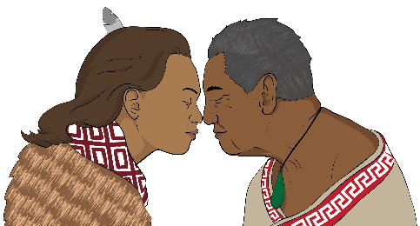
traditional food growing places
spiritual ideas.


Peace and order means following laws / rules.

Whaikaha

Whaikaha was started to be a partnership between:
the Government
disabled people
tākata whaikaha Māori / disabled Māori.


Here a partnership means people working together to make things happen.


Leaders in the disability sector said the partnership worked well at first.
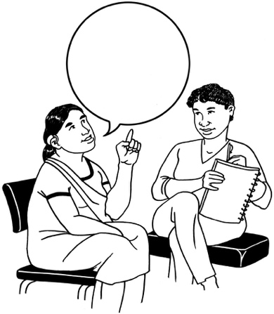
They said Whaikaha did a good job of making sure everyone:
was listened to
could take part in decisions.

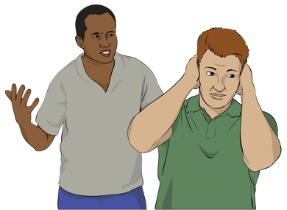
Leaders in the disability sector said Whaikaha stopped listening to them after the changes in 2024.
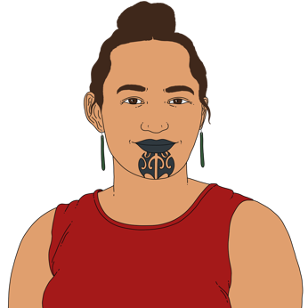

The changes had a big effect on leaders in the disability sector from:
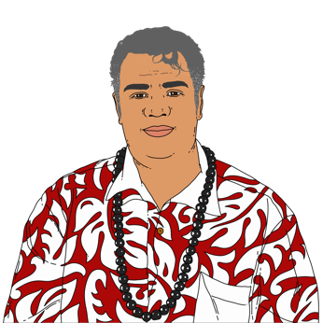
the Māori community
the Pacific community.

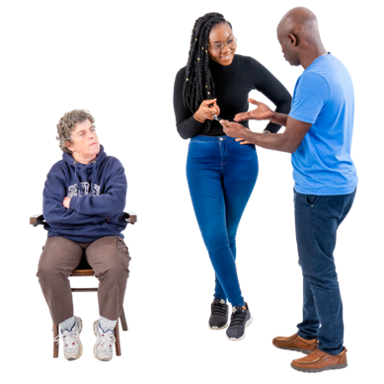
Participants said after the changes the Government decided:
what disabled people needed
how to meet those needs.
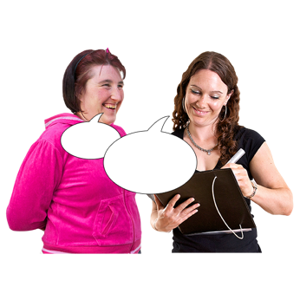


They said the Government often did not ask disabled people what they really needed.


Participants said it felt like the Government often:
decided what it was going to do
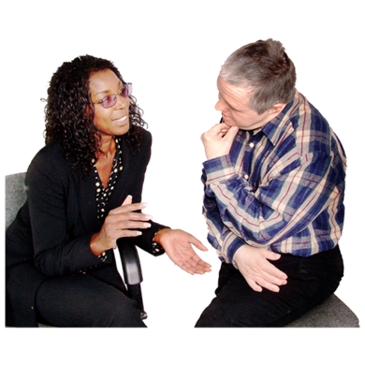
then
talked to people in the disability sector.


Leaders in the disability sector said that changes at Whaikaha should be:
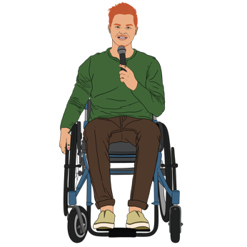
planned by disabled people
led by disabled people.

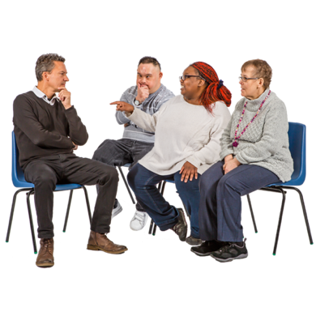
They said real consultation only happens before decisions are made.


Changes to Purchasing Rules

Some of the big changes Whaikaha made in March 2024 were to:

Purchasing Rules
Equipment and Modification Services / EMS.


Purchasing Rules say what people can buy with disability support funding.

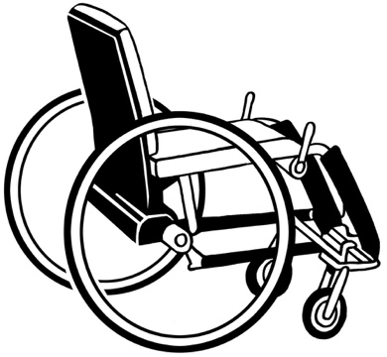
Equipment and Modification Services support disabled people to pay for things they need like:
equipment like wheelchairs

modifications to their:
- house
- car.
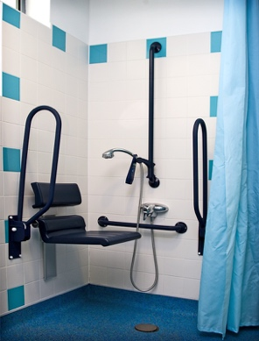

Here modifications are changes made to something so a disabled person can use it more easily.

Participants talked about how there was no consultation about the changes to Purchasing Rules.

These changes made big problems for a lot of disabled people.

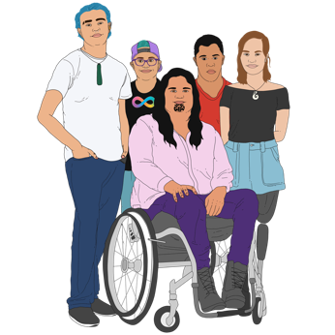
Participants said Whaikaha made changes to Purchasing Rules without thinking about:
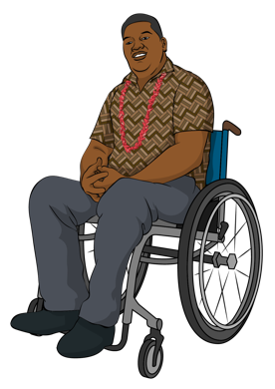
tākata whaikaha Māori / Māori disabled people
Pacific disabled people.

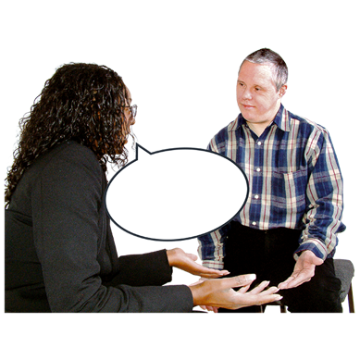
Whaikaha said they consulted with some disabled people.


Whaikaha said there was not enough time to consult with:
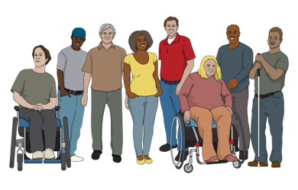
more disabled people
disability service providers

people who get disability support funding.


Participants said they did not have enough information about the changes to Purchasing Rules.


There was no accessible information about the changes to Purchasing Rules until late April 2024.

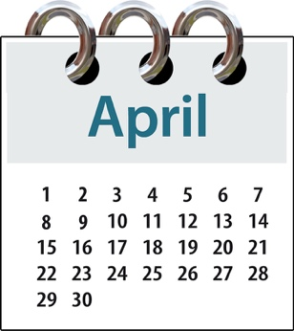
That was about 1 month after the changes happened.


Some disability service providers did not have enough information to understand the changes to Purchasing Rules.
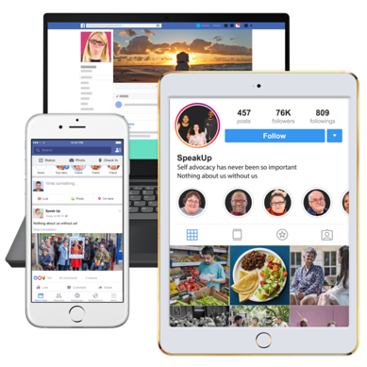

Many participants said the only way they found out about the changes was on social media like Facebook.

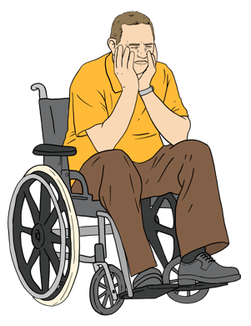
A lot of disabled people said the changes were very upsetting.

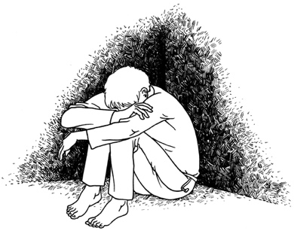
Participants said the changes to Purchasing Rules made them feel:
despair / hopelessness

panic
worry about their support needs.

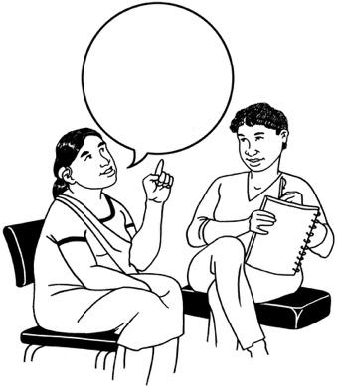
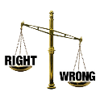
After the changes to Purchasing Rules there was an independent review of Whaikaha.


Here independent review means that someone who is not part of the Government looked at:
how Whaikaha is working
what might need to change.

There was no consultation with the disability sector for the independent review.

Disabled people said they had lost trust in:
Whaikaha
the Government.

What are the recommendations?

Participants gave recommendations on how the Government should do:
consultation
engagement.



A recommendation is something that would be good to do.

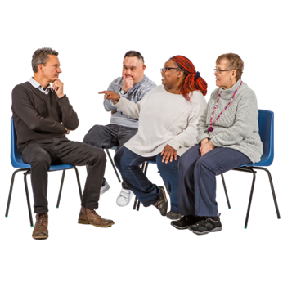
Participants said consultation should happen

early
often.

Participants said Whaikaha should listen to lots of different:
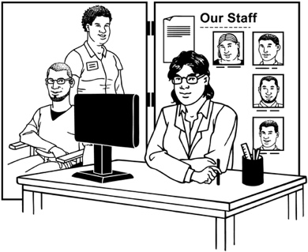
disabled people
disability organisations.

They said Whaikaha should:
really want to listen to people in the disability community
not do consultation just to make itself look good.

Participants said that people who work for the Government should get training about:
consulting with the disability community
the UNCRPD.

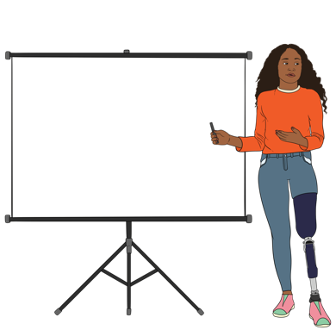
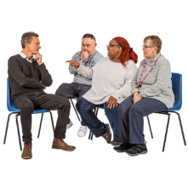
Participants said there should be training about how to do consultations with:
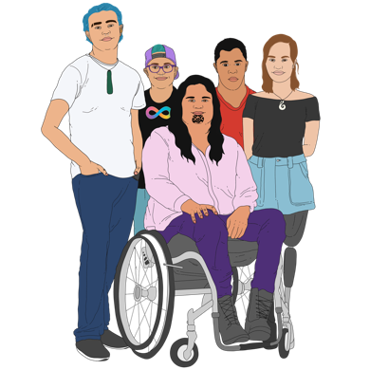
tākata whaikaha Māori / Māori disabled people
Turi Māori / Deaf Māori
disabled people.

More information


You can read the full report on the DBI website at:

https://www.donaldbeasley.org.nz/projects/disabled-person-led-monitoring-of-the-uncrpd/

The full report is not in Easy Read.

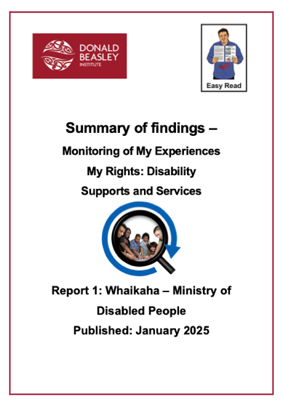
You can find an Easy Read of Part 1 of this report on the DBI website at:

https://tinyurl.com/293aw9dv

For more information about what DBI does you can go to the DBI website at:

www.donaldbeasley.org.nz

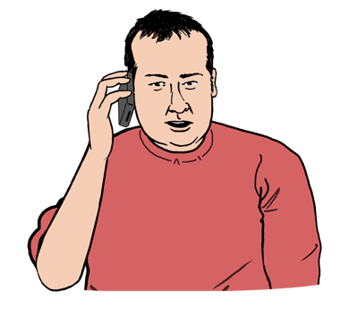
You can contact DBI by phone on:

03 479 2162


It may cost money to phone this number.

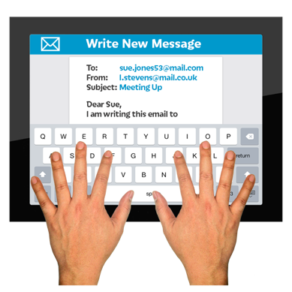
You can email DBI on:

admin@donaldbeasley.org.nz

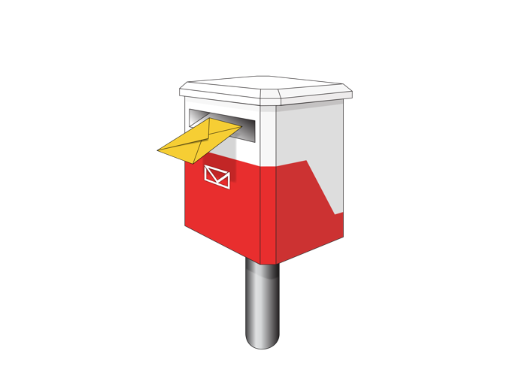
You can post a letter to DBI at:

Donald Beasley Institute

Suite 4

Level 2

248 Cumberland Street

Dunedin 9016

New Zealand


This information has been written by the Donald Beasley Institute.

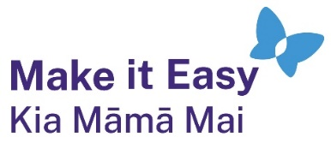
It has been translated into Easy Read by the Make it Easy Kia Māmā Mai service of People First New Zealand Ngā Tāngata Tuatahi.
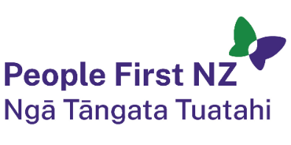
The ideas in this document are not the ideas of People First New Zealand Ngā Tāngata Tuatahi.

All images used in this Easy Read document are subject to copyright rules and cannot be used without permission.


Make it Easy uses images from:

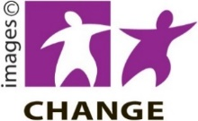
- Photosymbols

- Change Images


- Huriana Kopeke-Te Aho

- SGC Image Works

- T Wood


- Studio Rebeko

- Inga Kramer.

