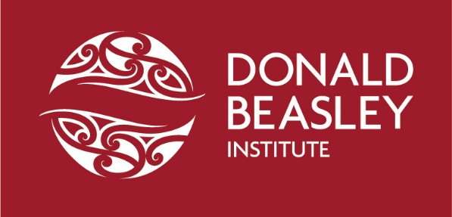
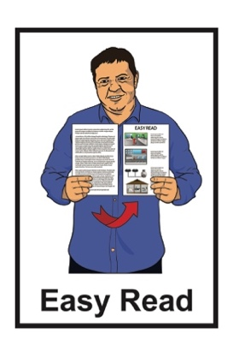

Summary of findings –

Monitoring of My Experiences
My Rights: Disability

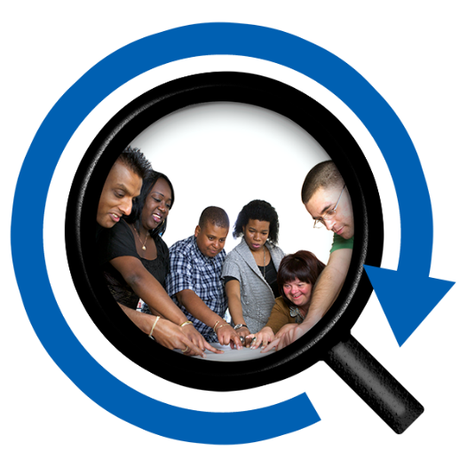
Supports and Services

Report 1: Whaikaha – Ministry of Disabled People
Published: January 2025

What you will find in here

Page number:

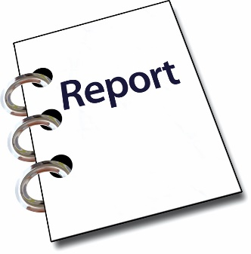
1
What is this Easy Read about? 2

What was the research about? 5


What were the findings of the
research? 11

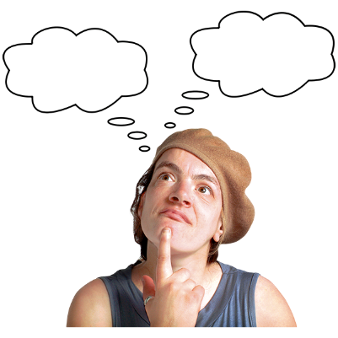


What are the recommendations? 22

What is this Easy Read about?

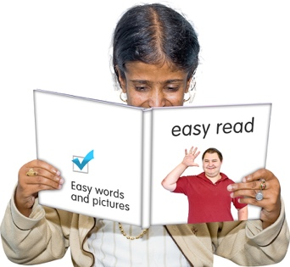
This Easy Read is a summary of findings from research done by the Donald Beasley Institute.


A summary is:
shorter than the main document
tells you the main ideas.


Research is when we:
look at things that have happened
try to find ways to do things better.


The Donald Beasley Institute researches about disability.

They are based in Dunedin in Aotearoa New Zealand.

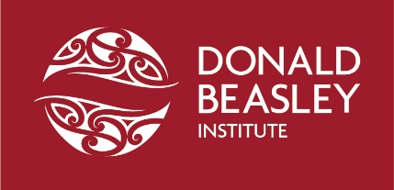
In this document the Donald Beasley Institute will be called the DBI.

1
This is the first report of what the DBI found out from monitoring supports and services.


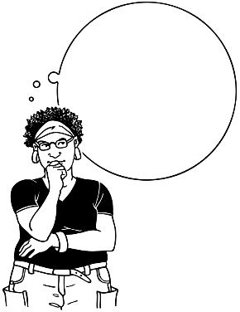
This report is about what disabled people and their families thought of Whaikaha – Ministry of Disabled People.


In this document Whaikaha – Ministry of Disabled People will be called Whaikaha.

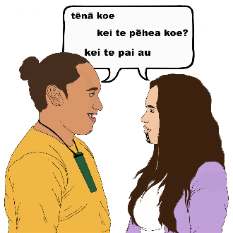
In this report the DBI uses the Kai Tahu way of speaking te reo
Māori / Māori language.

Kai Tahu is an iwi / tribe in
Te Waiponamu / the South Island.

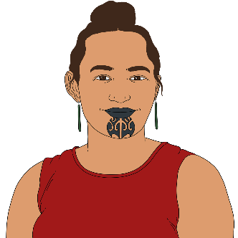
Using Kai Tahu words means they use the letter k instead of the letters ng.

Tākata whaikaha
Māori

For example Kai Tahu say tākata whaikaha Māori instead of tāngata whaikaha Māori when they are talking about Māori disabled people.

What was the research about?


The Disabled People’s
Organisation Coalition / DPO asked the DBI to start doing this research in 2021.

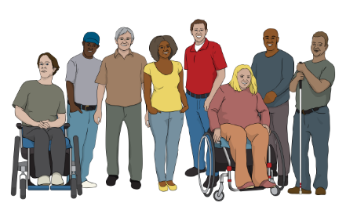
The Disabled People’s Organisations Coalition / DPO Coalition is a group of people who come from different disability organisations.


A coalition is a group of organisations that work towards shared goals.

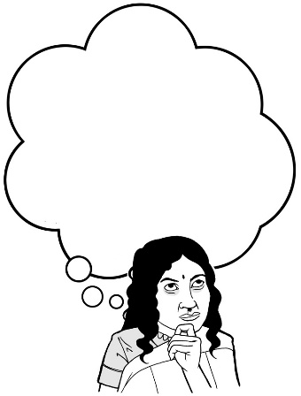
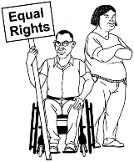
The DPO wanted to know how well the New Zealand government was making the United Nations Convention on the Rights of Persons with Disabilities work in the country.

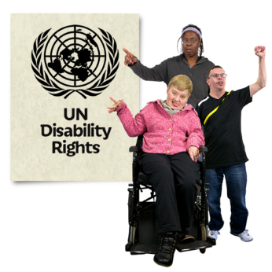
The United Nations Convention on the Rights of Persons with Disabilities / UNCRPD is a law lots of countries have agreed to.

It says what governments must do to make sure disabled people get the same rights as everybody else.

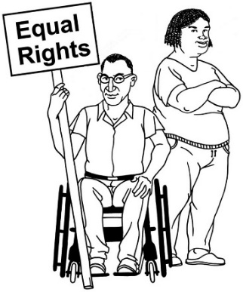
Rights are things everyone should:
have
be able to do.

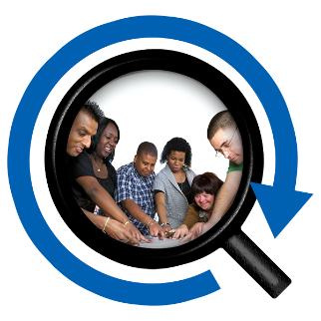
The DPO Coalition asked the DBI to research what disability supports and services are like in New Zealand.


Many big changes started happening to disability supports and services when DBI was doing the research.



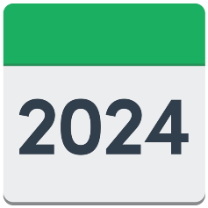
These changes include:
- Whaikaha starting in 2022
- changes in disability support services in March 2024
- what Whaikaha can do was changed in August 2024.


The research was done mostly by talking to:
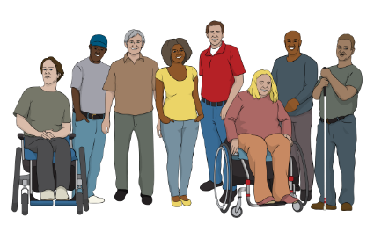
people who were leaders in the disability sector
disabled people
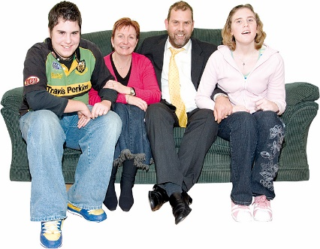
whānau / families
close supporters of disabled people.

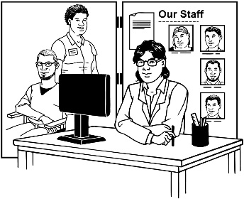
The disability sector includes:
disability support services
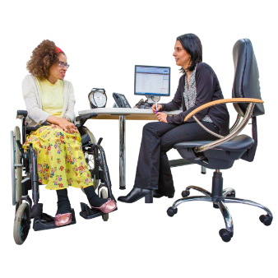
health services
government departments.

The interviews happened between:
late in 2022
and
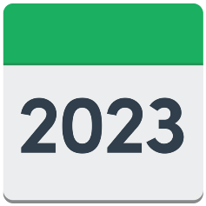
the middle of 2023.


Other research was done through:
one-on-one interviews
focus groups
questionnaires.

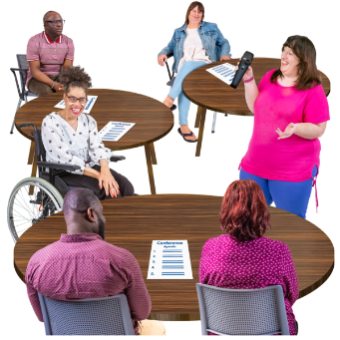
A focus group is a group of people who come together to talk about a thing they have in common.

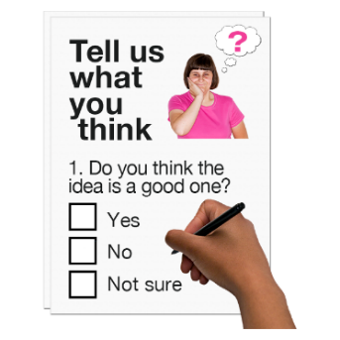
A questionnaire is a type of survey where somebody answers questions.

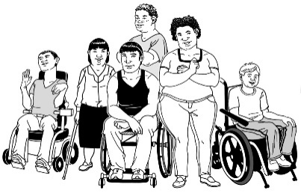
The people who took part were:
disabled people
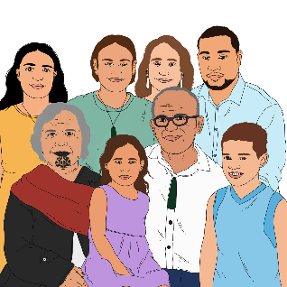
whānau / aiga / family of disabled people
support people.

What were the findings of the research?



Structure

Here structure means how something is put together.

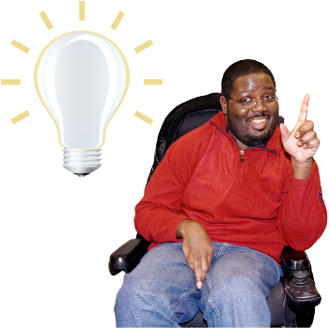

People who took part in the research said the foundations / ideas that make up Whaikaha were not always respected.

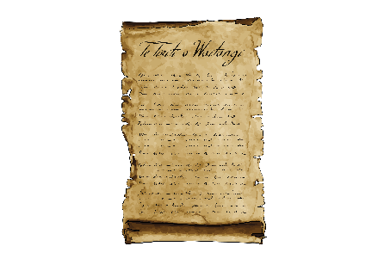
The foundations of Whaikaha are:
Te Tiriti o Waitangi / the Treaty of Waitangi
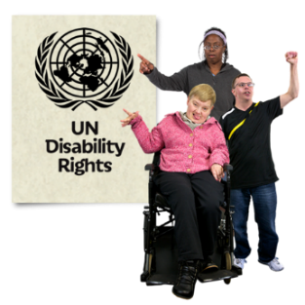
the UNCRPD
Enabling Good Lives / EGL.


Enabling Good Lives is a different way of thinking about disability support.

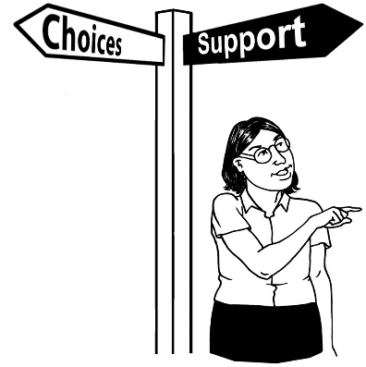
Enabling Good Lives is about having:
choice
control
the support you:

- need
- want
a good life.

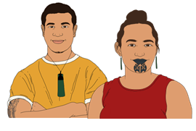
Te Tiriti o Waitangi / Treaty of Waitangi is an important agreement between:

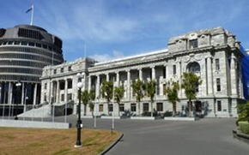
Māori
and
the Crown.

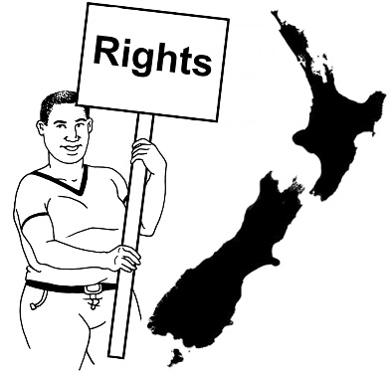
The purpose of Te Tiriti is to:
protect Māori:
- rights
- taonga
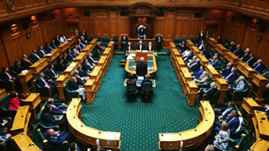
keep peace and order
set up government.


Peace and order means to follow laws / rules.


Taonga means treasures such as:
land
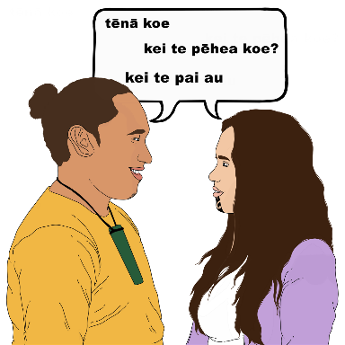
rivers
te reo Māori / Māori language
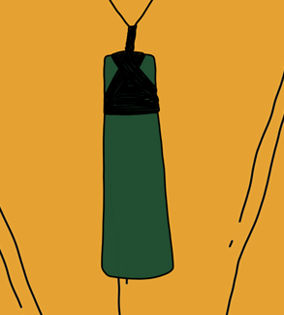
objects like
pounamu / greenstone
traditional food growing practices
spiritual ideas
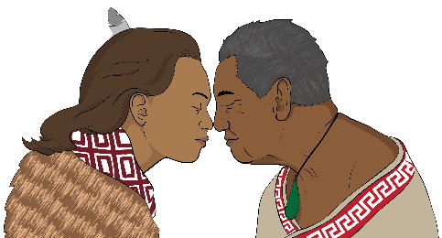
ways of life.

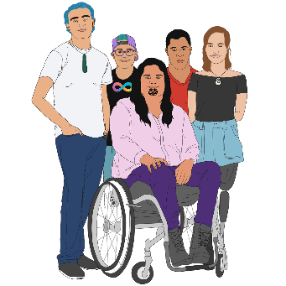
People who took part in the research said a partnership was important between:
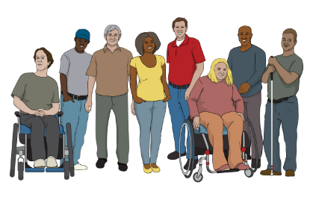
tākata whaikaha Māori / disabled Māori
disabled people

the Crown / government.

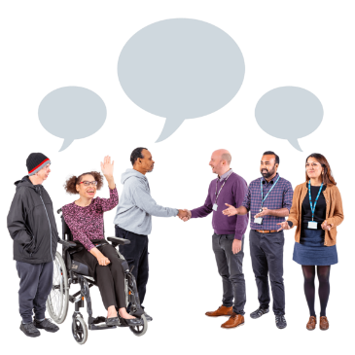
Here a partnership means people working together to make things happen.




People who took part in the research said people in the partnership must be given the things they needed to do a good job.

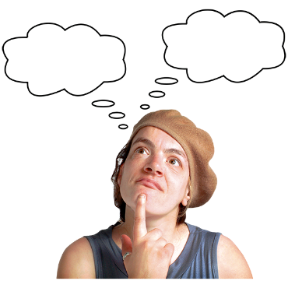


This was so they could:
make decisions
share power.

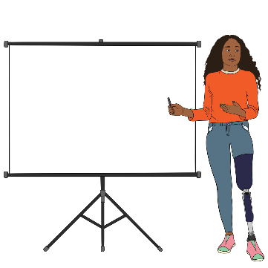

People who took part in the research also said disability culture should be:
promoted / talked about
celebrated.


Disability culture is disabled people:
sharing a way of thinking
doing things together
being proud of who they are.

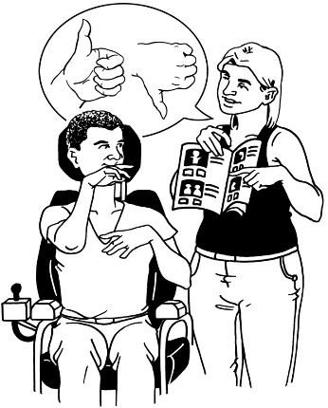
Operations and functions

People who took part in the research said Whaikaha must do what the disabled community needs.

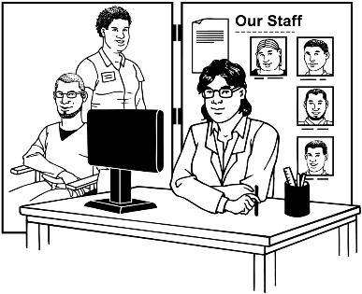
Some people who took part in the research were hopeful about Whaikaha looking after disability supports and services / DSS.

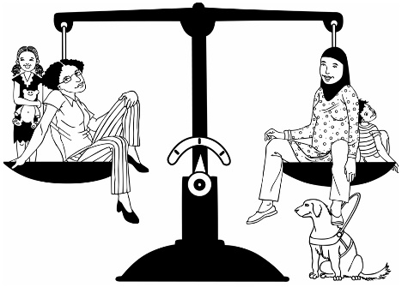
They wanted DSS to be:
given what it needed to work
focused on making things fair for disabled people.

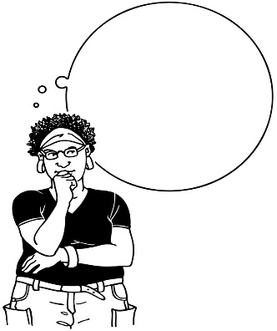
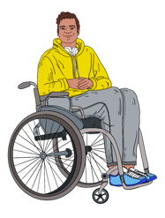
People who took part in the research talked about Whaikaha looking after disability issues for the whole government.

They thought this could support people to think about disability better.

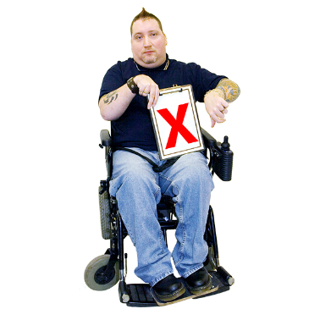
People who took part in the research said they were worried that other government agencies would:
not look after disability issues as well as they needed to be
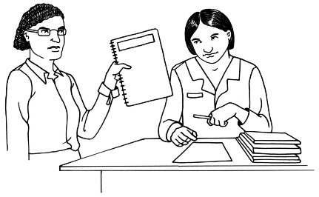
and
tell Whaikaha to work on them instead.

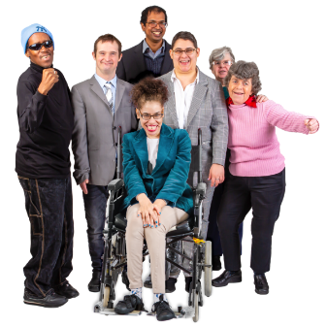
People who took part in the research said they were excited about what could be done with Enabling Good Lives / EGL at Whaikaha.

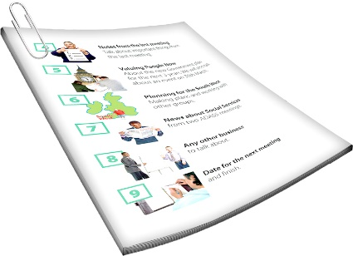

Bad and good things

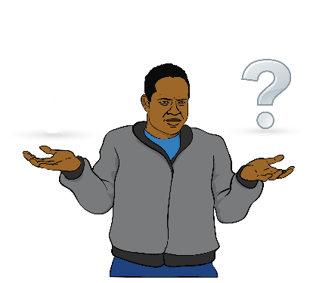
The problem most people talked about was not having enough accessible information about:

what Whaikaha does
and
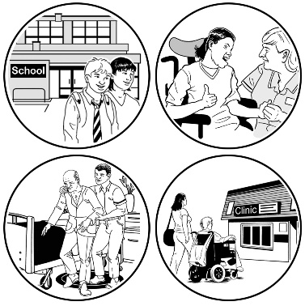
what support Whaikaha could give to:
- disabled people
- whānau / family.


People who took part in the research said they were worried a new government:
would affect what Whaikaha does
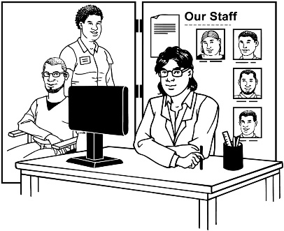
might not let Whaikaha keep doing what they wanted to.
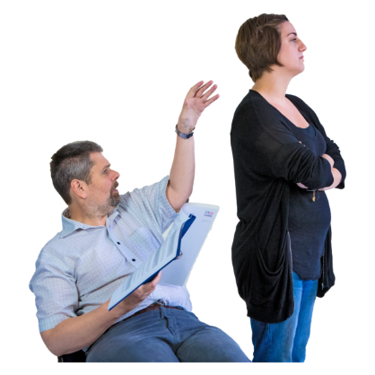
People who took part in the research said that people left out of what Whaikaha does were those with:
psychosocial / mental health disabilities
chronic health conditions.

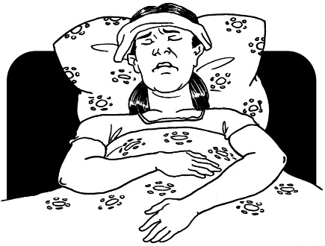
Chronic health conditions means health conditions that last:
for a long time
your whole life.


Some people who took part in the research said Whaikaha did a good job:
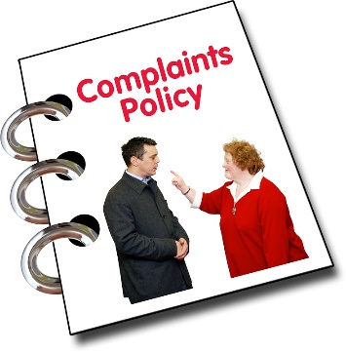
giving emergency response information like what to do in a flood

dealing with complaints.

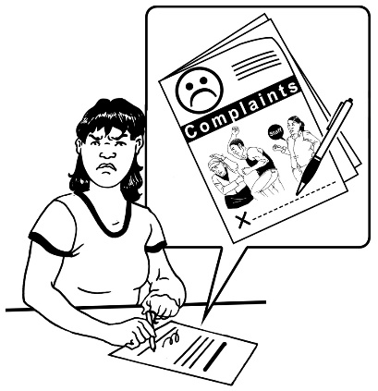
A complaint is when you tell someone:
something is wrong
and
how you want it to be fixed.

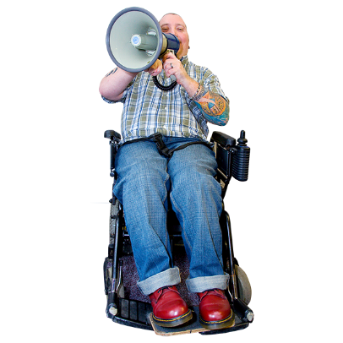
People who took part in the research said they wanted Whaikaha to be a strong voice for the disability community.

What are the recommendations?


People who took part in the research gave recommendations on what Whaikaha could do.

A recommendation is something that would be good to do.

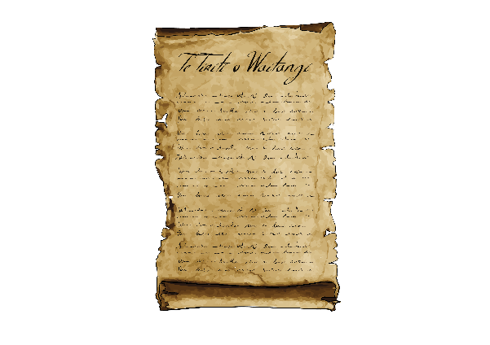
People who took part in the research said Whaikaha must use the principles / ideas from:
the social and human rights models of disability
Te Tiriti o Waitangi / the Treaty of Waitangi
Enabling Good Lives / EGL
the UNCRPD.

A model of disability means a way of understanding:
what disability is
the best ways of making sure disabled people can have good lives.

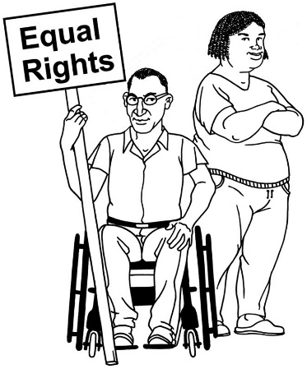
The social and human rights models of disability is understanding that disabled people have:
equal rights
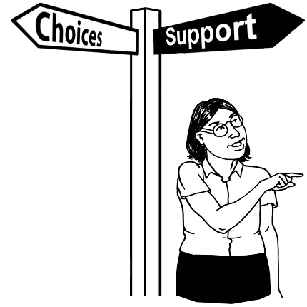
choice of what they want to do in their lives
control over their lives
are included in everything.


People who took part in the research said Whaikaha should:
make sure Enabling Good Lives / EGL is used by everyone in government.

work in partnership with disability communities
have good leaders who are:
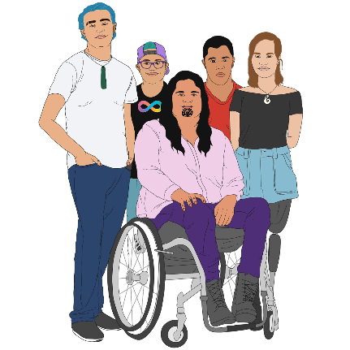
- tākata whaikaha / disabled Māori
and
- whānau hauā / Māori with disabilities and their whānau / families.

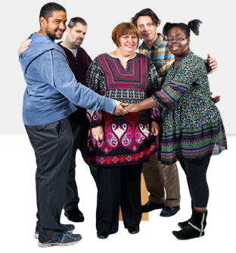
People who took part in the research said Whaikaha should:
build the disability community
bring the disability community together.

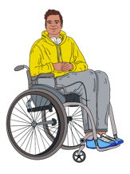
People who took part in the research said Whaikaha should support changing the way everyone thinks about disability.


This change in thinking should be from bad to good.


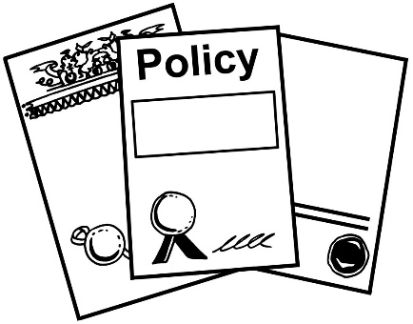
People who took part in the research said Whaikaha should make better:
policy / rules
legislation / law.
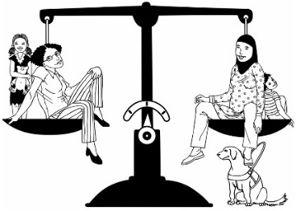
This is so disabled people have equitable outcomes.

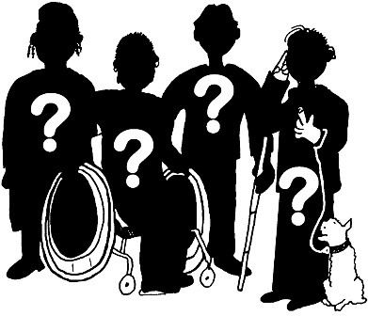
An equitable outcome means thinking about:
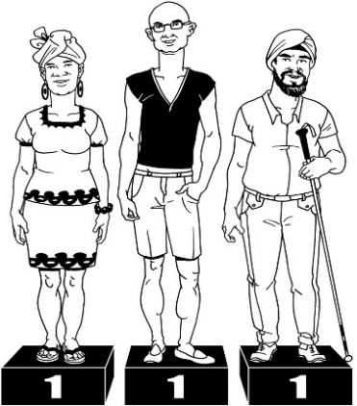
the different challenges people live with
and
how to make things things fair for everyone.

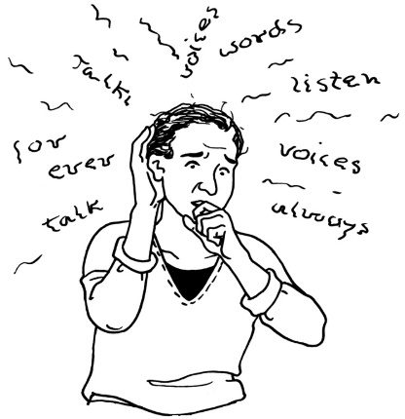
People who took part in the research said Whaikaha should include:
people with psychosocial disability / mental health disability
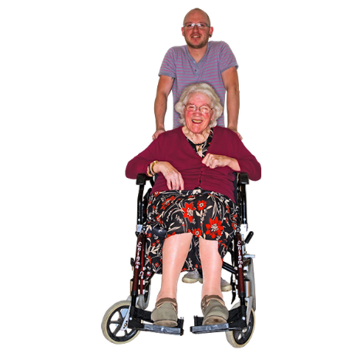
people with chronic health conditions
disabled people over 65 years of age.


People who took part in the research said Whaikaha should:
be properly funded

have people working for them who know what it is like to live with a disability.

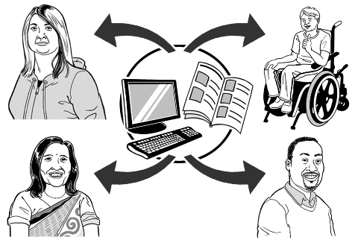
People who took part in the research said Whaikaha should be the one place disabled people can go to for:
information
support.

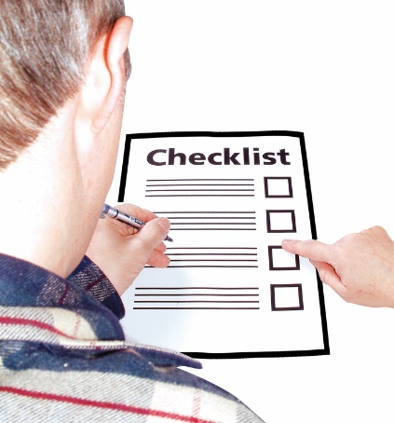

People who took part in the research said Whaikaha should provide good information about what it:
does
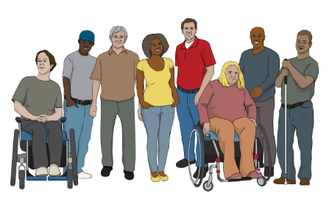
can offer to:
- disabled people
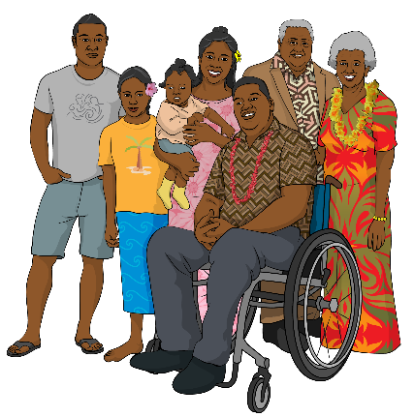
- whānau / aiga / family
- support people.

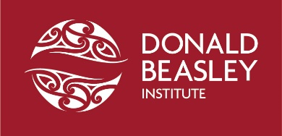
This information has been written by the Donald Beasley Institute.

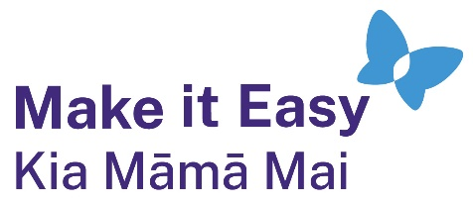
It has been translated into Easy Read by the Make it Easy Kia Māmā Mai service of People First New Zealand Ngā Tāngata Tuatahi.
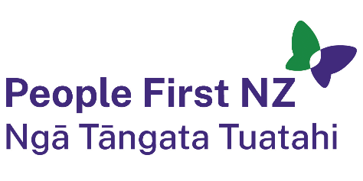
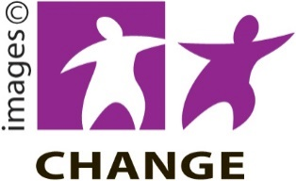
The ideas in this document are not the ideas of People First New Zealand Ngā Tāngata Tuatahi.

Make it Easy uses images from:


- Changepeople.org


            - Photosymbols.com

- SGC Image Works
- Huriana Kopeke-Te Aho

- T.Wood.

All images used in this Easy Read document are subject to copyright rules and cannot be used without permission.

