My Experiences, My Rights: A Monitoring Report on Disabled People’s Experiences of Health and Wellbeing in Aotearoa New Zealand (Short Report)

Disabled Person-Led Monitoring of the United Nations Convention on the Rights of Persons with Disabilities

Donald Beasley Institute. (2022). My Experiences, My Rights: A Monitoring Report on Disabled People's Experiences of Health and Wellbeing in Aotearoa New Zealand. [Short Monitoring Report]. New Zealand Disabled People’s Organisations Coalition.

E rua tau ruru, e rua tau wehe, e rua tau mutu, e rua tau kai
Persevere, keep at it, and success will follow
1- Foreword 2
2 - Introduction 4
3 - Methodology 6
4 - Findings 8
4.1 Article 25.a 8
4.2 Article 25.b 12
4.3 Article 25.c 14
4.4 Article 25.d 15
4.5 Article 25.e 18
4.6 Article 25.f 20
5 - Discussion 22
5.1. Honouring Te Tiriti o Waitangi 23
5.2. Funding Systems 24
5.3. Health Literacy 24
5.4. Complaints Procedures 25
6 - Recommendations 26
7 - Conclusion 28
References 30

1- Foreword
As a signatory to the United Nations Convention on the Rights of Persons with Disabilities (UNCRPD), Aotearoa New Zealand has a responsibility to monitor and critically examine our progress toward implementing this international human rights convention. Article 33.3 requires disabled people and their representative organisations to be centrally involved in monitoring disabled New Zealander's human rights in crucial areas of their lives. In 2018, The Disabled People's Organisations (DPO) Coalition commissioned the Donald Beasley Institute to undertake a three-year monitoring research project responsive to Article 33.3. The research was conducted exclusively by a disabled person-led research team and has involved many disabled people and their whānau and close supporters from across Aotearoa. This report details findings related to the second cycle of monitoring, which focused on Article 25 of the UNCRPD – Health.

As evidenced by their poor health status, the health system has not always served disabled people well. Therefore, the DPO Coalition recognised it was crucial to explore human rights breaches experienced by disabled New Zealander's in the area of health and wellbeing. The monitoring research detailed in this report provides an authentic and accurate snapshot of the myriad ways the health system has let disabled people down. It highlights how rights breaches in health and wellbeing intersect with rights breaches in other areas of disabled peoples' lives to create complex and multiple impacts. The report also identifies the strategies identified by the research participants that would make a real difference to our health and wellbeing and have a flow-on effect into other parts of our lives.

We are excited to release this comprehensive research on disabled people's health and wellbeing experiences at this critical point in history for disabled people and the health and disability sector. On Friday 29th of October, 2021, the New Zealand government announced plans for a new Ministry for Disabled People and several other initiatives to ensure greater choice and control for disabled people and their whānau. This announcement came on the back of sweeping reforms planned for the health system. As you read this report, you will see that a number of the recommendations made by disabled people and the disabled person-led research team appear to be underway, which is good news. However, other health and wellbeing experiences and associated recommendations outlined in this report remain invisible in the current disability- and health-systems reforms.

For this reason, the DPO Coalition encourages you to engage with this comprehensive monitoring research. It has multiple uses. It can underpin our reporting to the United Nations Disability Committee planned at this stage to occur in late 2022. It also provides evidence to inform policy and practice as the disability and health system reforms are embedded in Aotearoa New Zealand, over the coming months and years. Perhaps most importantly though, the report gives priority to the voices of disabled people. Monitoring health and wellbeing experiences has reminded us we still have a long way to go before we can truly be said to be exercising our right to enjoy the highest attainable standard of health without discrimination.

Anton Sammons
Chair
Disabled People’s Organisations Coalition

2 - Introduction
“My impairment shouldn’t be a barrier to getting good help, but it is often a barrier.” (Interview #49)

In 2008, the New Zealand Government signed and ratified the United Nations Convention on the Rights of Persons with Disabilities (UNCRPD), indicating its agreement to progressively realise the rights of disabled people in Aotearoa New Zealand. As part of this agreement, disabled people and their representative organisations must be involved in monitoring the implementation of the articles contained within the Convention (Article 33.3, United Nations, 2006).

Appointed by the New Zealand Disabled People's Organisations Coalition (DPO Coalition) the Donald Beasley Institute (DBI) has been leading the Disabled Person-Led Monitoring of the UNCRPD in Aotearoa since 2018. The DBI is a national, independent, non-profit organisation based in Ōtepoti Dunedin, Aotearoa, whose aim is to promote the rights of disabled New Zealanders through applied research, evaluation and education.

Having investigated disabled people’s right to adequate housing in two previous monitoring reports, health and wellbeing was identified as a topic that should also be monitored. The aim of this research project was to document the health and wellbeing experiences of disabled people in Aotearoa, and investigate whether the health and disability system is fit for disabled people, according to disabled people themselves.

This short report highlights the key themes and findings of the longer report. While this summary is based on Interviewee experiences, for reasons of brevity verbatim quotes have not been extensively used. Quotes, along with further research findings, can be found in the main body of the longer report.

3 - Methodology
This research examined whether the health and disability system is upholding disabled people’s right to the highest attainable standard of health. The use of the Disability Rights Promotion International (DRPI) methodology enabled disabled participants (Interviewees) to share their experiences directly, identify problems and rights violations, raise public awareness, enhance disabled people’s collective identity, and facilitate steps towards achieving social justice (DRPI, n.d.).
Over a period of six months, remote interviews were conducted by trained Monitors (disabled researchers) using Zoom or alternative forms of technology (in compliance with COVID-19 physical distancing protocols). Utilising a maximum variation sampling method of recruitment (Patton, 2002), Interviewees included disabled people over the age of 18, as well as family members, whānau or close supporters of people with multiple and complex disabilities.
The monitoring research was conducted over two phases. Phase One involved consulting with 157 disabled people (134 disabled people and 23 family, whānau, and close supporters) through online surveys and focus groups where participants were asked what health and wellbeing violations they would like to see investigated in this monitoring. The findings from Phase One were then used to inform the research framework of Phase Two.
During Phase Two, 100 Interviewees were recruited including 87 disabled people and 13 family members, whānau, or close supporters of people with multiple and complex disabilities. The Interviewees were diverse in terms of their type of disability (including physical disabilities, sensory disabilities, learning disability and neurodiversity, and psychosocial disabilities), with many identifying as living with multiple disabilities. The sample comprised of 68 female Interviewees, 28 male, four non-binary, and one transmasculine Interviewee. Seventy-seven Interviewees identified as Pākehā, 13 as Māori, eight as Pacifica, seven as Asian, seven as European, four as South African, and one identified as South American. During the interviews, Interviewees were asked about their experiences and interactions with the health and disability support system in order to establish whether those experiences aligned with their rights as specified in the UNCRPD.

Following the interviews, the data was transcribed and coded according to predetermined and emergent themes, before each code was assigned relevant sub-articles of Article 25 of the UNCRPD. The next section of this report presents a brief overview of the key findings.

4 - Findings
The opening text of Article 25 (Health) of the UNCRPD states that the New Zealand Government must:

[R]ecognize that persons with disabilities have the right to the enjoyment of the highest attainable standard of health without discrimination on the basis of disability. States Parties [the New Zealand Government] shall take all appropriate measures to ensure access for persons with disabilities to health services that are gender-sensitive, including health-related rehabilitation.

4.1 Article 25.a
“[I] got the referral and it said [...], “disabled woman shouldn't have a baby but has had one and needs help.”” (Interview #45)
Article 25.a pertains to the provision of health care for disabled people. More specifically, the New Zealand Government must provide “persons with disabilities with the same range, quality and standard of free or affordable health care and programmes as provided to other persons, including in the area of sexual and reproductive health and population-based public health programmes” (United Nations, 2006).
Interviewees reported a range of issues relating to Article 25.a. The findings were arranged into five categories: funding, sexual and reproductive health, population-based public health programs, access, and formal complaints procedures.
- Funding - Funding was one of the most common issues preventing Interviewees from accessing adequate health care and wellbeing services. Specifically:
- The two-tiered support systems of MoH and ACC were perceived as generating two different health classes within the disability community;
- Inadequate funding under the MoH system was reported as negatively impacting the type, timeliness, quality, and length of treatment and services provided to Interviewees;
- A lack of funding for disability-specific services (for example, for Fetal Alcohol Spectrum Disorder);
- A lack of consistency, coordination and communication was experienced by Interviewees who received funding from either the MoH and ACC;
- Primary health care, allied health care, and mental health services were unaffordable for many Interviewees;
- Prescriptions, as well as transport and the cost of parking at health services were also reported as unaffordable.
- Some Interviewees were financially disadvantaged by the length of appointments they required. For example, being charged for double appointments because they had a greater number of complex issues to discuss with health professionals, or because they communicated using an alternative form of communication.
- Sexual and Reproductive Health - Despite Article 25.a explicitly articulating disabled people’s right to sexual and reproductive health, the following issues were highlighted by Interviewees:
- Inaccessibility of fertility services;
- A lack of knowledge around intersex bodies and reproductive health;
- A lack of knowledge around gender affirming health care and disability;
- Negative assumptions regarding disabled peoples’ competency as parents.
- Population-Based Public Health Programmes - Population-based public health programmes refer to preventative and holistic health programmes that aim to improve the health status of a population as a whole (Shahzad et al., 2019). Findings revealed that in some circumstances, population-based public health programmes did not consider the rights, needs, will, and preferences of disabled people. For instance, the Government’s public health response to COVID-19, which:
- Disrupted disabled people’s Individualised Funding arrangements;
- Restricted or delayed disabled people’s access to Personal Protective Equipment (PPE);
- Delivered public health information in inaccessible formats;
- Led to disproportionate physical and social isolation for disabled people.
- Access - Findings revealed a broad range of issues regarding disabled people’s access to health and disability support systems. Access was referred to in a variety of contexts, including financial access (as discussed earlier in this short report), physical access, mental access, communication access and sensory access:
- Physical access - A number of Interviewees reported inaccessible health and disability services.
- Mental access - Past negative interactions with the health and disability support system had resulted in mental access barriers.
- Communication access - Barriers to communication were experienced by blind, low vision, and neurodiverse Interviewees, as well as Deaf Interviewees who experienced challenges with NZSL interpreter shortages and booking systems.
- Sensory access - Some Interviewees experienced auditory and sensory overload within public health settings, such as hospitals.
- Formal Complaints Procedures - Many Interviewees believed that formal complaints procedures within the health and disability system are ineffective. Reported barriers included:
- Unsatisfactory resolutions and a lack of accountability by people in positions of power;
- Falling through the cracks of different complaints procedures;
- Fear of adverse consequences when making complaints (such as being ‘blacklisted’);
- Lengthy, tiresome and complex procedures, which discouraged Interviewees from making formal complaints;
- As a result, some Interviewees indicated that they had preferred to change health care providers rather than make a formal complaint.
In summary, despite Article 25.a’s clear requirements regarding non-discriminatory access to health care, many Interviewees indicated that they were unable to access high-quality and affordable health care and disability support services.

4.2 Article 25.b
“[T]he past two years I have experienced hair loss from the trauma of my hospitalisation and I have struggled with things emotionally, however my GP has only suggested antidepressants. I have been turned away from counselling services because nobody wants to deal with somebody who is so complicated.” (Interview #21)

Article 25.b of the UNCRPD states that the New Zealand Government must provide “health services needed by persons with disabilities specifically because of their disabilities, including early identification and intervention as appropriate, and services designed to minimize and prevent further disabilities” (United Nations, 2006). Monitoring findings that directly related to this sub-article included:

- Choice and control - Interviewees said they had limited choice and control over which services, treatment and medication they could access, and when.
- Service Coordination - Poor service coordination between different health providers and departments was reported as a barrier to Interviewee health.
- Disability services and coexisting disabilities - Interviewees reported that services often failed to consider the interlinking nature of their coexisting disabilities.
- Diagnosis - Interviewees experienced challenges with:
- The financial cost of diagnosis;
- Diagnostic overshadowing, which often led to inappropriate service and treatment provisions;
- Misdiagnosis and correcting misdiagnosis.
- Prolonged wait times - Significant delays when accessing diagnosis and treatment.

Another important aspect of disabled people’s health and wellbeing is the Disability Support System (DSS). The DSS provides support for disabled people so that they may have an adequate standard of living (Ministry of Health, 2016). However, Interviewees shared that under the DSS they experienced a number of challenges, including:
- Unpaid and paid supports - Interviewees reported an overreliance on ‘natural supports’ which had a negative impact on both themselves and their families and close supporters.
- People with Multiple and Complex Disabilities and their Family, Whānau and Close Supporters - Challenges included:
- A lack of funding and resources to ensure access to qualified support workers and/or respite services;
- A lack of holistic and specialised care options, especially for people with multiple and complex disabilities and under-recognised disabilities such as FASD.
- Needs Assessment and Services Coordination services (NASCs) - Interviewees reported inadequate Needs Assessment and Services Coordination services (NASCs) assessment processes, resulting in restricted support and resources.

In summary, Interviewees recalled many challenges regarding access to disability specific health and wellbeing services. These complex layers of disability-specific provisions prevented Interviewees from maintaining the highest attainable health.

4.3 Article 25.c
“There’s nobody here in [regional location name removed] that I can talk to because there are no counsellors trained in the trauma that I’ve been through.” (Interview #5)
Article 25.c mandates that the New Zealand Government provide “health services as close as possible to people’s own communities, including in rural areas” (United Nations, 2006). Interviewees, however, noted that availability, provision, and/or quality of health care was dependent on geographical location (post-code health care). For example:
- The availability of services, supports, and funding varies across different DHBs;
- Interviewees living rurally experienced financial, physical, and mental barriers when accessing essential and allied health care services;
- There was a lack of specialist and disability support in some regions;
- Long wait lists and commuting to larger cities were common barriers to access health care;
- Some Interviewees felt pushed into paying for private health care because public health care could not be easily accessed;
- There was a significant lack of NZSL interpreting services in some regions.
In summary, Interviewees living in regional and rural areas reported a lack of access to adequate health and disability support services within their communities, and face further barriers when accessing services in larger cities.

4.4 Article 25.d
“[O]ften when you do go to a new doctor, they don’t understand um and yeah, so you don’t feel like you can trust them because they seem scared or not understanding, so you think how are they going to fix me when they don’t understand what I’m saying or what’s wrong with me.” (Interview #94)

Article 25.d articulates the responsibility of health professionals to provide disabled people with the same quality of care as non-disabled people, on the basis of “free and informed consent by, inter alia, raising awareness of human rights, dignity and autonomy” (United Nations, 2006). In order to achieve this, the New Zealand Government is obligated to ensure that health providers are appropriately trained in disability rights, while promoting ethical standards within health care services. Key findings related to this sub-article included:
- Attitudes - Interviewees reported experiencing negative attitudes and treatment by health practitioners, such as:
- Assumptions that disabled people lack competency when making informed decisions and providing informed consent.
- Failure to take disabled people and their health issues seriously;
- An assumption that disability is a negative experience;
- Failure to thoroughly investigate medical issues, leading to misdiagnosis and diagnostic overshadowing;
- Racial discrimination and denial of other identities (such as sexual and gender identities) on the basis of disability.
- Training - Negative practitioner attitudes were often attributed to a lack of disability training, including on:
- Disability, disability rights, disability culture, models of disability and ableism;
- Neurodiversity, particularly within the mental health sector;
- Disabled people’s capacity and self-determination;
- Alternative communication styles;
- Biases that lead to diagnostic overshadowing;
- Holistic approaches to health and wellbeing;
- Training on specific conditions (such as chronic health conditions);
- It was also noted that negative attitudes were compounded for Interviewees with intersectional identities (for example, whānau hauā/whaikaha Māori and trans Interviewees).
- Awareness of rights and responsibilities
Further to Article 25, Article 8 (Awareness Raising) of the UNCRPD also highlights the New Zealand Government’s responsibility to promote the Convention to both the public and the disability community (United Nations, 2006). When asked whether they knew about the UNCRPD, 64 Interviewees answered yes, 25 said no, two Interviewees were unsure, and nine Interviewees were not asked or did not respond. Most notably, of the 25 Interviewees who said they did not know about the Convention, 15 identified as Deaf. These findings highlight the need for greater awareness-raising efforts to be made amongst both health professionals, as well as the disability community - especially amongst specific cohorts such as Deaf people.
- Self-advocacy
- Interviewees felt a strong need to advocate for themselves in order to access the care they needed;
- Self-advocacy was related to a perceived power imbalance between health practitioners and disabled people;
- Self-advocacy often came at the cost of Interviewee’ fatigue.
- Confidentiality and informed consent
- Some Interviewees indicated that informed consent procedures were inadequate, particularly in relation to the delivery of accessible information;
- Interviewees provided examples of circumstances where health practitioners held deficit attitudes or assumptions about the capacity of disabled people to make valid medical decisions.
- Dignity - Many Interviewees felt their dignity had not been respected or upheld by the health and disability system. For example:
- Some Interviewees felt their disability had been the reason why they had not been treated with respect;
- Other Interviewees reported that the health and disability system did not respect their right to make informed choices about the care and support they receive;
- Many Interviewees reported feeling like they were not being listened to within health settings;
- Some Deaf Interviewees felt that health and disability systems were ill-equipped to accommodate their needs, such as accessible communication, choice and control.

In summary, Interviewee experiences highlighted the need for robust tertiary-level training and on-going professional development on human and disability rights-based practice.

4.5 Article 25.e
“Because of my disability I can’t get good health insurance.” (Interview #21)
Article 25.e of the UNCRPD requires the New Zealand Government to “prohibit discrimination against persons with disabilities in the provision of health insurance, and life insurance where such insurance is permitted by national law, which shall be provided in a fair and reasonable manner” (United Nations, 2006).
The findings related to this article were arranged into two categories; private health and life insurance, and ACC.

- Private health and life insurance
- Only a handful of Interviewees had private health or life insurance. The main barriers to obtaining private insurance related to either non-eligibility due to pre-existing conditions, or disproportionately high premiums to cover pre-existing conditions.
- ACC - ACC-funded Interviewees reported that:
- ACC assessments lean towards minimising and denying support and/or funding;
- ACC support ignores the evolving experience of disability over time, and has a narrow focus on rehabilitation in order to regain pre-injury employment status;
- ACC calculations and assessment tools focus on budget and cost control;
- There are inconsistencies in the support and services given to different ACC clients;
- Some Interviewees shared that they were grateful that their disability was caused by injury and not a result of congenital/medical conditions.

Despite the provisions of Article 25.e, many Interviewees reported being denied access to private health and life insurance due to pre-existing conditions. Although ACC cover was considered life-changing by some Interviewees, others shared that there is still considerable room for improvement.

4.6 Article 25.f
“I can’t get my mammogram appointment because I’m in a wheelchair.” (Interview #5)

Article 25.f of the UNCRPD stipulates that the New Zealand Government must “prevent discriminatory denial of health care or health services or food and fluids on the basis of disability” (United Nations, 2006).

While the monitoring research found no evidence of the denial of food or fluid on the basis of disability, there was evidence of the denial of health care and services on the basis of disability. This included Interviewee reports of:

- Treatment, services and medication:
- Being denied access to diagnosis and treatment, particularly for Interviewees living with coexisting and complex conditions;
- Fear of the denial of health care due to practitioner prejudice towards people with multiple and complex disabilities;
- Fear of the denial of health care based on prejudices relating to disability and the End of Life Choice Act.
- Choice and control:
- Being denied choice and control over the type and timing of medication and treatment (such as medicinal cannabis);
- Denial of choice and control under the Mental Health (Compulsory Assessment and Treatment) Act 1992 (Mental Health Act).
- Covid-19:
- Being denied health and disability services due to disruptions caused by the COVID-19 pandemic and subsequent lockdowns.
- Health care in prisons:
- Being denied access to health care while in prison.

In summary, even though the denial of food and fluids on the basis of disability were not evident in the interviews, Interviewees repeatedly highlighted experiences where they were either directly or indirectly denied health care and services on the basis of their disability.

5 - Discussion
“I don’t think they’ve got any idea of what’s really happening out there for a disabled person.” (Interview #85)

The findings outlined in this monitoring research project represent a vast array of human rights issues, challenges and barriers experienced by disabled New Zealanders and our right to the highest attainable standard of health. A key theme woven throughout the interviews concerned Interviewee wellbeing. In line with the findings of other mental health inquiries, this monitoring research brought to light serious and prevalent mental health and wellbeing challenges experienced by disabled people. For example:
- Stress and anxiety when engaging with health and disability systems;
- A lack of financial security, which negatively impacted Interviewee health and wellbeing;
- Loneliness and isolation;
- A lack of community access;
- Negative emotional and cognitive implications of Covid-19 disruptions and lockdowns.

Another key factor influencing this cycle of monitoring research was the review of the national health and disability system, and subsequent reforms. While April 2021’s announcement envisioned a health and disability system with the potential to address some of the concerns raised by Interviewees, the findings of this report show that there are also issues raised throughout the interviews that do not appear to have been directly addressed by the reforms, including:

- Inconsistent and inadequate funding systems
- Needs Assessment and Service Coordination services (NASCs)
- Access to diagnosis
- Medication subsidies
- Disabled people in prisons
- Inaccessible complaints procedures

A final key theme that was identified throughout the interviews related to models of disability. The way in which disability and impairment is understood and responded to by the health and disability sector has a significant impact on the way we navigate our health and wellbeing. Reflecting on the findings, two key disability model themes emerged. At a systems level, the health and disability system review and reforms appear to have made a positive move away from the medical model of disability and embraced the ethos of the social model by recognising existing barriers within the current health and disability system. However, at the time of writing this report there was little evidence of a rights-based approach being utilised to guide policy responses to disability rights violations. At an individual level, however, findings indicated that there is still a long way to go until health and wellbeing professionals fully understand the difference between the medical, social and rights models of disability, and actively move towards the unapologetic promotion of the rights model of disability within their respective professions.

In addition to the identified issues, challenges and barriers, further analysis of the data by the disabled person-led monitoring team also revealed four key areas of systemic failures that underpinned the findings reported by Interviewees: Te Tiriti o Waitangi; funding systems; health literacy; and complaints procedures. Echoing the negative experiences of disabled people, these key systems and areas were identified as requiring significant improvement in order for the health and disability system to deliver on the obligations contained within the UNCRPD.

5.1. Honouring Te Tiriti o Waitangi
The findings of the Health Services and Outcomes Inquiry (Wai 2575) commissioned by the Waitangi Tribunal revealed that tāngata whaikaha/ whānau hauā (disabled Māori) experience significant barriers and challenges in the health and disability system (Kaiwai and Allport, 2019). Confirming the findings of the Inquiry, this monitoring research showed that population-based health programmes often do not meet the specific needs of tāngata whaikaha/ whānau hauā. This was compounded by a lack of understanding and implementation of Te Tiriti principles. Hence, the health and disability system must not only adopt more recent interpretations of Te Tiriti that facilitate its realisation (Health and Disability System Review, 2020), but it must also consider te ao Māori perspectives of disability, mātauranga Māori (Māori knowledge), and adapt procedures, processes and policies accordingly.

5.2. Funding Systems
The monitoring findings revealed that different ‒ and often inequitable ‒ systems of funding had negatively impacted the health and wellbeing of disabled people. Inadequate funding and inconsistencies between ACC and MoH systems were frequently mentioned by Interviewees whose health and wellbeing experiences were negatively impacted by inequitable, widespread, and sustained funding issues. Addressing inequitable funding is a prerequisite for the realisation of Article 25 and other Articles of the UNCRPD. This requires sector reforms that extend beyond the current health and disability system reform in order to address the existing inequities.

5.3. Health Literacy
Analysis of the monitoring findings suggested that disabled people must have a certain level of knowledge and skills in order to effectively navigate the health and disability system. Many Interviewees believed that the outcome of their interactions with the health and disability system were directly correlated with the information and knowledge they had of the system itself. That is, the more knowledge they had, the better the treatments, services, and support they received. Reflecting the concept of ‘Health Literacy,’ the current health and disability system demands a high, and sometimes unrealistic, level of knowledge and skills that can be difficult for disabled people to obtain and maintain. The monitoring research also highlighted the shortcomings of the health and disability support system in enhancing health literacy specifically for disabled people.

5.4. Complaints Procedures
In Aotearoa, there are various formal complaints procedures to ensure ethical health and disability services. This multi-layered system of complaints procedures was reported to be inaccessible for many in the disability community. The analysis of these findings indicated a need for formal complaints procedures to be reviewed in order to address the lack of accessibility experienced by disabled people, and accountability by people in positions of power. An effective, timely, easy-to-navigate, and safe complaints process ensures that adverse experiences are appropriately addressed and resolved. These same procedures must also lead to systemic-level change, so that other health consumers do not experience similar challenges in the future.

6 - Recommendations
“We’re not asking for special treatment. We’re just asking to be treated normally. But to be treated normally we’ve got to have some things in place so we can actually maneuver and be.” (Interview #16)

As prolonged and frequent users of the health system, disabled people are best positioned to provide recommendations on how to progressively realise Article 25 (Health) of UNCRPD in Aotearoa. Outlined below is a selection of the frequently mentioned recommendations, as well as more specific recommendations that provide clear and practical solutions for promoting disabled people’s right to the highest attainable standard of health.

- Establish a ministry dedicated to disability and disabled people so that there is a clear distinction between health and disability;
- Replace the two-tiered funding system (ACC and MoH) with an equitable funding and support system for all people, regardless of the cause of disability;
- Prioritise tāngata whaikaha/ whānau hauā in all aspects of health care and programmes;
- Ensure existing and new laws and policies are aligned with the UNCRPD;
- Increase disability representation and ensure formalised consultations with a diverse range of disabled people in all policy design and reforms;
- Implement free regular health care for disabled people, including dental care;
- Increase Deaf and disabled representation in health care professions;
- Increase the awareness of the UNCRPD, disability rights and health literacy for disabled people;
- Improve disability rights training and awareness for health professionals and medical students;
- Increase funding for more highly qualified carers and support people;
- Commit to an urgent national roll out of Enabling Good Lives (EGL);
- Increase health and disability support in rural areas;
- Improve coordination efforts between different health agencies and departments;
- Provide holistic health care, rather than siloed services;
- Abolish medically unnecessary surgical interventions on intersex bodies;
- Recognise FASD as a disability, with greater access to early diagnosis, funding, and services.

In order for the government to fulfil its obligations under the UNCRPD, the disabled person-led monitoring team also identified three system-level recommendations guided by the responses of the Interviewees:

- Adopt a disability rights-based framework in the upcoming reforms, and all other policy/programme developments. Ensure all future decisions regarding health and wellbeing are made with the Convention in mind, with a particular focus on Article 25 (Health) and other relevant articles.
- Commit to improving the issues, challenges and barriers recognised in the short and long reports. This monitoring research has collected and analysed the experiences of over 250 disabled people, and therefore provides an unparalleled body of evidence which can, and should, be used to inform the review, and ongoing health and disability system reforms.
- Measure the provision and progress of all health programmes, policies and reforms against the Government’s commitments under the UNCRPD, together with robust, ongoing, disability-led data, evaluation and monitoring processes (as obligated by Article 31, 33 and 35 of the Convention).

7 - Conclusion
“We need to bring the government accountable, to honour what they agreed with signing the CRPD, the Convention, and change every single policy [and] legislation, whatever, that perpetuates discrimination against disability. I think we all need to stand our ground and stop accepting that it’s okay to be discriminating, because it’s not.” (Interview #12)
Article 25 of the UNCRPD states that disabled people “have the right to the enjoyment of the highest attainable standard of health without discrimination on the basis of disability” (United Nations, 2006). Throughout this monitoring research, Interviewees shared issues, challenges and barriers at every level of their interactions with the health and disability support system: from financial, physical, communication, mental and sensory access to population-based health programmes and specialist care, to the negative attitudes of health and wellbeing practitioners. Further analysis of these findings illustrated four key areas where systemic change is required: upholding the Te Tiriti o Waitangi for tāngata whaikaha/whānau hauā; addressing inequitable funding systems; enhancing disabled people’s health literacy; and improving complaints processes. Interviewees then suggested a range of solutions and recommendations they deemed necessary for realising their right to the highest attainable standard of health.
Despite progress in promoting disabled people’s rights in Aotearoa, this monitoring research has revealed that there is still a long way to go until the right to health is realised in a meaningful and effective way. While ‘progressive realisation’ indicates that some aspects of the Convention can be implemented over time, it has taken more than 13 years to begin to address disabled people’s right to the highest attainable standard of health. Much like the earlier monitoring reports, solutions to the identified challenges can, and must, be found in the wisdom of those who have lived through the challenges identified in this monitoring research.
Despite only having only scratched the surface, this monitoring research has demonstrated the potential for disability and family/whānau-led progressive realisation of the UNCRPD in Aotearoa, and a future where all people can enjoy their rights, freedoms, and dignity in a full and meaningful way.

References
Disability Rights Promotion International (DRPI) (n.d.). Disability Rights Promotion International: Establishing a Monitoring System to Address Disability Discrimination Globally (n.d.). York University. https://drpi.research.yorku.ca/welcome-drpi/
Donald Beasley Institute (DBI) (2021). My Experiences, My Rights: A Monitoring Report on Disabled Person's Experience of Health and Wellbeing in Aotearoa New Zealand - Disabled Person-Led Monitoring of the United Nations Convention on the Rights of Persons with Disabilities (Long Report).
Government Inquiry into Mental Health and Addiction (2018). He Ara Oranga: Report of the Government Inquiry into Mental Health and Addiction. https://mentalhealth.inquiry.govt.nz/inquiry-report/he-ara-oranga/
Health and Disability System Review (2020). Health and Disability System Review. https://systemreview.health.govt.nz/final-report/
Kaiwai, H., & Allport, D. (2019). Maori with Disabilities (Part Two). Waitangi Tribunal. https://forms.justice.govt.nz/search/Documents/WT/wt_DOC_150473583/Wai%202575%2C%20B023.pdf
Ministry of Health (2016). About Disability Support Services. https://www.health.govt.nz/our-work/disability-services/about-disability-support-services
Patton, M. (2002). Qualitative research and evaluation methods (3rd ed.). Thousand Oaks.
Shahzad, M., Upshur, R., Donnelly, P., Bharmal, A., Wei, X., Feng, P., & Brown, A. D. (2019). A population-based approach to integrated healthcare delivery: a scoping review of clinical care and public health collaboration. BMC public health, 19(1), 1-15.https://doi.org/10.1186/s12889-019-7002-z
United Nations (2006). Convention on the Rights of Persons with Disabilities. https://www.un.org/disabilities/documents/convention/convoptprot-e.pdf
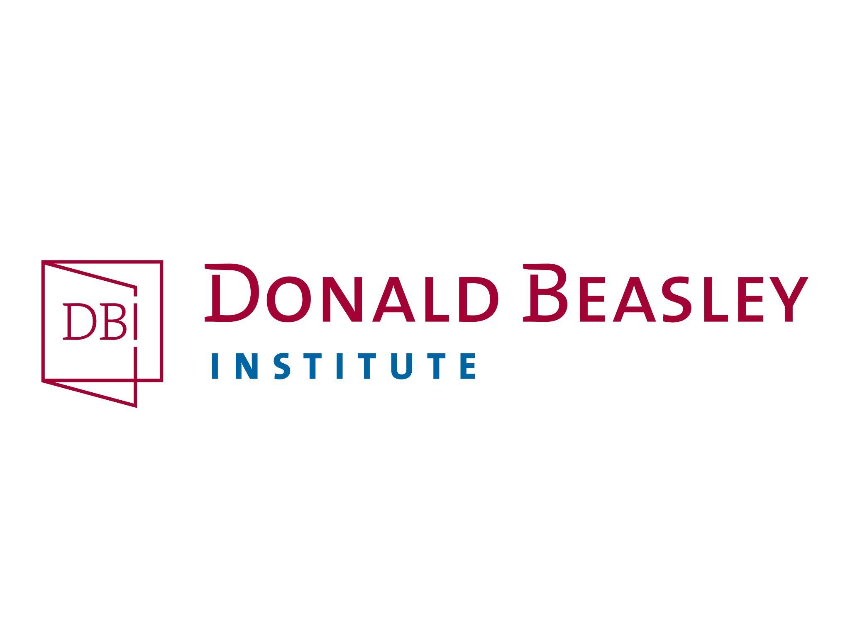
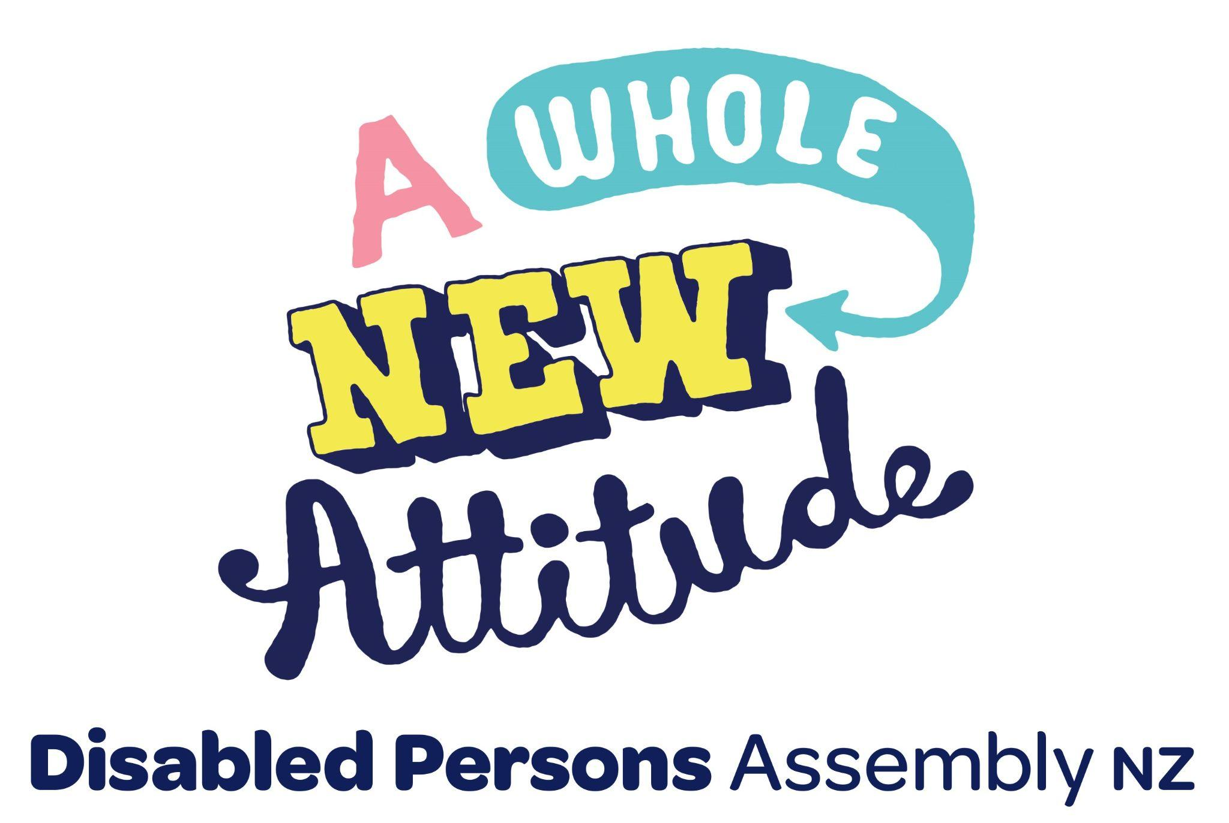
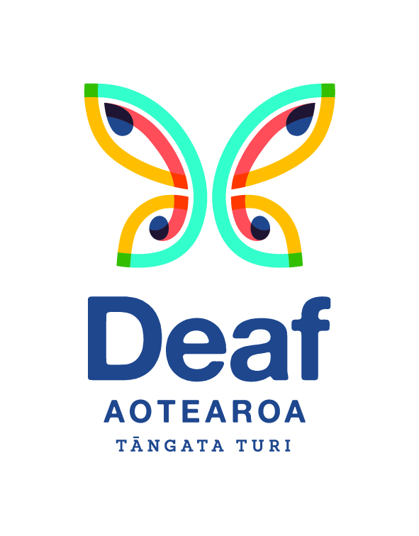
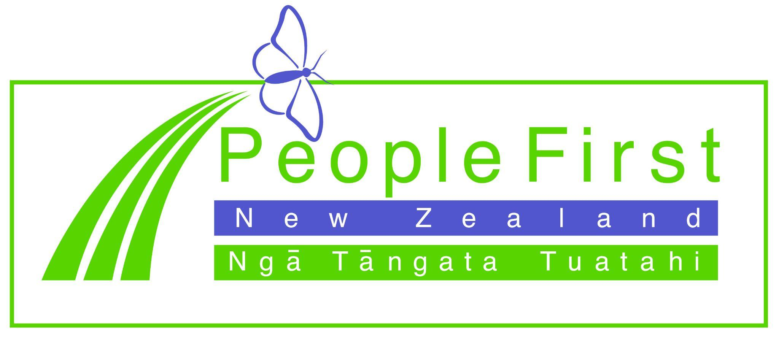
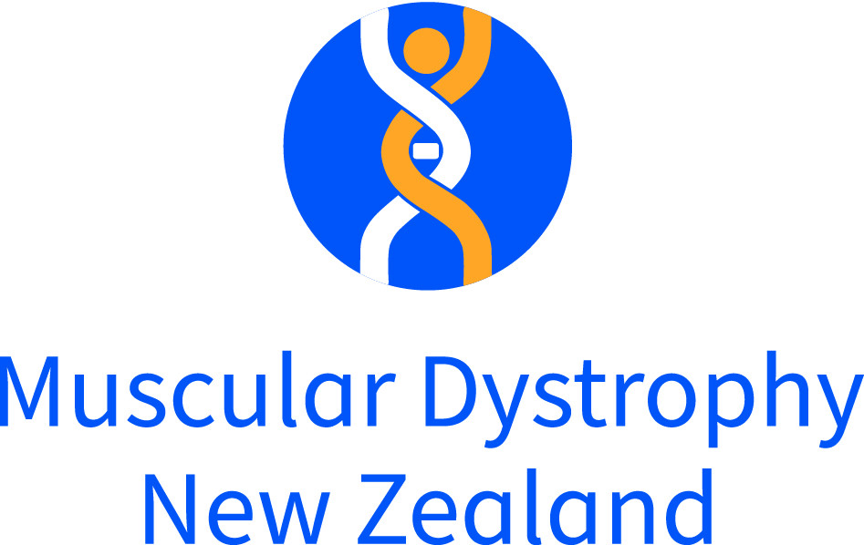
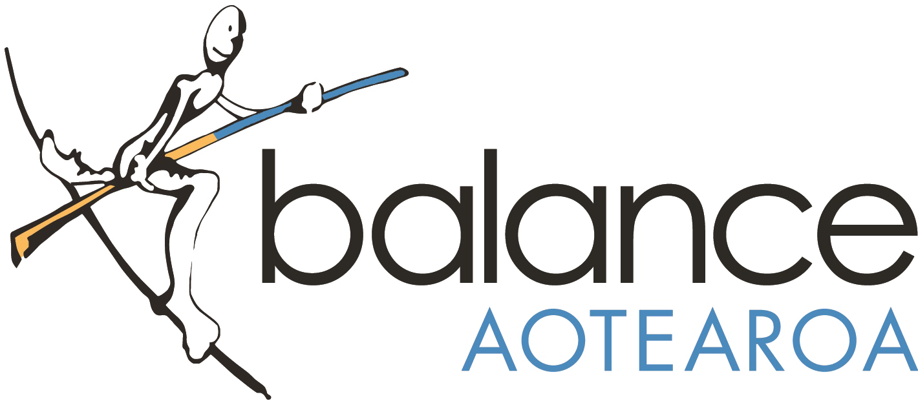
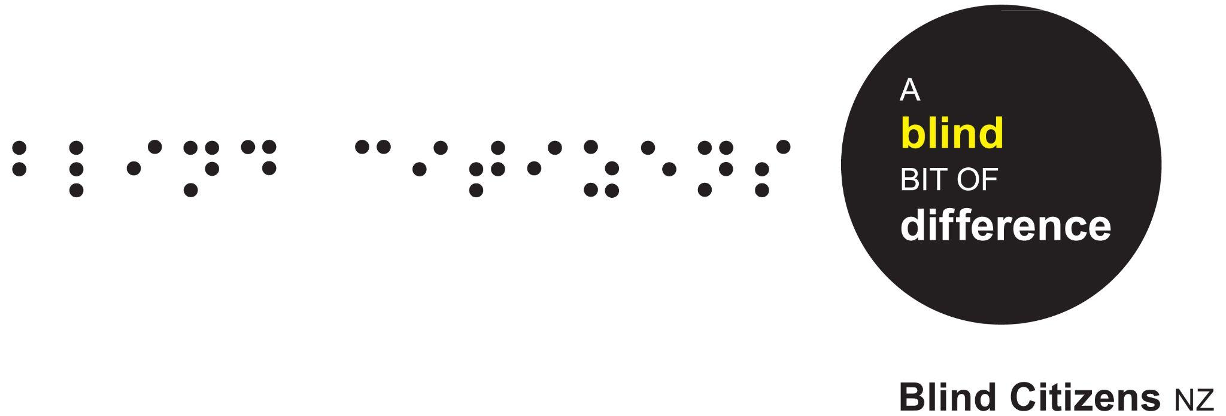

Hereafter referred to as ‘Aotearoa’.
See: My Experiences, My Rights: A Monitoring Report on Disabled Person's Experience of Health and Wellbeing in Aotearoa New Zealand Disabled Person-Led Monitoring of the United Nations Convention on the Rights of Persons with Disabilities (2021)
For example, see: Government Inquiry into Mental Health and Addiction (2018). He Ara Oranga: Report of the Government Inquiry into Mental Health and Addiction. https://mentalhealth.inquiry.govt.nz/inquiry-report/he-ara-oranga/

