“It might be all houses there now”

by Allan and Nathan

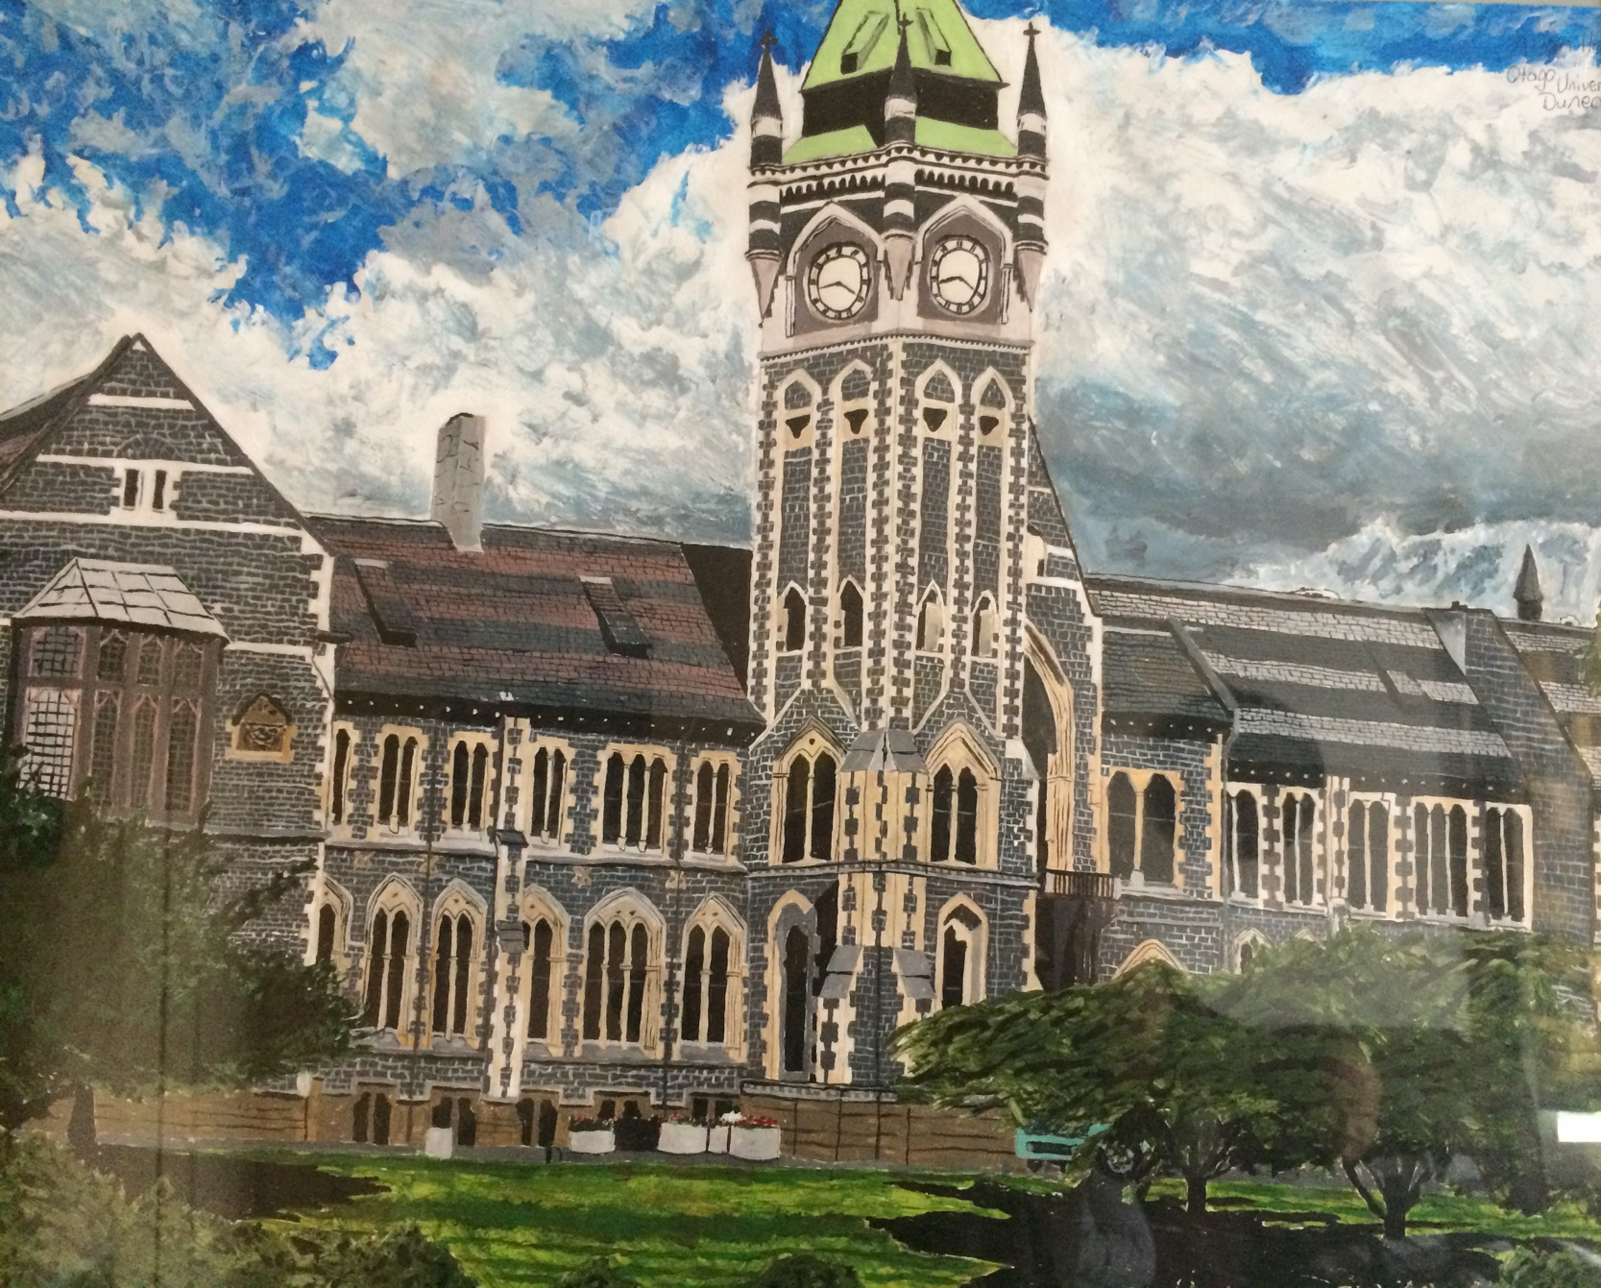
2
A: I was born in a rural town in South Island. I have two half-brothers and a sister. My mum's still around. I used to have a dad but he passed away a couple of years ago. He lived to a good age. He was 87. But I remember that was a very sad time for the family and me when we lost dad.

I would like to go back to experiences I had in my early childhood …
Before I went to the school in Christchurch I used to find it very hard to fit in. If I wasn't sure how to do something, I noticed that some of the teachers wouldn't listen to me and thought that I was trying to be naughty when I made a mistake of something. When a teacher wouldn't show me how to do something, I wasn't sure what to do but they got me to figure it out myself. And then I tried giving it a go and got something wrong, the teachers would sometimes yell at me for getting it wrong and I felt really awful.

I got diagnosed as autistic because I went to Wakari when I was about five to be assessed. I went there with my mum and dad. Teachers didn't know what was wrong with me before I got assessed. It was a stressful time. I think it got to a stage where other schools couldn't handle me. I would get stressed because they couldn't understand me. And from the age of eight I went to a boarding school in Christchurch.

It wasn't my choice to go and I think my dad had no say in it. Cause I think what happened with the problems I was having, one of the behaviour specialists was going to send me to Cherry Farm Hospital. But my mum and dad decided well no, we're going to send him to a special school where he can get an education and learn stuff. Cause my mum and dad knew that if I went there I couldn't learn. So my mum and dad decided to send me to the school and get me an education rather than being locked up in an institution. They wanted the best for me.

But I remember I even had the same problem with the teachers at the school. Like some of the teachers would do the same to me even at Hogben. They wouldn't show me how to do something. When I wasn't sure what to do, I ended up looking in the wrong place and I ended up getting yelled at. That made me very annoyed and angry. They told me to think for myself because if I did things wrong they just thought I was trying to be naughty. And it wasn't good. It didn't work for me. Cause if I'm not sure about something I always like to be shown so then I can remember where it is. Rather than them telling me to use my head. Other times when teachers didn't explain things to me in a way that I understood, I sometimes would get it wrong and then I'd be yelled at. I think sometimes I would have outbursts and then I'd be sent to sit on the hot seat. It's a chair in a corridor right by the principal’s office where you sit by myself. I was sort of isolated from the rest of the pupils. It wasn’t helpful.

N: If I didn’t want to do anything at school, the teachers would write a note and go get someone. They were pretty angry and they came to get us. If it was not the hot seat, they used to send me back to the villas. I had to go back and stay quiet by myself until other students finished school.

A: At the school, we basically learned about cooking. But my favourite things to learn were maths and artwork. Before I went to Hogben I think when I was seven I used to do three dimensional pictures with crayons. Like I used to do a picture of a hillside and I used to draw the things on the hills and then the ocean. Cause that's how I did my art.

I used to be called rabies and ra-ra woof-woof by other pupils because I was scared of dogs. There was some people that would even hit me and even throw stones at me and even do all sorts of things because I had a disability such as Asperger's autism. I used to sometimes tell the staff and tell the teachers. But some staff would just say I got upset when I was being bullied. They were not being very helpful because some of the staff you know, thought I was just over reacting when all I was just trying to do was get my point across and ask staff to help me and support me when I didn't feel safe around some of the pupils. I'm not too sure if I trusted anyone in the school. But I did have some friends that would stick up for me if I was being bullied. And those people that used to bully me I used to be too scared to go near them. But it didn't matter if I walked away from them. They would follow me. Well then my friends used to stick up for me and bully them back. My friends were stronger. They had my back. They were friends from back home. I used to go on the same plane from Invercargill to Christchurch and they used to be good friends with me. I remember I used to have lots of good friends.

I first met my friend Nathan in the mid 1980s. We used to meet at the Invercargill airport cause we used to go to the same school together. I would have only been thirteen. Nathan came later. You are a little younger than me.

N: Yeah. I didn’t like the school I went to in my home town either. The teachers were not great. It didn’t work for me. So my mum and dad sent me to Hogben’s school. I felt better there than the other school.

A: I notice that Nathan used to sometimes get bullied at school too. There was a person who used to be in the same class as him. But I think some people would stick up for Nathan.
Nathan also told me about what happened in the villas after school. We sometimes used to play on the adventure playground together.

N: I used to throw bark and I got told off. [laughs] There might be houses where those playground used to be now.

A: There were lots of time for playing when we weren’t doing school work. We would sometimes go to the field and play games, we would play at the adventure playground, we would do all sorts of things like play in the sand dunes behind the villas. I think the villa staff would sometimes play with us, supervise and make sure it didn’t get too rough.

N: They used to call us when it was tea time.

A: The food was good at the school! There used to be a big kitchen where they used to cook all our meals. I used to sometimes help with bringing the trolley with the Bain Marie with the food back to the villa from the kitchen. It used to be like a trolley that had wheels on it. We used to wheel it. Not lift it.

N: If it was raining we had to stay and the staff went and got it and brought it back. I think they would have gotten rid of the trollies by now.

A: Hogben school wasn't only just a school but it also had villas where you could stay and sleep in. There were five different villas in the school, there was villa five, villa four, villa three, villa two and villa one. When I first went there I was in villa five that was from the age of 8 until 12, and when I was 12 I went to villa four until I was 14, and then when I was 14 I went to villa two right up until I left school at the age of 16. That’s where I used to live with Nathan also. Villa five was the junior villa, and I think villa four was more like the intermediate villa, I think villa three, villa two and villa one were more the senior villas. There were quite a few people, about 24 to each villa, so, there were easily over 100 pupils in the school.

I think there was one big dormitory in each villas. They had beds in each cubicle in the dormitory and there was lockers as well. But I don't think in there you got your privacy. It was sort of embarrassing sharing the dormitory with so many other students. Cause I'm a person who likes to have my own privacy. There were curtains to the windows but I think the cubicles, they were all open to the dormitory. We had separate showers. It was all in the same room but they had doors and stuff. There were three showers each in the bathroom.

N: Where the villas are, it's all houses and where the offices were, there's all houses there now.

A: Some villa staff were helpful but some weren't so helpful. When I was being teased or bullied and I got upset and complained they would think I was over reacting. And after a while it made me a bit scared to go to that staff member. So I would go to someone else who I could trust and who would be more supportive of me.

If we played up in the villa’s we were put on restrictions. Because one day when I used to do things that weren’t good, I used to be put on isolation or restrictions.

N: Or you had to go and sit outside the seniors office. I remember that. If you were outside the senior’s office you had to stay there till bedtime. When everyone else was in bed, they took you over then. You had to be nice and quiet when you went in.

A: When you are put on isolation, you had to sit in a chair by yourself, and you had your meals by yourself. You weren’t allowed to talk to anyone. I think the longest that it went on for me would be 24 hours. They usually would put you on it for 24 hours or 48 hours, depending on what you did.

If I could change what happened, I would have wanted the staff to listen to me and talk to me. Because when staff didn’t understand me and expect me to do things that I wasn’t sure about, then yell at me for getting it wrong, then I would explode, they would just see me as a person who was trying to be naughty or out to be dangerous. And that wasn’t the case at all. I think there was a misunderstanding and I wasn’t being listened to is what the problem was. I think there were abuse that happened in the early-mid 1970’s, but that didn’t happen when I started in 1980.

N: It might be all houses there now. I don’t know where Mr things office was, I don’t know what’ll be there though.

A: Every time it was holiday, we went back to our family. Christmas holidays would go from mid-December to late January. Sometimes even early February. And we would be back at school for term 1. That would go right till early May. And the May holidays would be from early may till late May. And from late May till mid to late August would be the winter term. Then we'd go home for August holidays from late August to nearly mid-September. Then we'd go back for term 3. Term 3 would start from early to mid-September right till mid-December and that's when it would be the end of the year. But sometimes even in the winter term 2 we used to have a mid-term break. I will say at the end of the school holidays Nathan and I used to take the same flight to go back to the school, and his parents and my parents met at the airport. We used to talk about what we got up to in the holidays.

N: When I was home sick they used to tell the air hostess on the plane. Cause I had to be kept an eye on. At the end of the flight, the air hostess used to say see you again in the holidays.

A: I used to also be very sad to leave my parents and go back to school cause I used to get what's called home sick. When I was sad, talking to staff who understood was helpful.

N: There were certain nights our parents would ring, but we couldn’t talk to them. The staff would take the phone and shut themselves in the room to have private conversation.

A: Yeah we were told to go and sit in the lounge. If there was something important, then the staff told me afterwards. But once a week I used to write a letter to my mum and dad about fun things I got up to and they used to send letters back to me. That’s how we used to keep in touch.

And I had good times too at Hogben because we used to go on outings. We used to sometimes even go on school camps to Arthurs Pass and play in the snow. Go for bush walks. On the weekends, we used to go on van rides and we used to go out to a local dairy, get an ice cream and lollies and fizzy drink. I remember those good old days. Sometimes we used to play hide and seek, we used to play ball rush, in the fields we used to play games like cricket, hockey, football, softball, all sorts but my favourite sport was going swimming in the pool there. I always used to like going to QEII for a swim and I always liked jumping around in the water. It was a swimming pool centre in Christchurch. I couldn’t go swimming whenever I wanted to, I could only go if the staff was able to let us go swimming. I will say I miss QEII being there because that was my favourite place in Christchurch.

Me and Nathan had a savings book when we were at the school and we used to go into the bank in Addington.

N: I used to go in with a teacher, they would walk with me and show me how to catch the bus. But one time I bought fish and chips before catching the bus and the bus came earlier. I had to throw the fish and chips in the bin. Who would have told it to come early? What a waste.

A: I remember I used to go into the big chapel there at St John of gods. When the brothers used to run the school, we used to have church services every Sunday morning. We sang at the church. It was quite big inside, interesting stain glass windows in it. I have never been a catholic but I had to go to the church even though I didn’t want it. That’s what the school wanted me to do. I'm not generally a religious person. I would be saying no if I had a choice to not go to the church. I didn’t have the choice at the Hogben, at the Maryland’s. It's something that we were told that we had to do.

Well I was there at the Hogben school for eight and a half years nearly. They used to keep people up there till seventeen eighteen. But I think when I left the school they only would keep people there till sixteen. I was there from 21st July 1980 to the 15th December 1988. Then I went back home in Invercargill. While I was back home, I learned to paint, and I have done painting ever since. It’s easier to mix colour with paints and it's not the same when you use crayons or pastel.

I stayed at home up until I was 20. But I had a lot of problems around home because they didn’t understand me. So I was sent to Cherry Farm. I was being assessed and then I was there for two weeks because Cherry farm was soon going to close down so they sent me to ward 12 in Invercargill hospital. To tell you the truth I didn’t like ward twelve because they fed me on a lot of pills.

N: I also went to Cherry farm. I don’t remember where I went there from. I was also at ward 5 in Invercargill hospital. I wasn’t allowed any visitors there, even though other people had visitors, I wasn’t allowed. I didn’t think that was fair.

A: After three months of being in ward 12 in Invercargill hospital, I joined Invercargill home support. I didn’t get very good support there. I was only getting half an hour support a week. That’s really not what I call support. Basically they left me on my own to defend myself. If I wanted to do important things like learning how to cook, there wouldn’t be staff there to support me. I was in there from early 1993 till September 1997 and then I went to Wakari and I was there for nearly two years until August of 1999. I went to 9A and then I went to 10A, and then 8C and then back to 10 A. When I was in 10 A, Nathan and I lived together.

N: I don’t know how they put us together. But I think the nurses decided. We didn’t have choice.

A: Every Monday we went on van rides.

N: We went to buy fish and chips but we had to go back and eat them in the ward.

A: Sometimes we did but sometimes we even ate them at the domain in Milton. And other times we would go tramping on Friday, we would go for a walk and we would take a cut lunch with us. Do you remember on a Friday when we were in 10A we used to get given a beer.

N: : Oh, I remember getting a beer on a Friday. They used to come with a beer in their hand.

A: I don’t know about you but I liked Wakari better than Cherry farm. Cherry farm you were half an hour out of Dunedin, at least if you were in Wakari you were right in town. They used to catch a shuttle from Wakari into the hospital and I used to sometimes walk from there to art centre. In 10A they would sometimes teach me to be independent. But even at Wakari, there was a nurse that would make assumptions about me. There was a nurse that wanted me to open a gate and I couldn’t do and I tried and I couldn’t do it and he tried to make me.

N: There might be all new staff there now.

A: After I left Wakari I joined the community trust and I lived at the DeCarle street and I was there for a year. After I moved out of the DeCarle street I lived here at my own flat and I’ve been in my flat for 21 years, 4 months. I was glad to leave Whakari and be out in the community. At the moment I get 14 hours support a week. I get support for 2.5 hours on a Monday, and I get support 1.5 hours on a Tuesday and I get about 6-6.5 hours on a Wednesday and I get 1.5 hours on a Friday. The only day I don’t get support during the week is Thursdays and in the weekends.

N: I also moved to community after Wakari, and I moved to a different house once. We have good food where I live now.

A: Nathan and I quite often have pizza and chips in my house. And I've provided the fizzy drink. After our food sometimes we've even play Yahtzee. That Yahtzee game I've got I've had it for just on 36 years. I got it on Christmas day 1985. So I've had it all that time.

I always say this, that everyone should be treated equally. I didn’t feel like I was treated equally before I started living in the community. I think when you are out in the community you have your own freedom and you’re not, you’re not told when to shower or when to eat and you have choices of what you want to do. Rather than what you were told to do. I have control on my own choices and more freedom too. I have a good landlord, a new couch and a new chair. I’ve been very settled here with the community care trust and I’m very happy to stay with the community care trust forever. I’m going to be living in the community until I’m an old man.

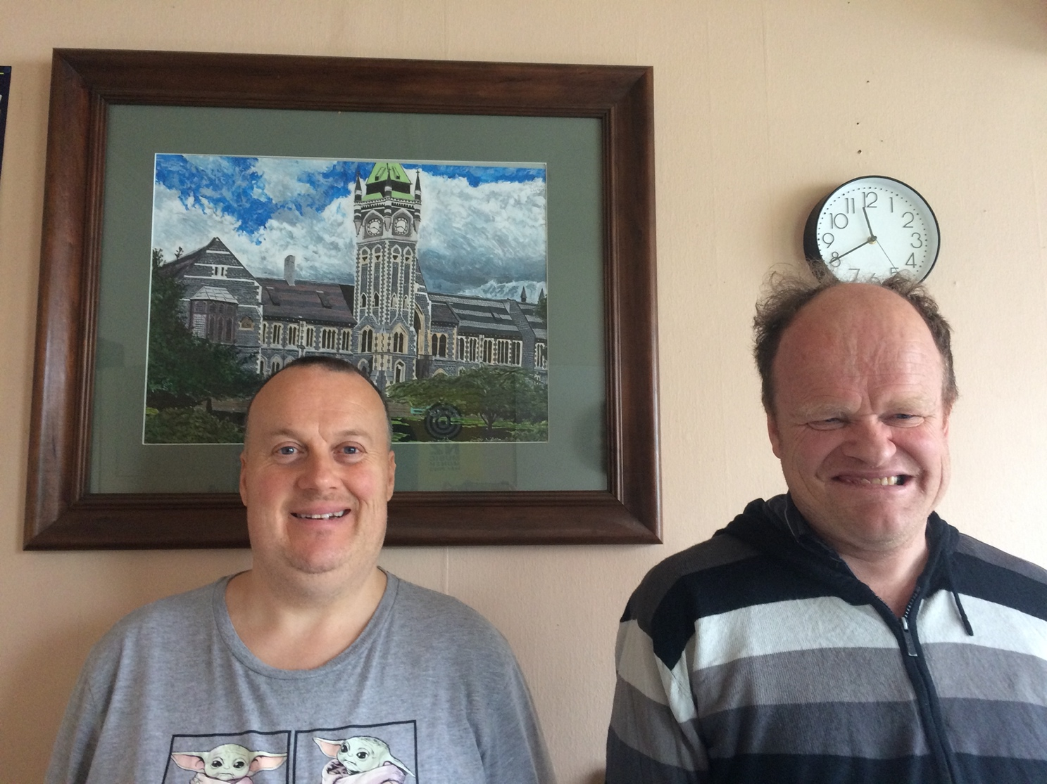

Allan and Nathan both chose to use their real first names in this story.
2 Artwork by Allan – University of Otago Clock Tower
This street name has been fixed since the main report has been finalised.

