

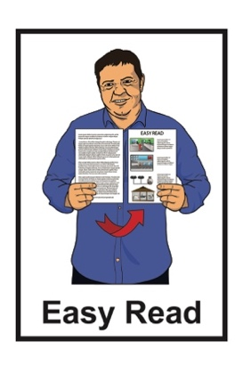

A summary of the research
project called:
Understanding Policing Delivery −
Tākata Whaikaha, Deaf / deaf and disabled people
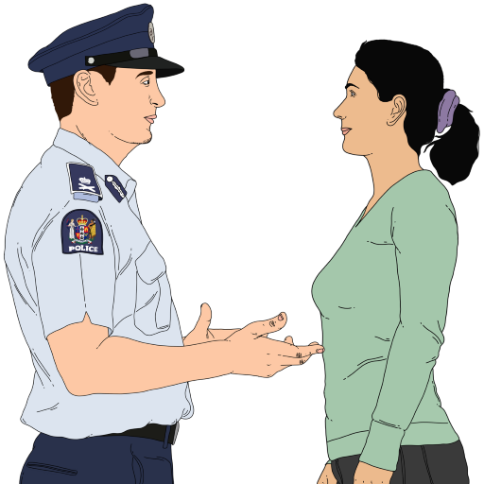

Published: November 2024

Before you start


This information may upset some people when they are reading it.

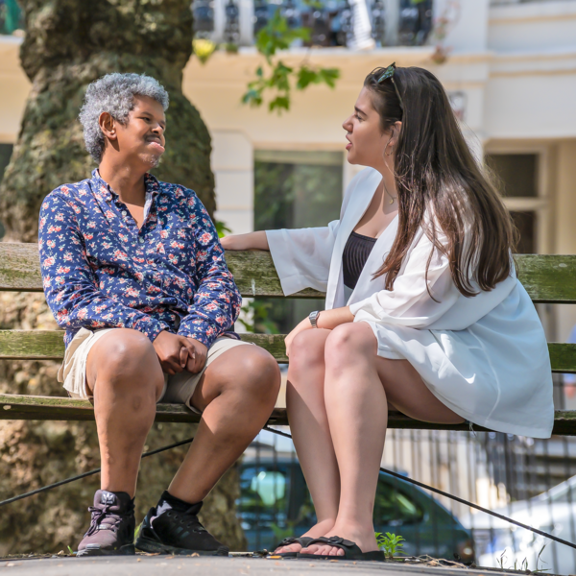
If you are upset after reading this document you can talk to your:
- whānau / family
- friends.

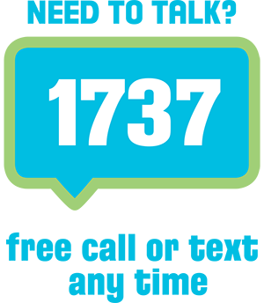
You can also contact Need to Talk by:
calling 1737


texting 1737

It does not cost any money to
call / text Need to Talk.

What you will find in here

Page number:

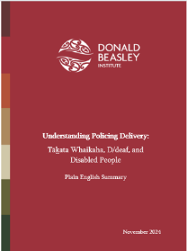
About this document 3

About the research 6



What the research found out 11

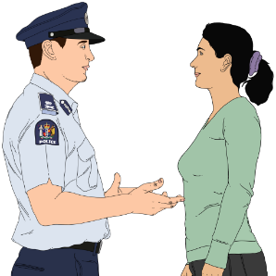
Recommendations for what
the Police should do next 23

About this document

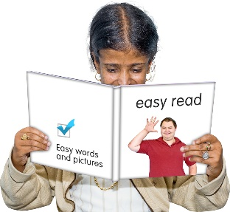
This Easy Read document is from the Donald Beasley Institute.

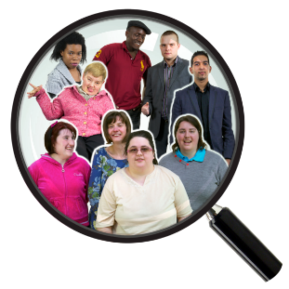
The Donald Beasley Institute is a place that does research into things to do with disability.

Here research means someone:
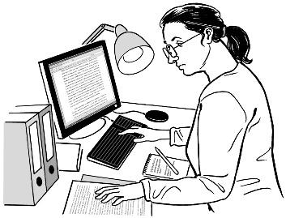
looks at what has happened
tries to find ways to do things better.


In this document we will call the Donald Beasley Institute the DBI for short.


When you see the words we / us in this summary it means the DBI.

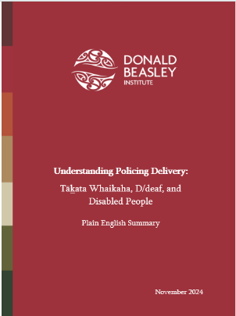
This document is a summary of a research project called:

Understanding Policing Delivery − Tākata Whaikaha, D/deaf and Disabled People

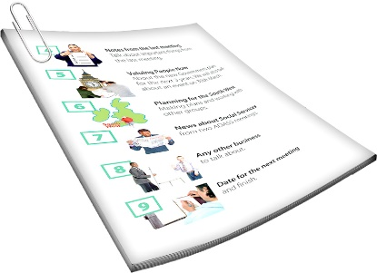
A summary:
is shorter than the original
message
tells you what you need to know.

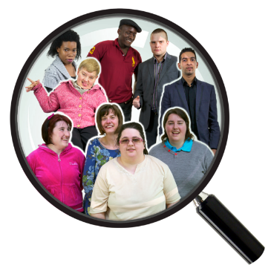
This report was done as part of a bigger Understanding Policing Delivery research project.

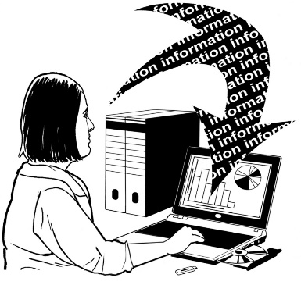
Research was also done by different research groups to look at other parts of policing.


You can find out more about the research project on our website at:

https://tinyurl.com/4fy4j22w
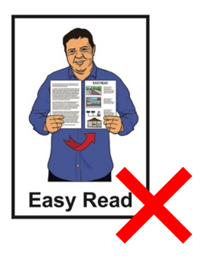
The website is not in Easy Read.

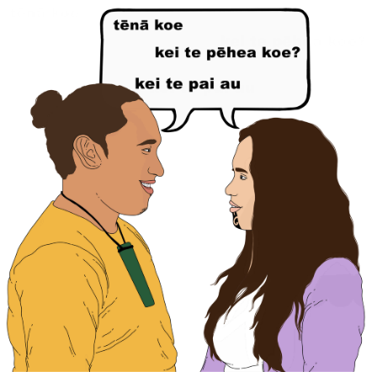
In this document we use the
Kāi Tahu dialect when writing in
te reo Māori.

This means that we use k in the place of ng.

k
We have put a line under the k wherever we have used this.

About the research

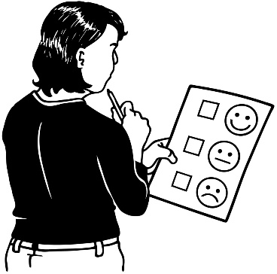
The research looked into if the ways the New Zealand Police do things are fair for everyone in New Zealand.


The job of the New Zealand Police is to:
stop crime from happening
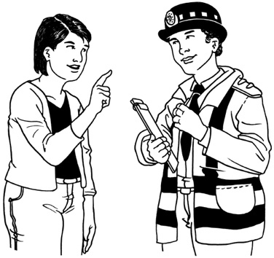
keep people safe
make sure everyone follows the laws of New Zealand
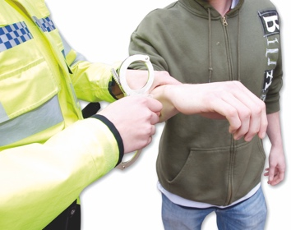
deal with people who do crime in ways that also think about their rights.

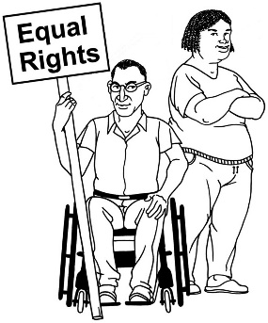
Rights are things everyone should have to live a good life.

Rights also say how people should be treated by others.

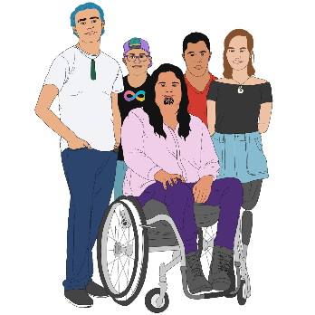
Researchers from the DBI worked with 22 people who were:
tākata whaikaha / disabled Māori
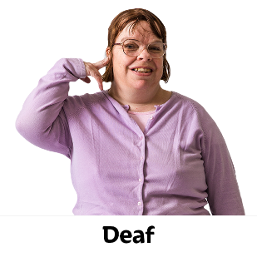
Deaf / deaf
disabled.

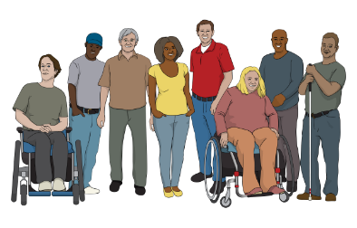
In this document we will call these
22 people disabled people for short.

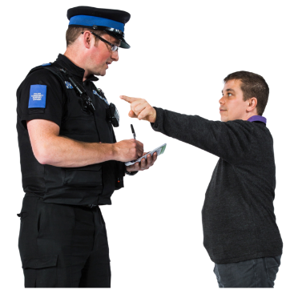
These 22 disabled people had:
been stopped / spoken to by Police
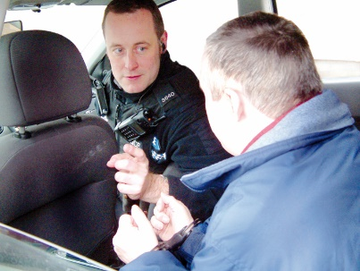
been charged by Police
experienced use of force by Police.

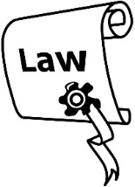

Here charged means the police
says someone has broken the law.

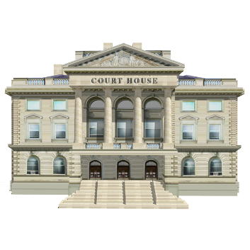
It can also mean being told to go to court for things you may have done.

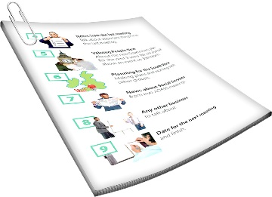
We will talk more about charges on page 16 of this document.

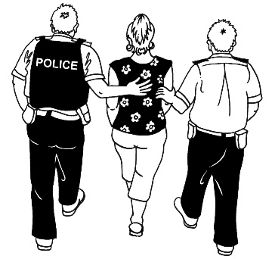
Use of force means Police stop someone doing something by:
holding someone down so they cannot move / get away
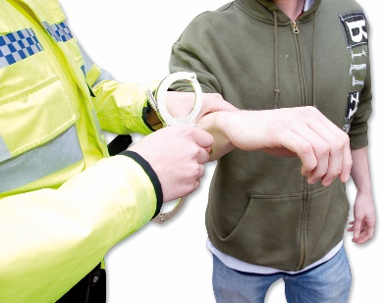
using handcuffs
using a Taser.

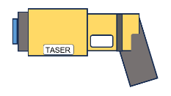
A Taser is a device that gives people an electric shock.


The research also included people with learning disability who had experiences with the New Zealand Police.

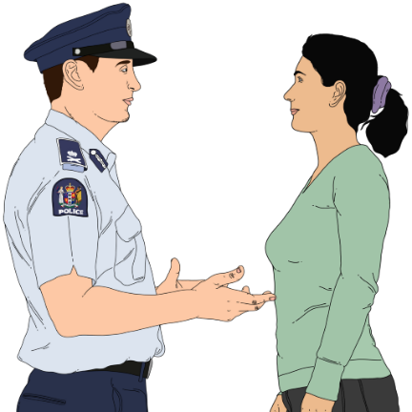
Researchers from the DBI also talked to 20 people from the New Zealand Police about their experiences of working with disabled people.
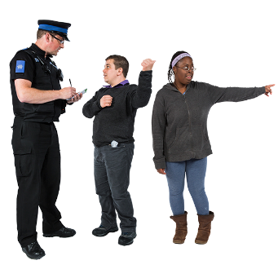
The 20 people from Police were:
frontline Police officers
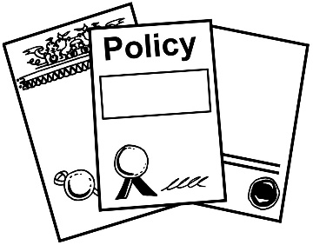
people who make Police policy
people who work in prevention.

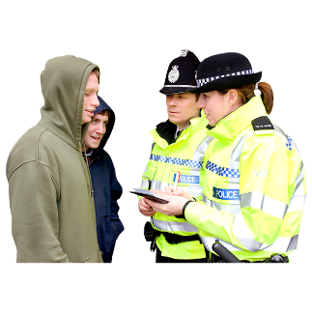
Frontline means Police officers who work with people in the community.

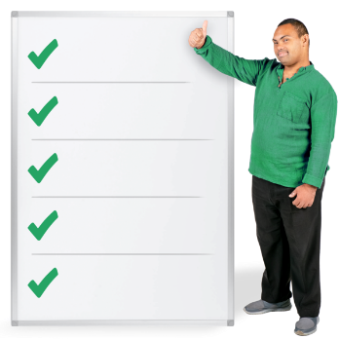
Policy means rules that say how things should be done.


Here prevention means doing
things to stop crime happening.

What the research found out

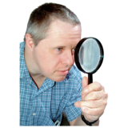
Overall findings

Overall findings means the main things that the research found out.

The research found that:

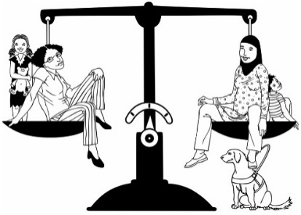
disabled people felt they had not always been treated fairly by the New Zealand Police
but
they could also tell us about some good experiences.

The research found that disabled people and the New Zealand Police mostly agree on the unfair ways Police treat disabled people like how they:
talk to them
act towards them.


Disabled people and Police also had the same ideas about how New Zealand Police could be more:
disability aware
responsive.



Disability aware means you:
know someone has a disability
act in a way that shows you understand their needs


Here responsive means you act in a way that:
shows you have thought about someone else
is the right way to act at the time.

Findings about being stopped or spoken to by Police

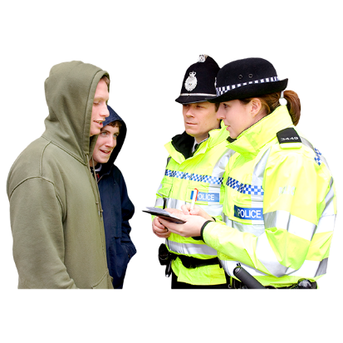
The research found that Police do not always notice if someone has a disability when they stop / speak to disabled people.

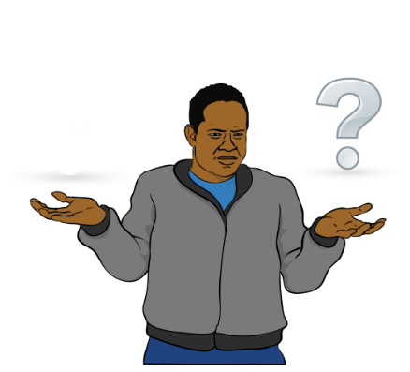
This can lead to disabled people not:
understanding what is going on
being treated fairly.

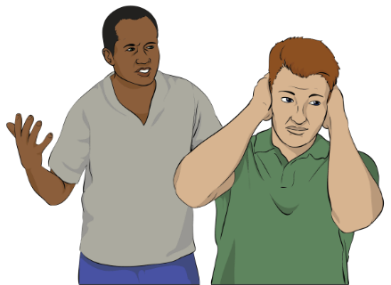
Some disabled people said when they told Police they had a disability
Police did not:
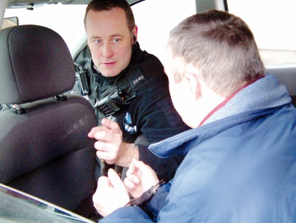
believe them
treat them in the right way.

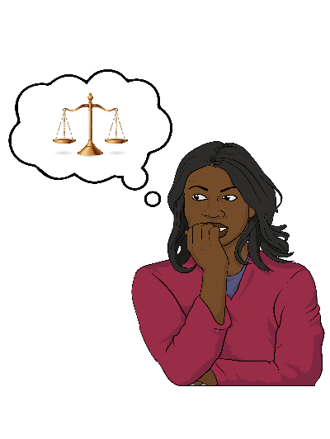
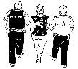
This made disabled people feel like they were not:
safe
being supported by Police.

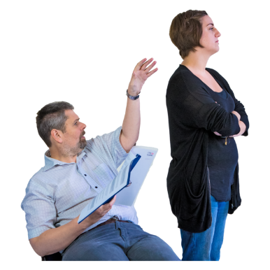
It also meant disabled people did not get treated by Police in a way that worked with their disability.


The research also found that Police often thought how disabled people acted made them seem like they might be:
doing something wrong
breaking the law.

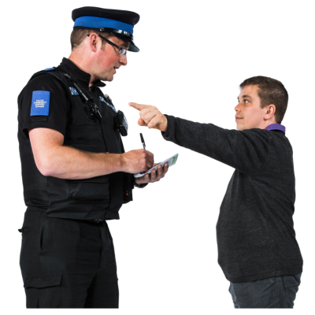
This meant that disabled people:
were watched more by Police
had more contact with Police
were questioned more by Police.
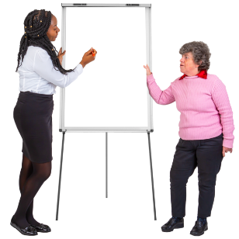

Police and disabled people said that Police need more training to:

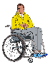
be aware of when someone has a disability
understand different disabilities.

Findings about the Police laying charges

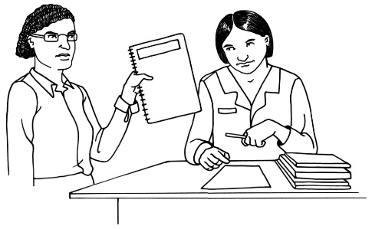
Police must make sure they have evidence to charge someone with a crime.

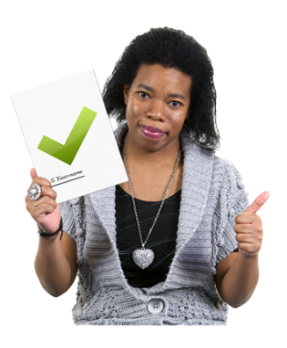
Here evidence means something that shows something:
is true
has happened.

The research found that disabled people felt that Police sometimes did not:
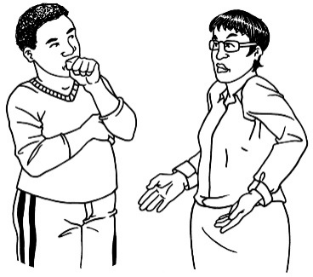
believe them
respect them when they said something had happened.
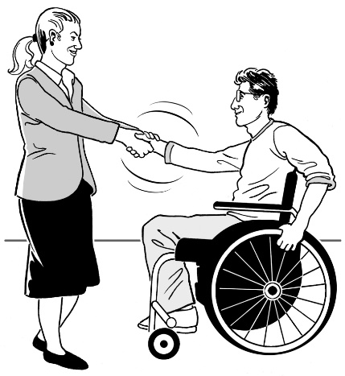
Respect means you think about:
how someone else might feel
how the way you act might make someone feel.

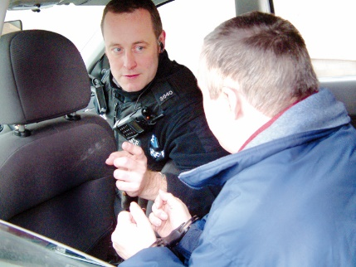
Disabled people said they felt that:
sometimes Police said they had done something wrong

but
they did not have a good reason to say that.

Some disabled people felt they:
had been charged for things they had not done
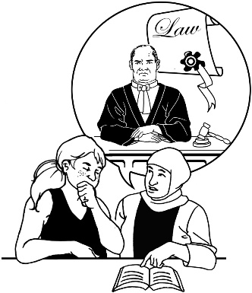
did not get the support they needed when they were being charged.
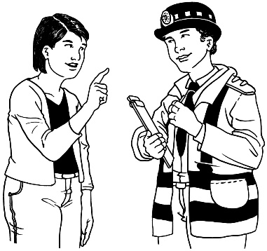
When Police did not understand how a disability might affect someone they often acted in ways that made things worse for disabled people.

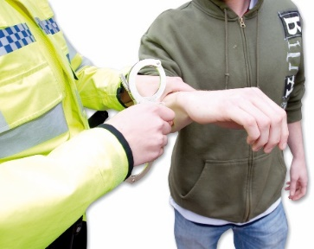
For example sometimes Police used more force on disabled people than was needed.

Police and disabled people said it would make things better for everyone if Police:

understood how disability affected someone
had more training about things to do with disability
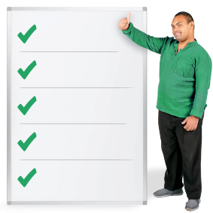
had rules that were fair to everyone.

Findings about the Police using force

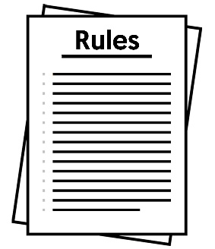
There are very important rules that say when Police can use force on people.
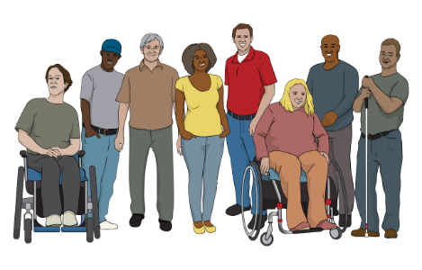

These rules include disabled people.

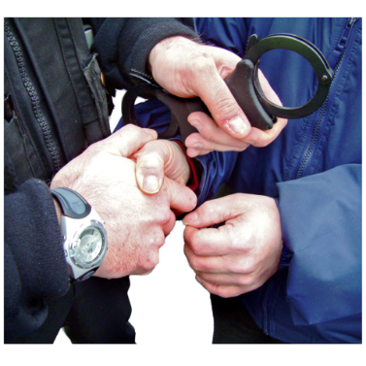
The research found that disabled people thought that Police sometimes used too much force on them.



This often happened when Police did not understand how disability made someone act.

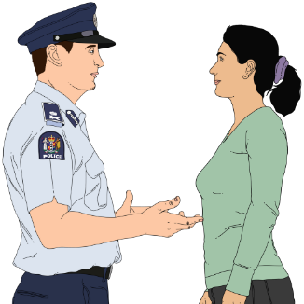
For example if an autistic person has an autistic meltdown Police should:
try to calm them down
not use force to stop them.

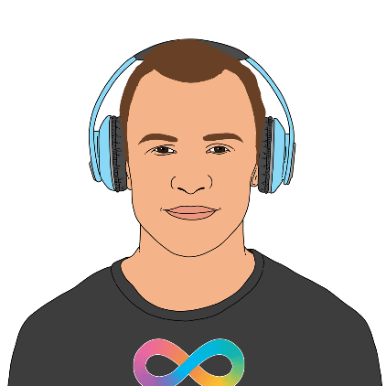
Autistic people have brains that work differently from the brains of people who are not autistic.

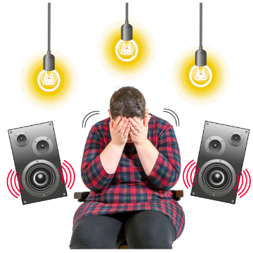
An autistic meltdown is when an autistic person finds it hard to deal with something like:
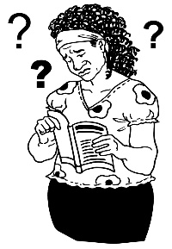
loud noises
lots of information
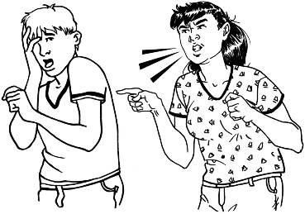
being told to do different things.

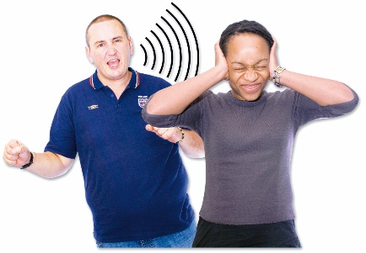
When someone is having an autistic meltdown they might:
not be able to do what people ask them to

run away
throw things.

Police and disabled people said they think that Police need more training so they can act in the right way when
disabled people:
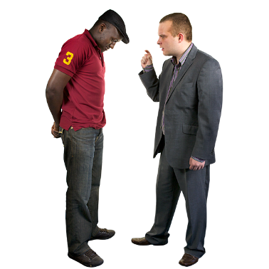
are upset
act in a way that Police do not understand.


This would mean Police would use less force so everyone would feel safe.

Recommendations for what the Police should do next

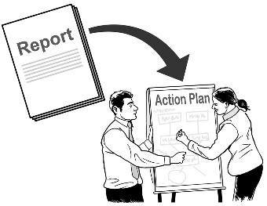
A recommendation says what could be done to make things better.

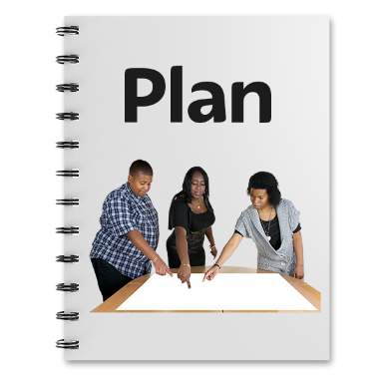
The New Zealand Police have put together a Disability Road Map.


A road map is a plan that sets out:
what should happen
what needs to be done to make things happen.
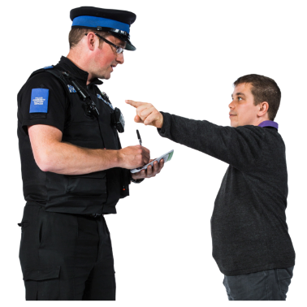

The Disability Road Map will guide Police on how best to work with disabled people.

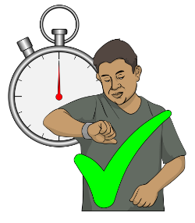
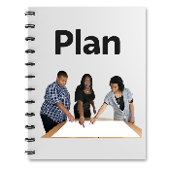
The findings from this research project show that:

ideas in the Disability Road Map should be used straight away
more work on the plan needs to happen.

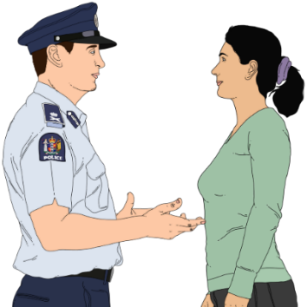
Police and disabled people said Police should:
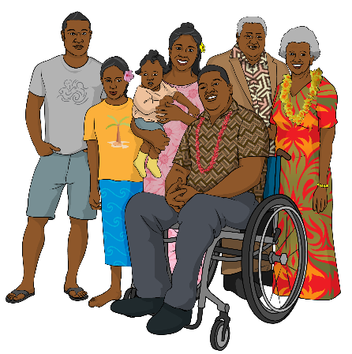
find ways to work well with people close to disabled people like their:
- family / whānau
- friends
- other support people
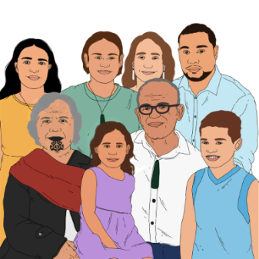
find ways to work well with whānau whaikaha Māori / family of disabled Māori.
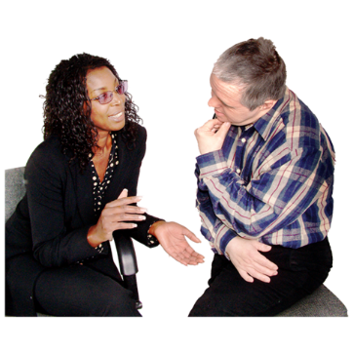
Police and disabled people also said Police should:
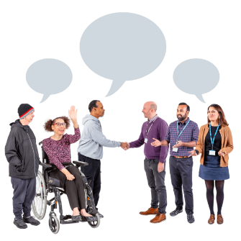
have training so they can communicate well with disabled people
have policies in place that include ways to:
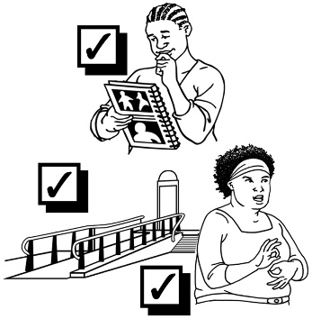
- communicate well with disabled people
- think about the needs of disabled people
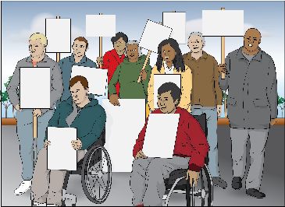
make information about disability rights a part of Police training.


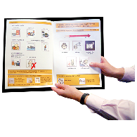
Police and disabled people also said Police should:
know about resources that give information about a disability someone has like:
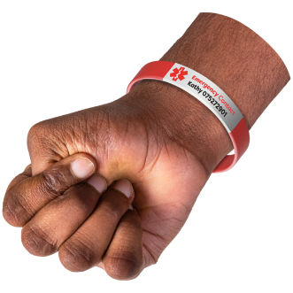
- health passports
- information cards
- medical bracelets.


work with disabled people and their whānau to:
- find better ways to keep information about disabled people in their police files
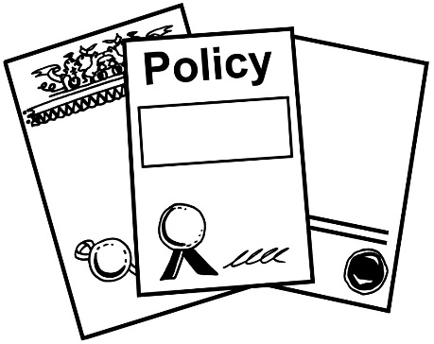
- make sure Police policy has information about disabled people that frontline police officers can use.
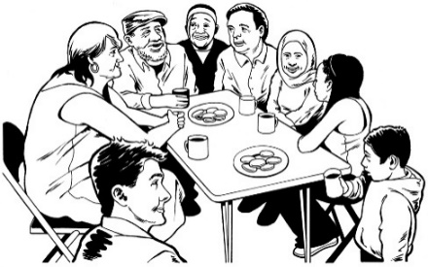
Police and disabled people also said Police should understand what things are important to disabled people like:
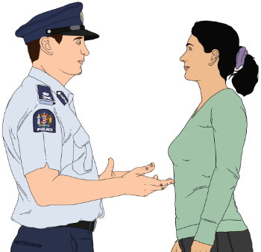

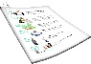
support in the community
disability services
resources that disabled people can use.

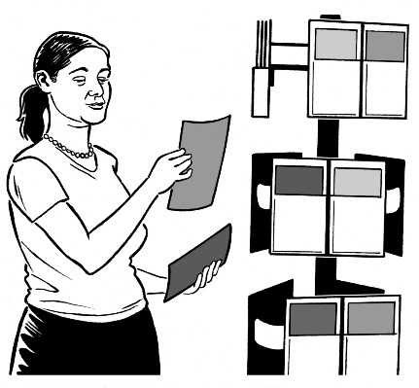
Resources are things that can support people to:
find information they need
do things they need to do.


This information has been written by the Donald Beasley Institute.


It has been translated into Easy Read by the Make it Easy Kia Māmā Mai service of People First New Zealand Ngā Tāngata Tuatahi.

The ideas in this document are not the ideas of People First New Zealand Ngā Tāngata Tuatahi.


Make it Easy uses images from:

- Changepeople.org


            - Photosymbols.com



- SGC Image Works
- Huriana Kopeke-Te Aho
- T. Wood.

All images used in this Easy Read document are subject to copyright rules and cannot be used without permission.

