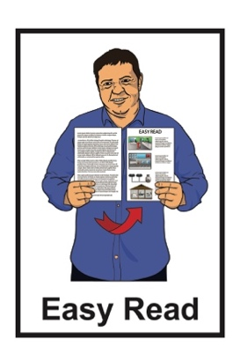

Taking part in some research about the experiences of disabled people with the police:

Participant Interest Form
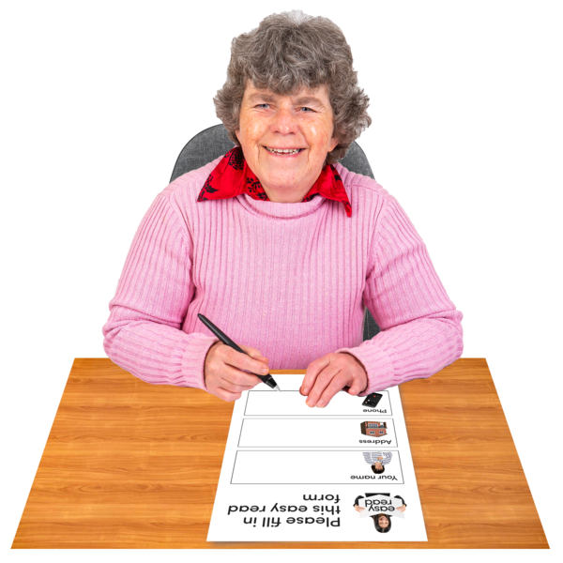

Published: September 2023

About this Participant Interest Form

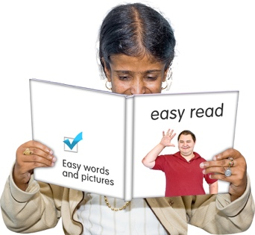
This Easy Read form is for you to tell the Donald Beasley Institute that you want to take part in some research they are doing.

The Donald Beasley Institute is a place that does research into things to do with disability.

When you see the words we / us in this form it means the Donald Beasley Institute.

Research is when someone:

looks at what has happened
tries to find ways to do things better.

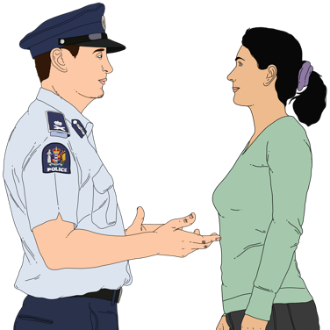
The research is about the experiences disabled people have had with the New Zealand Police.

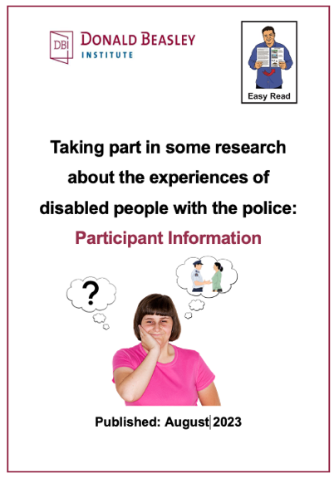
You can find out more about the research in the Easy Read document called:

Taking part in some research about the experiences of disabled people with the police:
Participant Information

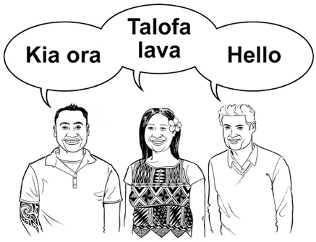
It is up to you if you want to fill in this form in:
English
te reo Māori.

You can also fill in the Participant Interest Form online at:

https://tinyurl.com/4fz2c5h9

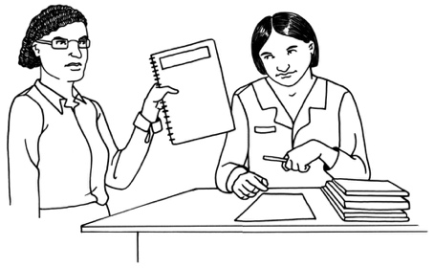
If you fill in the form online your answers will be sent to the DBI research team straight away.

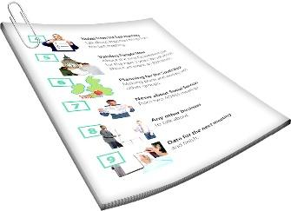
You can also download the form as a Word document from our website at:

www.donaldbeasley.org.nz/projects/understanding-policing-delivery

You can fill in the form then email it to Lydie Schmidt at:
lschmidt@donaldbeasley.org.nz

You can also print out the Word document of the form to fill in then send it to us by post to:

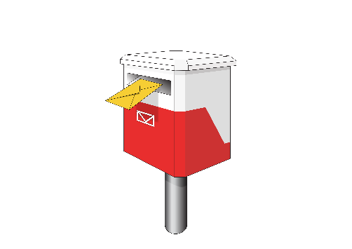
Donald Beasley Institute

Suite 4, Level 2

248 Cumberland Street

Dunedin 9016

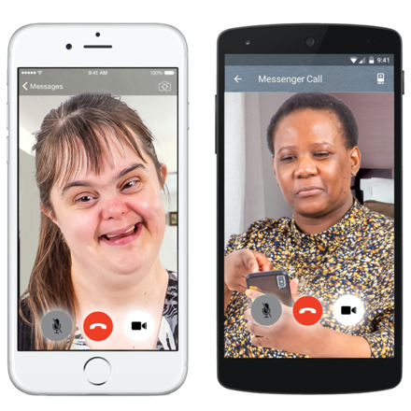
You can also email us a recording of your answers like as a:
video
voice recording.
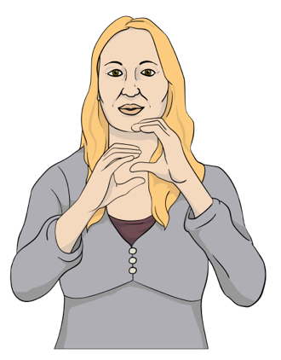
If you use New Zealand Sign Language you can email us with a video of what you want to tell us.

You can also:
- Go to the SeeFlow Direct website at:

https://seeflow.co.nz/direct
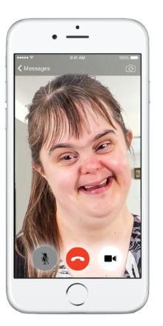
- Video record your answers on the website.

- Your answers will be sent to us.

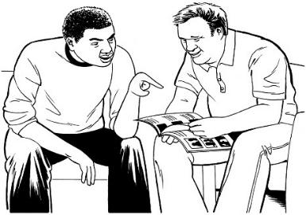
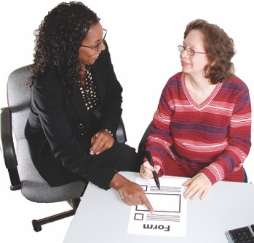
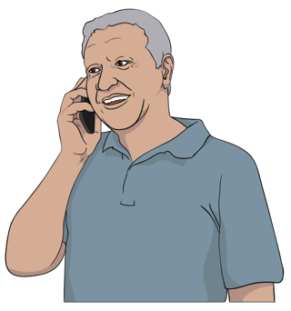
If you need support to fill out the form you can:
- talk to someone on the DBI research team by calling:

0800 878 839
send an email to Lydie Schmidt to arrange a time to fill it out together at:
lschmidt@donaldbeasley.org.nz

- ask someone else to support you to fill out the form like a:
- friend
- family member
- support worker.

Participant Interest Form

Please answer the 9 questions on pages 8 to 21 of this form to tell us that you would like to take part in the research.

We need to know this information to make sure we ask a lot of different people to take part in the research.

We will not use the information you give us on this form in our research.

Question 1: About me

Write your answers on the lines below.

My full name is:

My telephone number is:

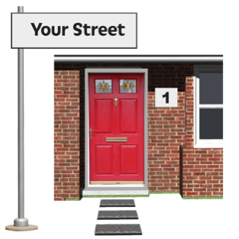
My address where I live is:

Write your answers on the lines below.

My email address is:

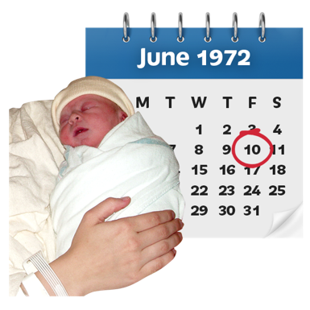
I was born on / my date of birth is:

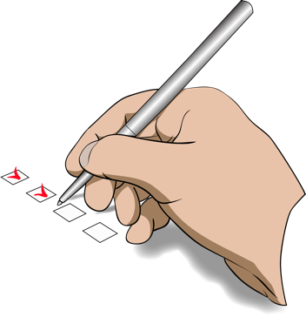
Question 2: More about me

Put a tick inside the box to show us your answer:

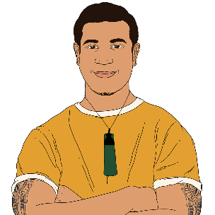
I am:

tāne / male / a man
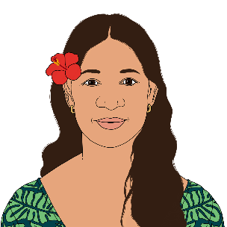
wāhine / female / a woman

something else – please let us know:

I do not want to tell you.

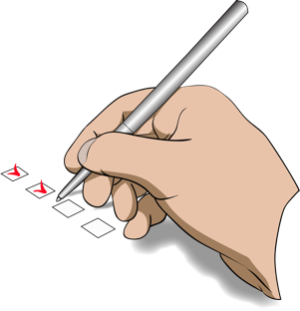
Question 3: More about me

Put a tick inside the box to show us your answer:

I am:
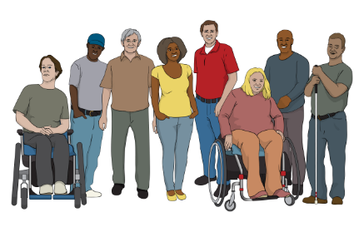

I am tākata Whaikaha
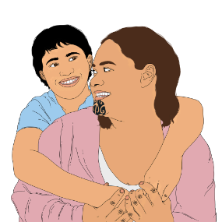
I am whānau hauā

I am a disabled person

I am tākata Turi / Deaf / deaf

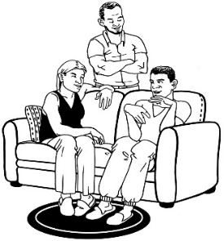
I am whānau / aiga / family member of someone with multiple and complex disabilities.

Multiple and complex disabilities means a person has:

more than 1 disability
has a disability that is very
challenging / affects them a lot.

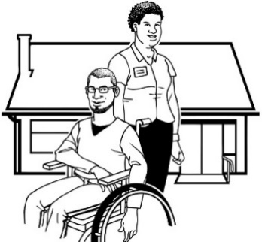
Here are some other boxes that might fit who you are.

I am a support person of someone with multiple or complex disabilities.

something else – please let us know on the lines below.

I am:

Question 4: My disability
Please tell us a little about what kind of disability you have.
If you are filling this in as a support person / family member of a disabled person please tell us about their disability.

Write your answer on the lines below.

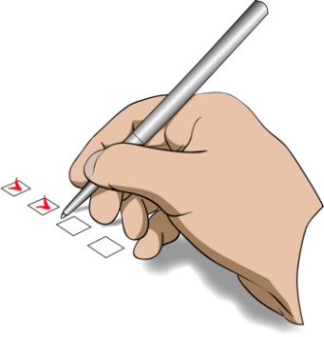
Question 5: My ethnicity

Put a tick inside the box next to the choices that fit you best:

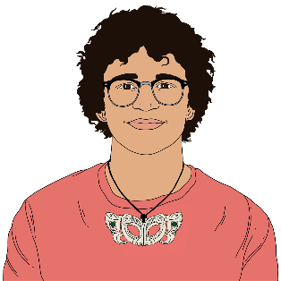
I am:

Māori

NZ European / Pākehā

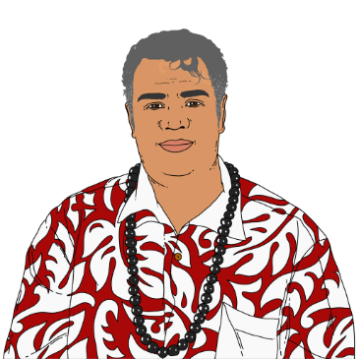
Tongan

Fijian

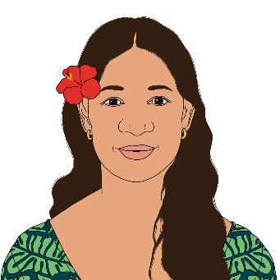
Cook Island Māori

Samoan

Niuean.
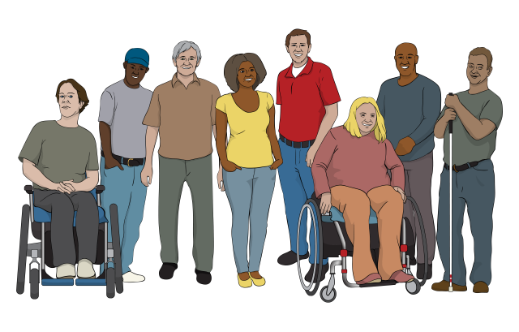
Here are some more boxes that might fit your answer about your ethnicity.

Put a tick inside the box next to the choices that fit you best:
Indian

Chinese

something else – please let us know on the lines below:

I do not want to tell you.
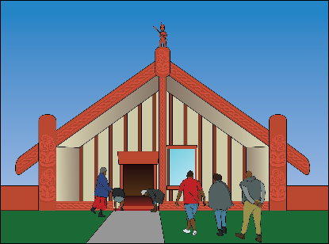
Question 6: What is the name of my iwi / hapū / marae?

Move on to Question 7 if you:
- do not know
- do not have an iwi / hapū / marae.

Write your answer on the lines below.

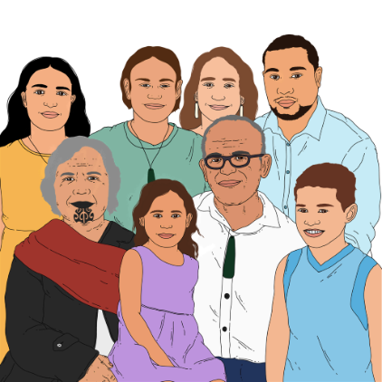
My iwi is:

My hapū is:
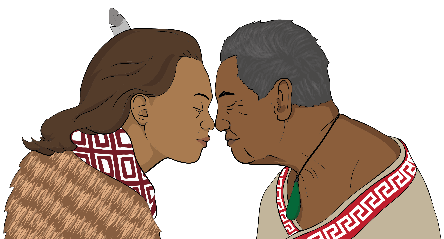

Write your answer on the lines below.

My marae is:

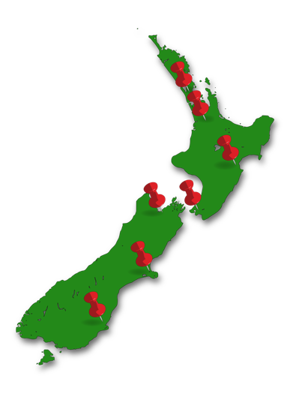
The place in New Zealand where my iwi / hapu / marae is:

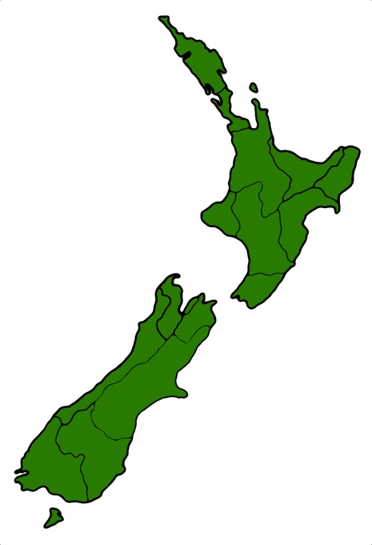
Question 7: Where I live

Tell us where in New Zealand you live.

Write your answer on the lines below.

I live in:

I do not want to tell you.

Question 8: Who I live with:

Put a tick inside all the boxes that are right for you:

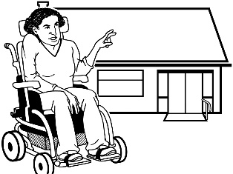
I live by myself

I live with a partner
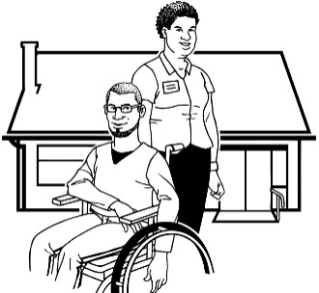
I live in a flat with other people

I live in a house with staff support
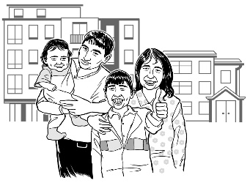
I live with my family / whānau / aiga

I board with another family

I live in social housing.
Here are some more boxes to tick about where you live.

Put a tick inside all the boxes that are right for you:
I rent my home from someone

I own my own home
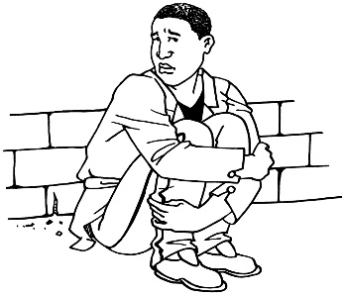
I do not have a place to live

something else – please let us know on the lines below:

I do not want to tell you.

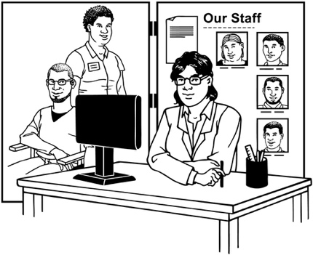
Question 9: Disability supports and services

Please tell us if you get any disability support and services.

Write your answer on the lines below.

How to contact us

Thank you for filling in this form.

Someone from the DBI research team will get in touch with you soon.

If you have any questions about the research you can get in touch with Lydie Schmidt who is part of the research team by:
phone on:

0800 878 839
email at:
lschmidt@donaldbeasley.org.nz

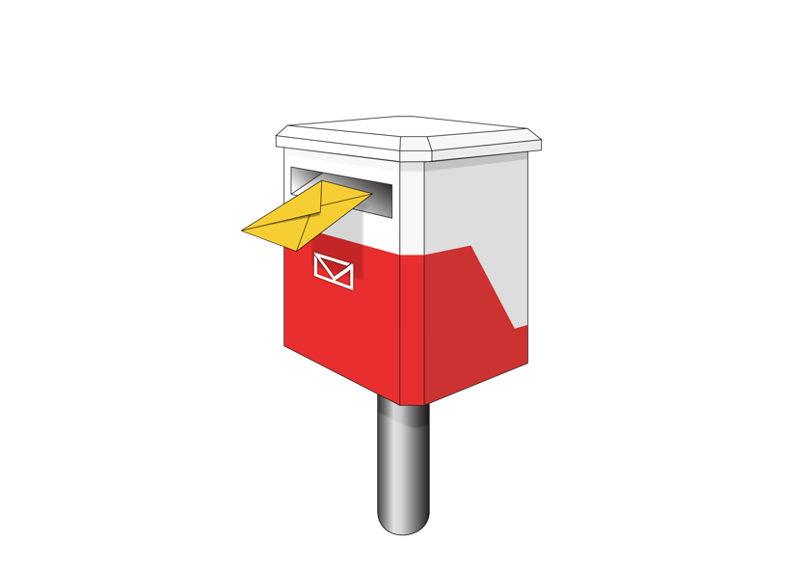
You can also get in touch with the DBI research team by post at:

Donald Beasley Institute

Suite 4, Level 2

248 Cumberland Street

Dunedin 9016

New Zealand
You can also find more information on our website at:

www.donaldbeasley.org.nz/understanding-policing-delivery

This information has been written by the Donald Beasley Institute.

It has been translated into Easy Read by the Make it Easy Kia Māmā Mai service of People First New Zealand Ngā Tāngata Tuatahi.

The ideas in this document are not the ideas of People First New Zealand Ngā Tāngata Tuatahi.

Make it Easy uses images from:

- Changepeople.org

- Photosymbols.com

- SGC Image Works

- Huriana Kopeke-Te Aho
- T.Wood.
All images used in this Easy Read document are subject to copyright rules and cannot be used without permission.

