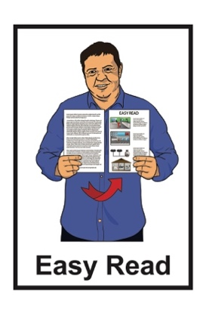

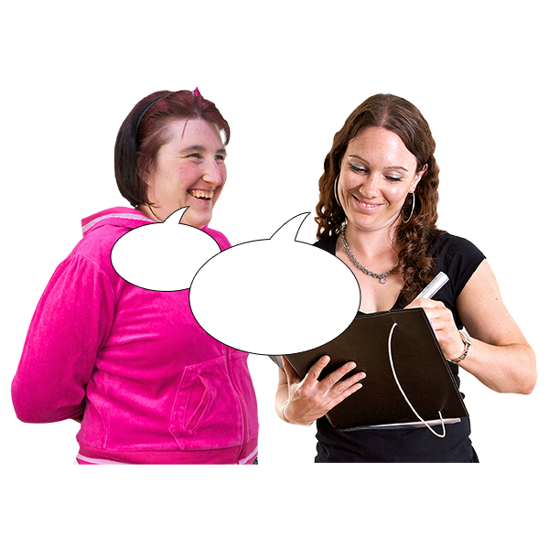
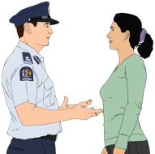
An invitation to take part in
some research about the experiences of disabled people with the Police

Published: September 2023

What is this invite about?

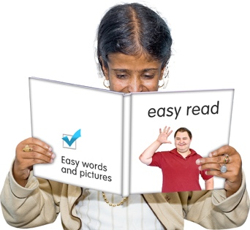
This Easy Read invitation is about taking part in some research being done by the Donald Beasley Institute.

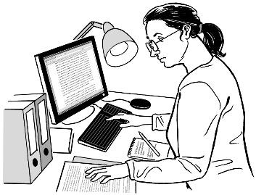

Research is when someone:
looks at what has happened
tries to find ways to do things better.

The Donald Beasley Institute is a place that does research into things to do with disability.

In this document we will call the Donald Beasley Institute the DBI.
When you see the words we / us in this invitation it means the DBI.

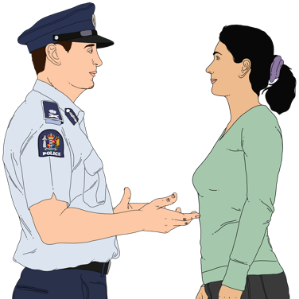

The research is about the experiences disabled people have had with the New Zealand Police.

The job of the New Zealand Police is to:
stop crime from happening
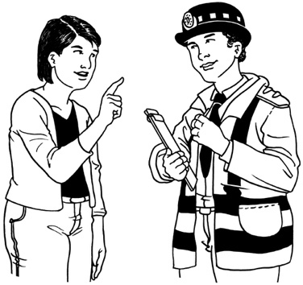
keep people safe
make sure everyone follows the laws of New Zealand
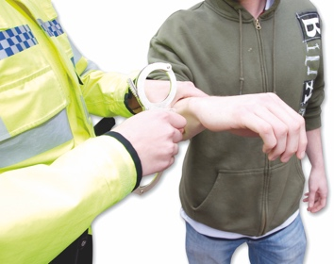
deal with people who do crime in the right ways.

The New Zealand Police are working with some researchers at the DBI on a study called:

Understanding Policing Delivery
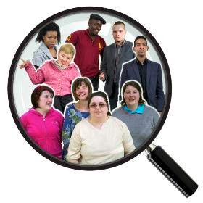

The study will look at bias that happens in the police system.

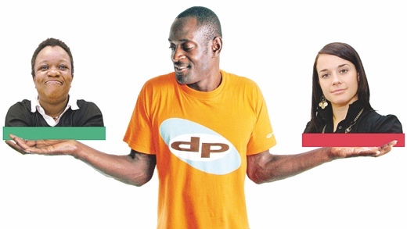
Bias is when someone:

thinks 1 person is better than another person
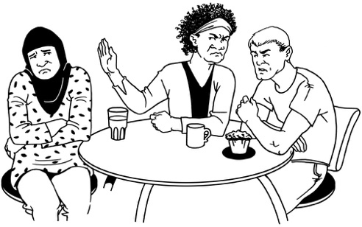
does things that support the person they like
treats someone badly because of the way they think about them.

Bias can also mean someone experiences discrimination.
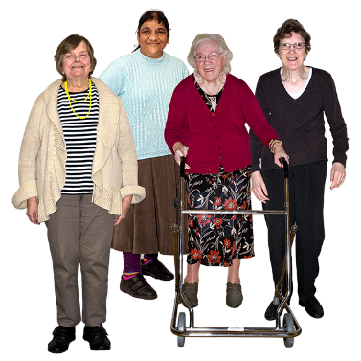
Discrimination is when people are treated differently because of things like:

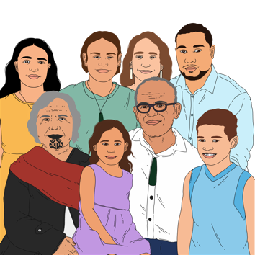
how old they are
if they are disabled
if they are Māori.

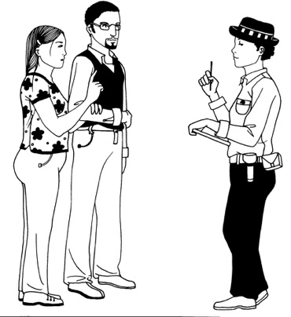
The study will support the New Zealand Police to find out about:
if there is bias in the Police system
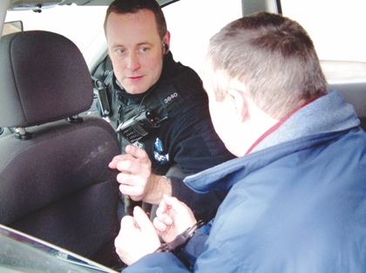
where the most bias happens
how often bias happens.

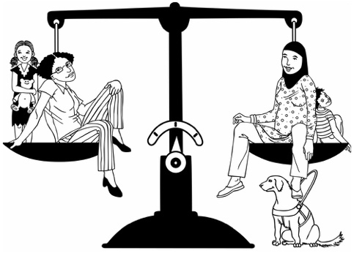
The things they find out in the study will support the Police to make sure the Police services are
fair
equitable.

Equitable means everyone has what they need to do well in the ways they need it.

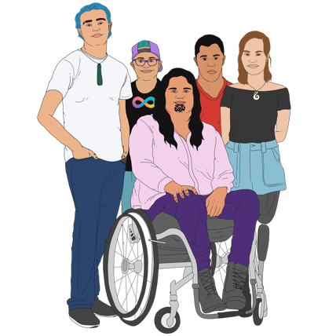
The Police service must also be fair and equitable for:
tākata whaikaha
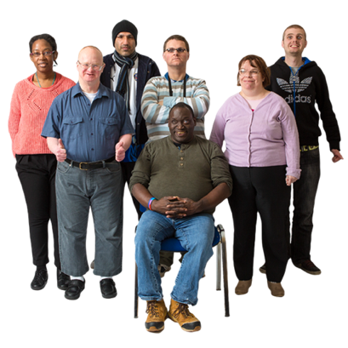
Deaf / deaf people
disabled people.

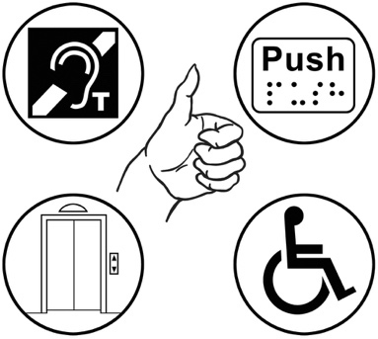
Police services that are fair and equitable to everyone would:
be accessible
think about all the different kinds of people in New Zealand
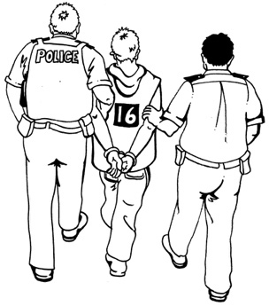
work to better support people who are often harmed by the Police.

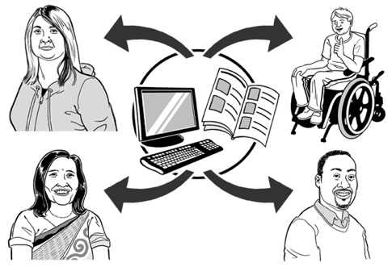
Accessible means that it is easy for everyone to:

find the things / information they need
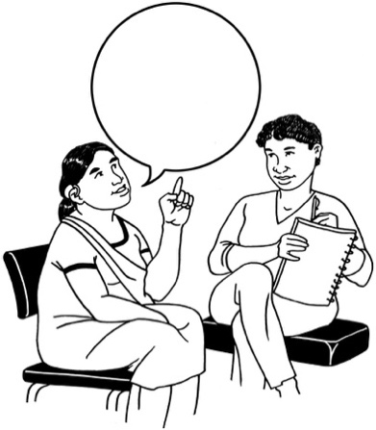
use the things / information they need
get around in ways they want to
communicate with other people.

Who we want to hear from

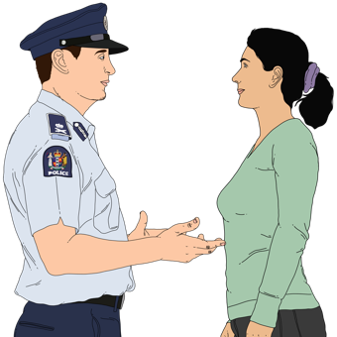
We want to talk to 20 disabled people about their experiences of being:
stopped by the Police
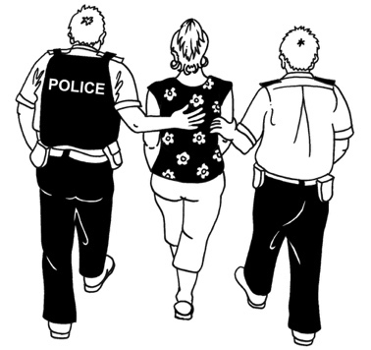
questioned by the Police
arrested by the Police.

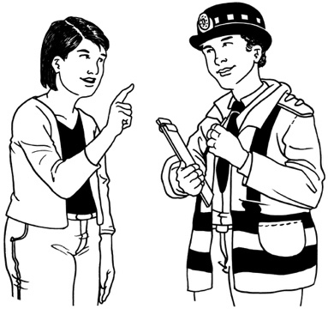

Being questioned means the Police ask you questions to find out if you know something about a crime.

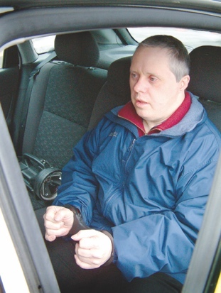
Being arrested means the Police can take you to a police station because they:
found / saw you doing a crime
believe you have done a crime.
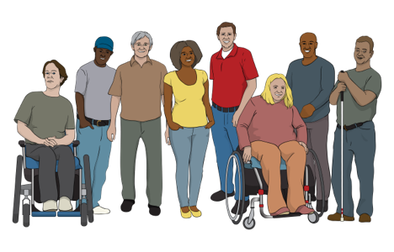
For this research we want to hear from:
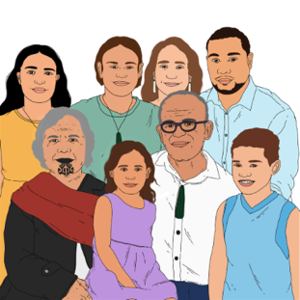
- disabled people
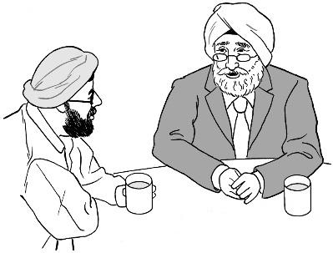
- whānau / family of disabled people
- close supporters of disabled people.

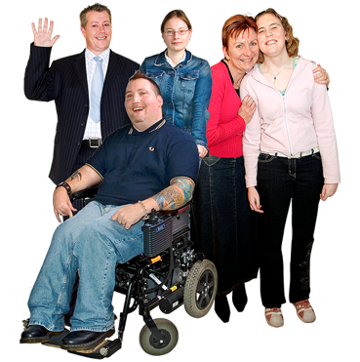
Everyone who takes part in the research must be:
18
aged 18 years old or older
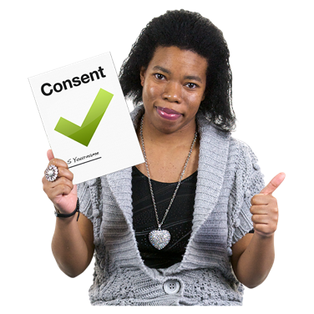
able to give informed consent to take part.

Informed consent is when you:

say yes to something
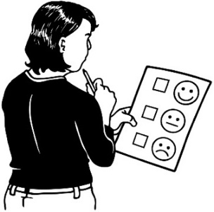
understand what it is you are saying yes to.

You do not have to take part in the research if you do not want to.

If you want to take part in the research

You can tell us that you want to take part in the research by getting in touch with us.
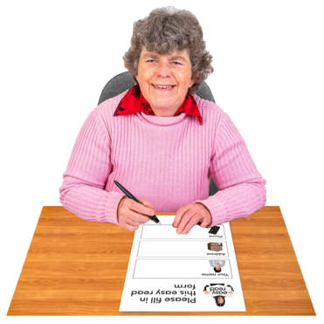

Someone from the research team will send you a Participant Interest Form.

If you have any questions you can get in touch with Lydie Schmidt who is part of the research team by:
phone on:

0800 878 839
email at:
lschmidt@donaldbeasley.org.nz
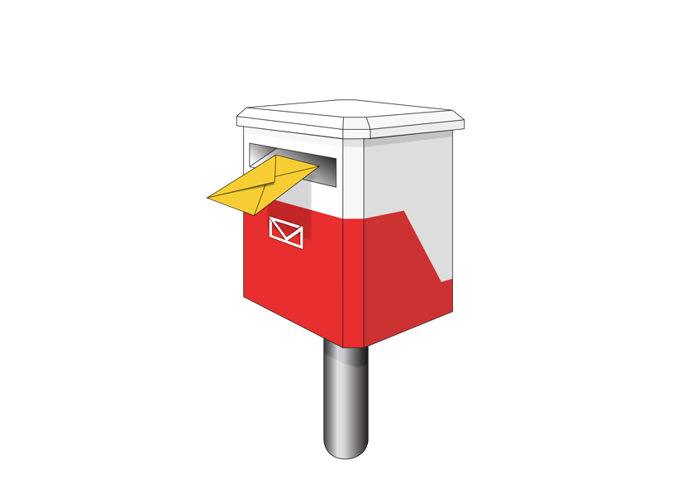
You can also get in touch with the DBI research team by post at:

Donald Beasley Institute

Suite 4, Level 2

248 Cumberland Street

Dunedin 9016

New Zealand
You can also find more information on our website at:

www.donaldbeasley.org.nz/understanding-policing-delivery

This information has been written by the Donald Beasley Institute

It has been translated into Easy Read by the Make it Easy Kia Māmā Mai service of People First New Zealand Ngā Tāngata Tuatahi.

The ideas in this document are not the ideas of People First New Zealand Ngā Tāngata Tuatahi.

Make it Easy uses images from:

- Changepeople.org

- Photosymbols.com

- SGC Image Works

- Huriana Kopeke-Te Aho
- T.Wood.
All images used in this Easy Read document are subject to copyright rules and cannot be used without permission.

