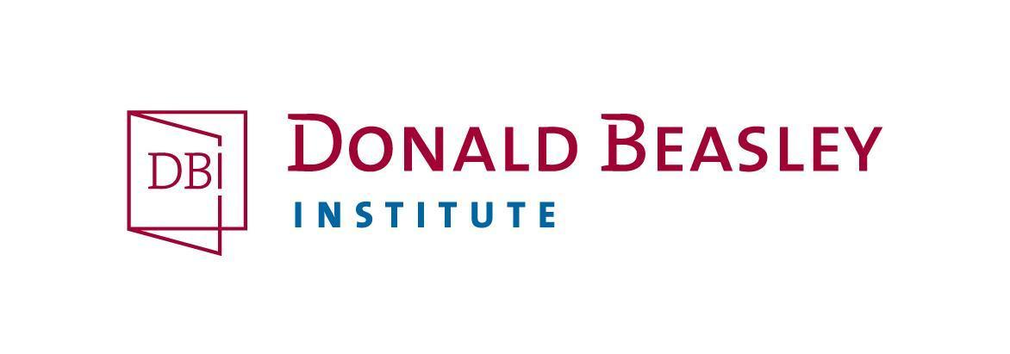
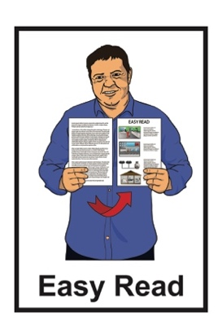

Young adults with learning disabilities’ ideas about sport and activity
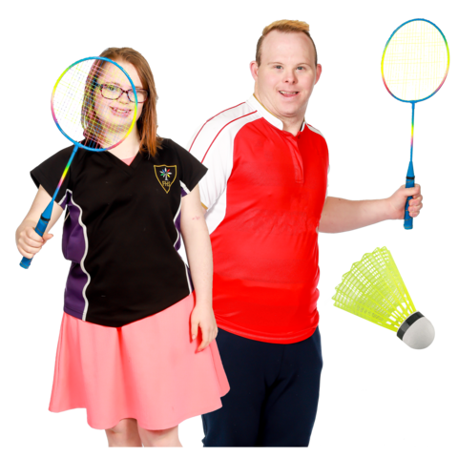

Information about a research project
Published: June 2023

What is this invitation about?

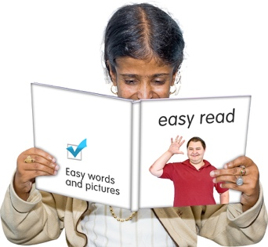
This is an Easy Read invitation to be part of some research called:
Young adults with learning disabilities’ ideas about sport and activity.
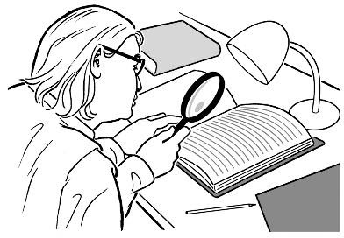

Research is when we:

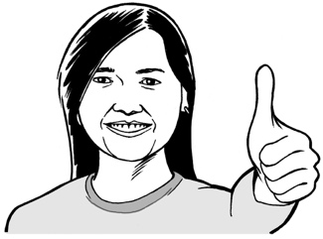
- look at what things have happened

- find ways to do things better.

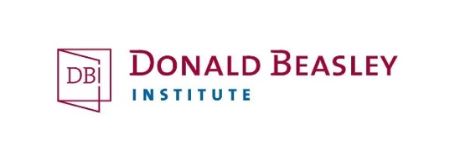
The research is being done by the Donald Beasley Institute.
The Donald Beasley Institute does research with disabled people about their lives.
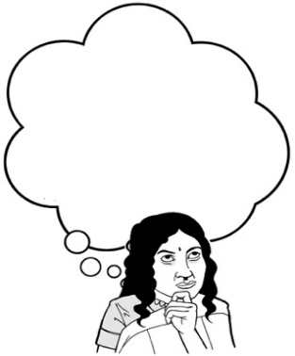
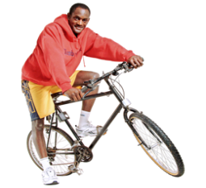
This research project will look at what young adults with learning disabilities think about sport / physical activities.
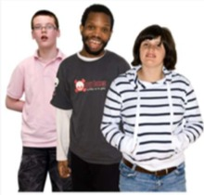

Young adults are people aged between 18 to 35 years old.

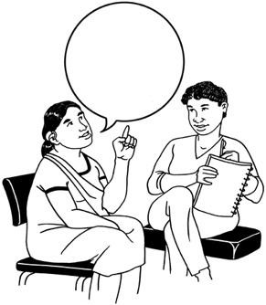
Learning disabilities can affect how you:
- use / understand words
- use / understand numbers
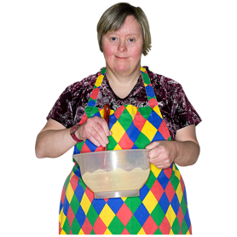
- use / move your body
- stay focused on a task.

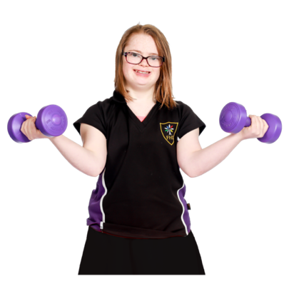
Physical activities are things you do:
- by moving your body
- usually for fun.
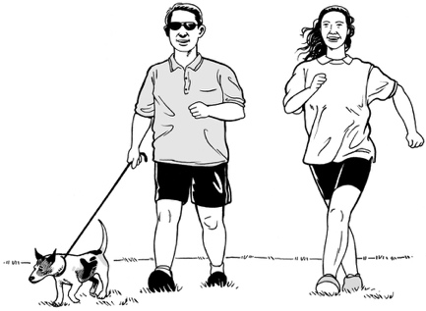

Physical activities are things like:
- walking / running
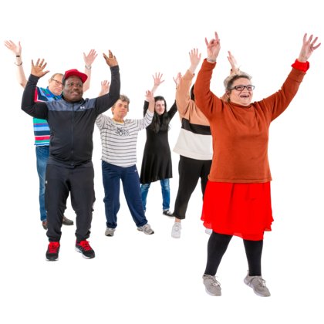
- riding a bike
- doing yoga classes
- dancing groups
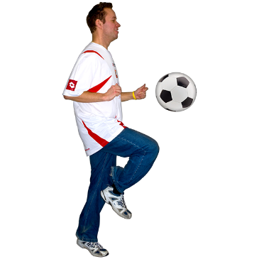
- being part of a football team
- being part of a bowling league.

What is the research about?

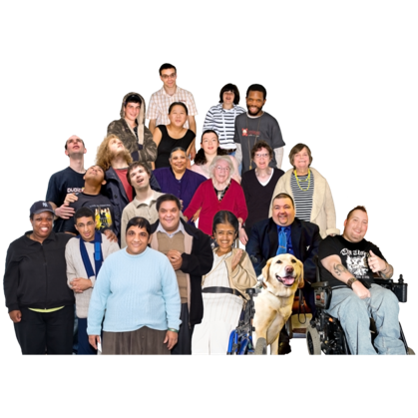
The research is being paid for by Special Olympics New Zealand.

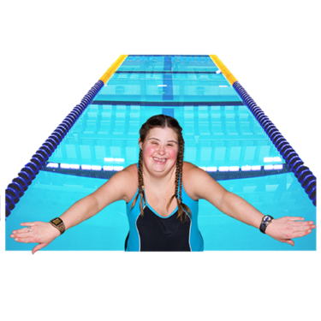
Special Olympics New Zealand is an organisation in New Zealand that encourages people with learning disabilities to get involved in:
- Special Olympics
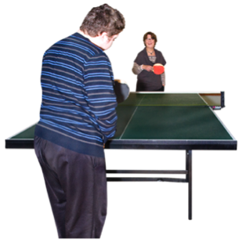
- sports
- physical activities.
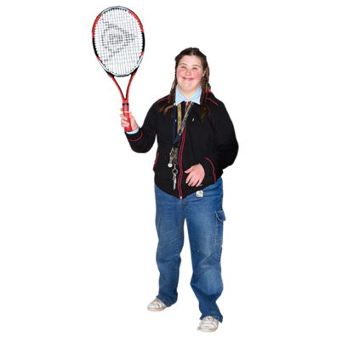

In this document we will call these 3 things Special Olympics for short.

Special Olympics is the biggest organisation in the world that supports people with learning disabilities to take part in sports.

Some people with learning disabilities:
- do not know about Special Olympics
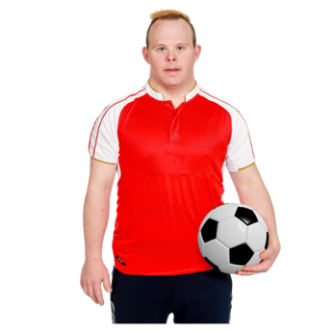
- cannot be a part of Special Olympics
- do not want to be a part of Special Olympics
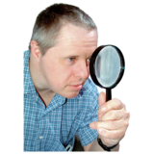

This research project will look at why this is happening.

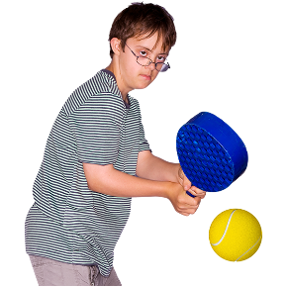
We want to learn more about:
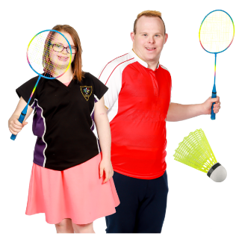
- what sports and activities young adults with learning disability are doing
- what sports and activities young adults with learning disability would like to do if they could
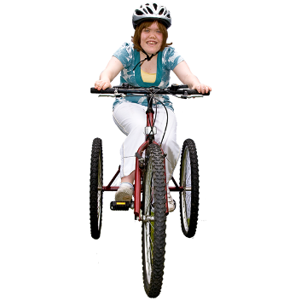
- what young adults with learning disability need to do the sports and activities they want to
- what young adults with disabilities know about Special Olympics.

Who can take part in this research?

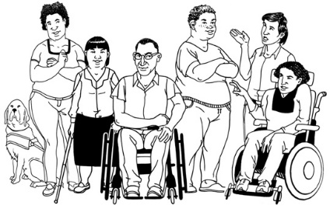
We want to talk to 15 young adults with a learning disability.

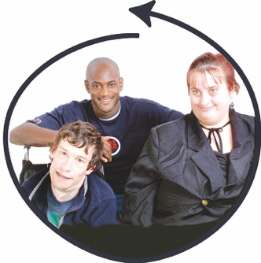
These 15 people should be:
- aged 18 to 35 years old
- not involved with Special Olympics New Zealand at the moment.
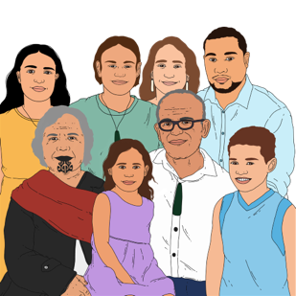

We also want to talk to:
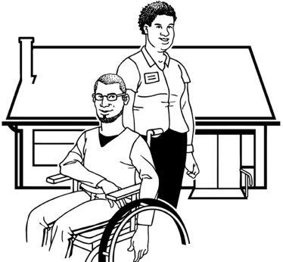
- their family / whānau / aiga
- other people who support them.

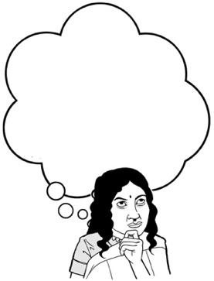
We will ask the young adults who take part who else they think we should talk to.

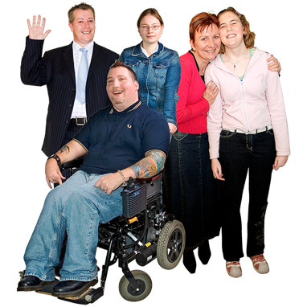
Everyone who takes part in the research must be:
18
- over 18 years old
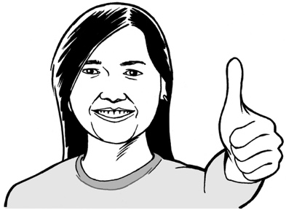
- able to give informed consent to say they want to take part.

Informed consent means:
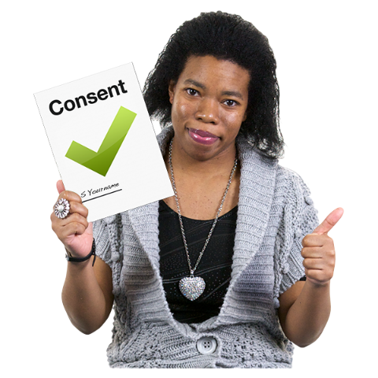
- you say yes to doing something
- it is your own choice to say yes or no
- you understand what you are saying yes to.

How to take part in the research

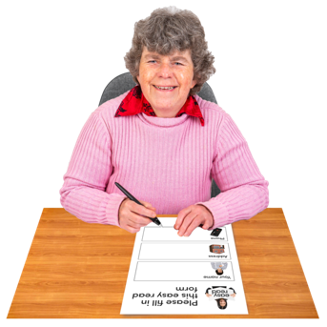
If you want to take part in the research you should fill out a Participant Interest Form.

You can fill in a Participant Interest Form online:

https://corexmss43gf6x5cw7qm.qualtrics.com/jfe/form/SV_6WE218CM604ECd8

Or through our website at:

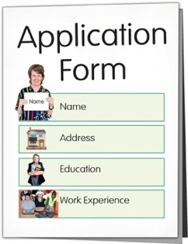
https://www.donaldbeasley.org.nz/projects/being-active-feeling-good/

You can also contact our research team to ask them to send you a form.

You can find out more about the Donald Beasley Institute on our website at:

www.donaldbeasley.org.nz

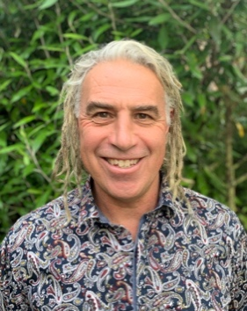
To find out more about this research project you can get in touch with Paul Milner who is part of the research team.

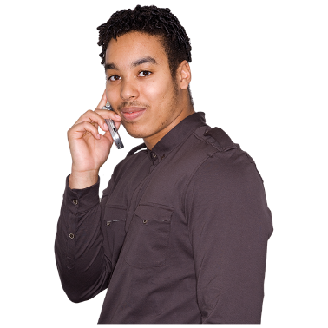
You can get in touch with Paul:
- by phone on:

027 738 2684

- by email at:
nottheotherpaulmilners@gmail.com

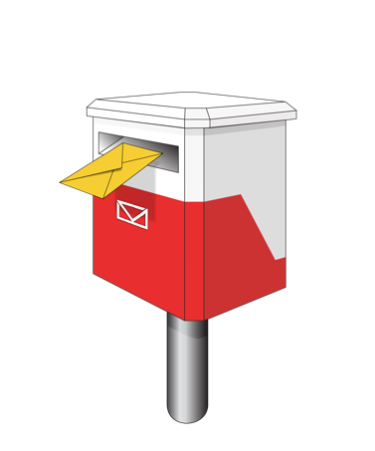
- by post to:

Suite 4, Level 2
248 Cumberland Street
Dunedin 9016
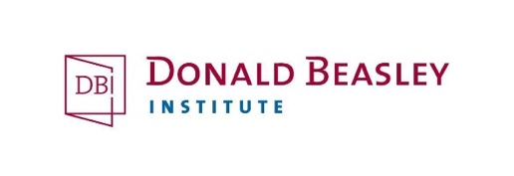
This information has been written by the Donald Beasley Institute.

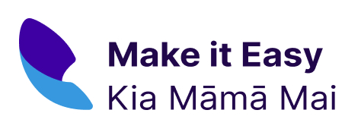
It has been translated into Easy Read by the Make it Easy Kia Māmā Mai service of People First New Zealand Ngā Tāngata Tuatahi.

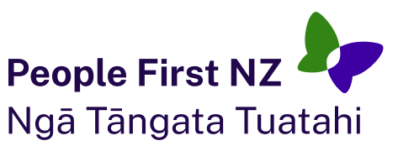
The ideas in this document are not the ideas of People First New Zealand Ngā Tāngata Tuatahi.

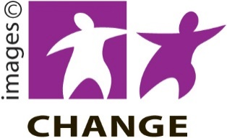
Make it Easy uses images from:

- Changepeople.org

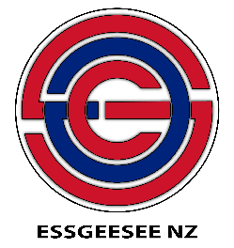
- Photosymbols.com

- SGC Image Works

- Huriana Kopeke-Te Aho.
All images used in this Easy Read document are subject to copyright rules and cannot be used without permission.

