Taking part in some research about the experiences of disabled people with the police:
Participant Information

Published: September 2023

Before you read this document

This is a long document.

While it is written in Easy Read it can be hard for some people to read a document this long.

Some things you can do to make it easier are:
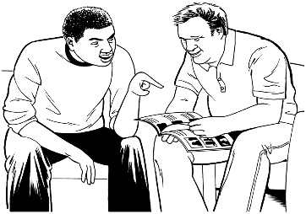
- read a few pages at a time
- have someone support you to understand it like a:
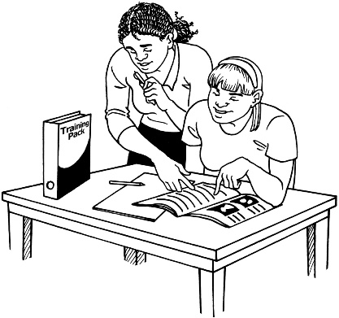
- family member
- friend
- support person.

What you will find in this document

Page number:

What is this document about? 5

What is the research about? 7

Who is doing the research? 10

Why is the research important? 12

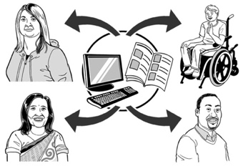
How will the research be used? 14

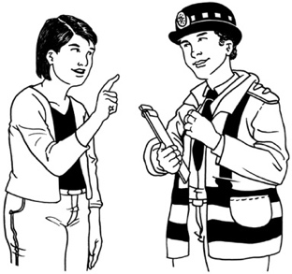
Who can take part in the
research? 18

Page number:

What will happen if you take
part in the research? 21

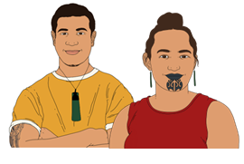
What you can expect if you
are Māori and want to take
part in the research 25

Writing and sharing your story 26

What will happen with the
information you tell us? 28

Other questions you might have 36

How to take part in the research 39

Page number:

How to contact us 45

Other people you can contact 47

What is this document about?

This Easy Read document is information about how you can take part in some research being done by the Donald Beasley Institute.

Research is when someone:
looks at what has happened
tries to find ways to do things better.

The Donald Beasley Institute is a place that does research into things to do with disability.

In this document we will call the Donald Beasley Institute the DBI.
When you see the words we / us in this invitation it means the DBI.

This document is to support you to decide if you want to take part in the research.

You do not have to take part in the research if you do not want to.

We will tell you more about what the research is about on the next few pages.

What is the research about?

The research is about the experiences disabled people have had with the New Zealand Police.

The job of the New Zealand Police is to:
stop crime from happening
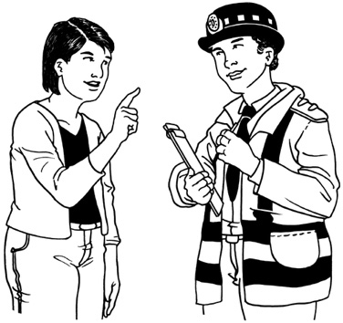
keep people safe
make sure everyone follows the laws of New Zealand
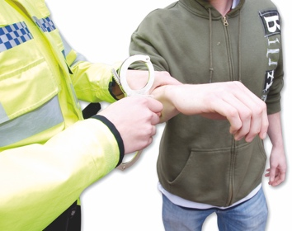
deal with people who do crime in the right ways.

The New Zealand Police are working with some researchers at the DBI on a study called:

Understanding Policing Delivery

The study will look at bias that happens in the police system.

Bias is when someone:

thinks 1 person is better than another person
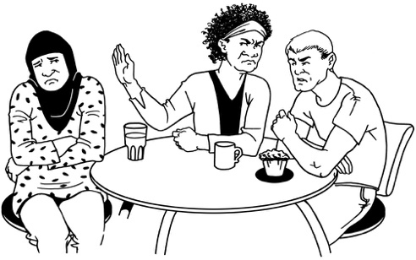
does things that support the person they like
treats someone badly because of the way they think about them.

Bias can also mean someone experiences discrimination.
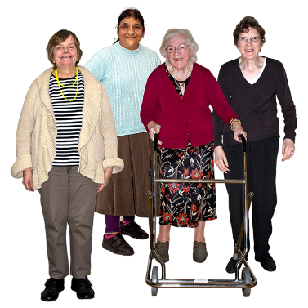
Discrimination is when people are treated differently because of things like:

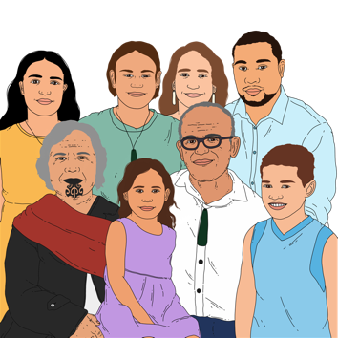
how old they are
if they are disabled
if they are Māori.

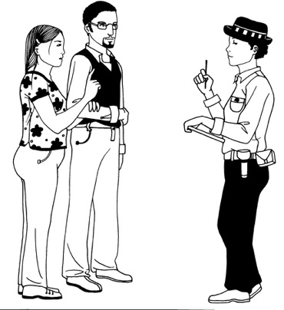
The study will support the New Zealand Police to find out about:
if there is bias in the Police system
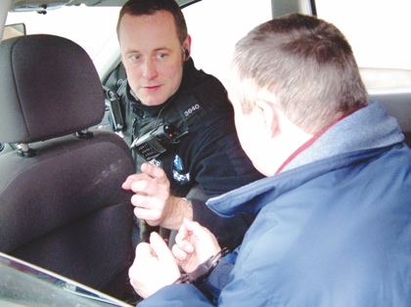
where the most bias happens
how often bias happens.

Who is doing the research?

The research is being paid for by the New Zealand Police.

A group of people from the DBI called researchers are doing the research.

The DBI is not a part of the Police.

The people from DBI have all worked with disabled people in research projects for a long time.
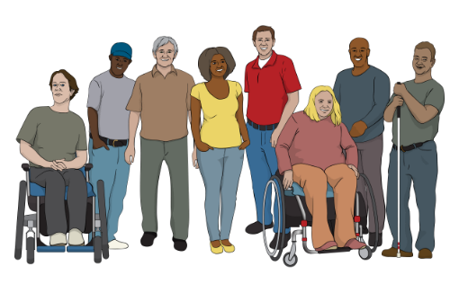

Most of the researchers are also disabled as well.

The people from the DBI working on this research are:
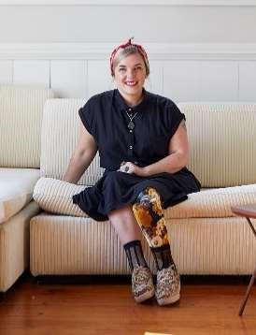
● Dr Brigit Mirfin-Veitch
● Dr Kelly Tikao
● Dr Robbie Francis

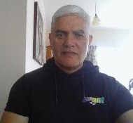
● Lydie Schmidt

● Wally Noble.
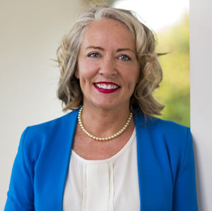
Professor Kate Diesfeld from Auckland University of Technology will also be part of the research team.

Why is the research important?

There is not a lot of research that shows how the Police act / do things with disabled people in New Zealand.

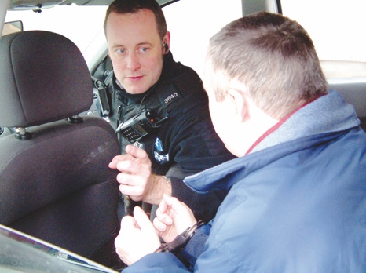
Research that has been done around the world shows that the Police often treat disabled people differently to non-disabled people.

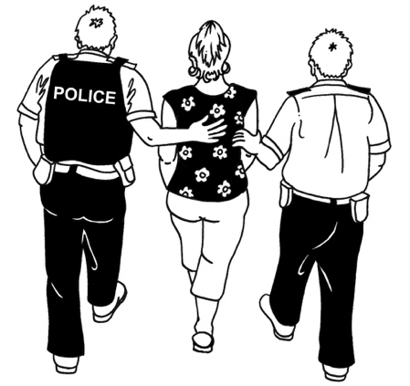
The Police often think that the way some disabled people act makes them seem like they might be doing crime.
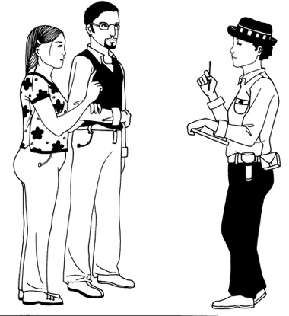

Disabled people have said they often find it hard to communicate with the Police.

The New Zealand Police said in a report that many of the people who work for the Police do not fully understand disability.

The Police can only work well with disabled people if they:
listen to them
learn from them
think about what it might be like for disabled people when dealing with the Police.

By doing this the Police service will work much better for disabled people.

How will the research be used?

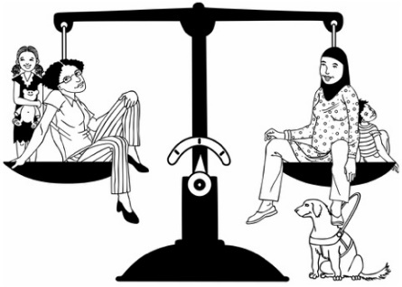
The research will support the Police to make sure their services are:
fair
equitable.

Equitable means everyone has what they need to do well in the ways they need it.
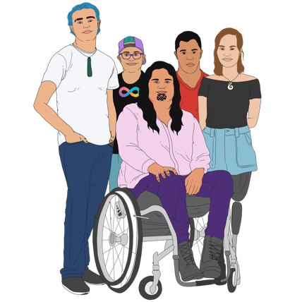

The Police service must also be fair and equitable for:
tākata whaikaha
Deaf /deaf people
disabled people.

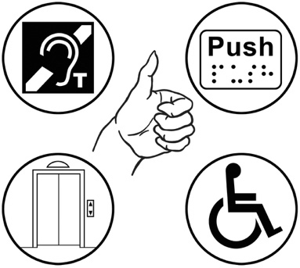
Police services that are fair and equitable to everyone would:
be accessible
think about all the different kinds of people in New Zealand
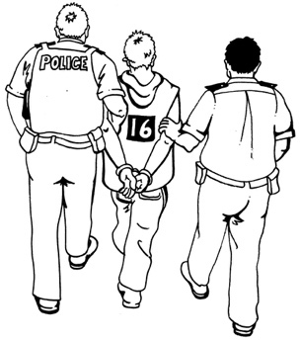
work to better support people who are often harmed by the Police.

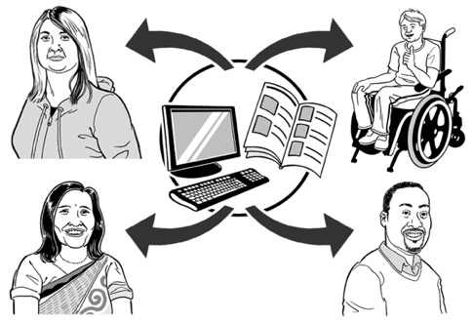
Accessible means that it is easy for everyone to:

find the things / information they need
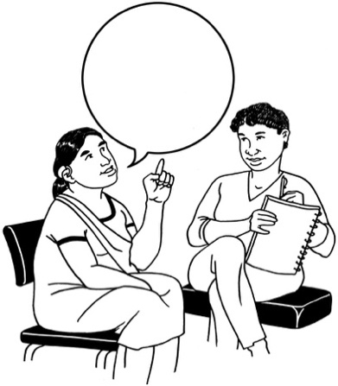
use the things / information they need
get around in ways they want to
communicate with other people.

The research will be given to the Police by people who represent the disability community.

Represent means to speak up / act for other people.

There will be lots of ways for people to find out what the research showed like:
things that everyone can read like:
- a report
- articles
a hui / meeting to talk about the research.
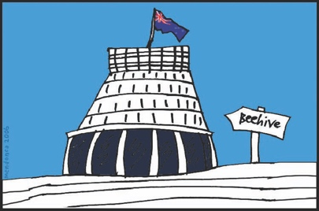

The research will also be shown to people who work in Government.
The main things that are found out from the research will be put into:
other languages like te reo Māori
accessible formats like:
- Easy Read
- Large Print
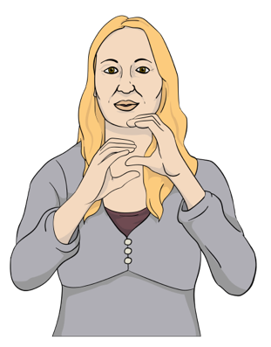
- New Zealand Sign Language.

Who can take part in the research?

There are 2 parts to this research.

For part 1 we want to talk to 20 disabled people about their experiences of being:
stopped by the Police
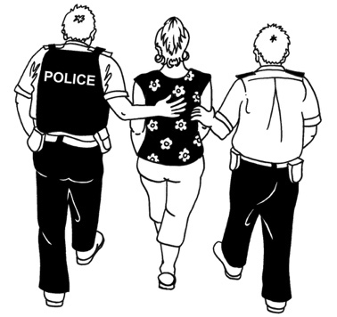
questioned by the Police
arrested by the Police.

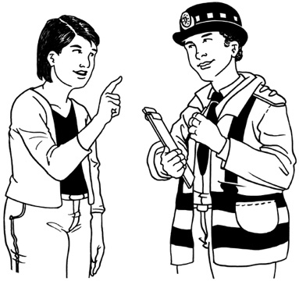

Being questioned means the Police ask you questions to find out if you know something about a crime.

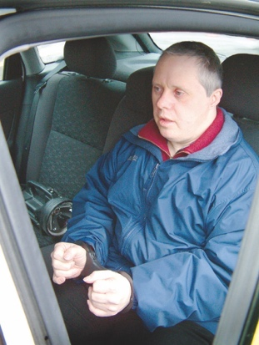
Being arrested means the Police can take you to a police station because they:

found / saw you doing a crime
believe you have done a crime.

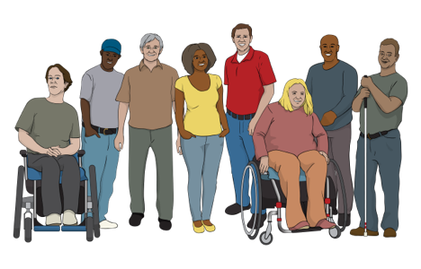
For part 1 we want to hear from:
disabled people
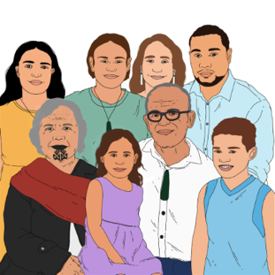
Deaf / deaf people
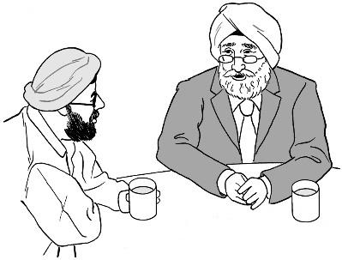
whānau / family of disabled people
close supporters of disabled people.

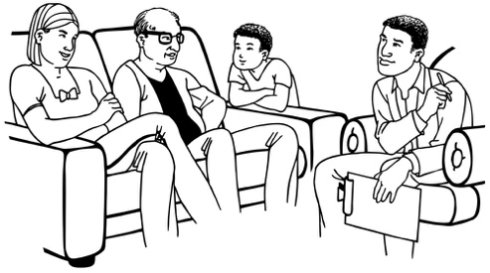
We will also talk to some whānau and close supporters of disabled people who have had experience with the Police.
For part 2 of the research we will talk to 10 people who:
work for the Police
have had experience with a disabled person as part of their work.
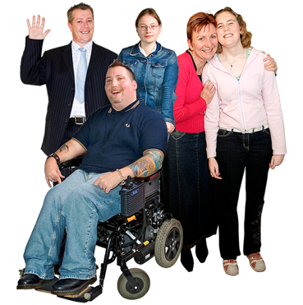
18

Everyone who takes part in the research must be:
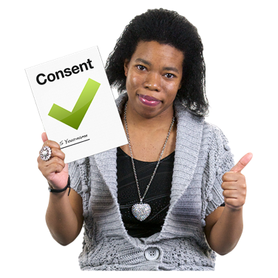
aged 18 years old or older
able to give informed consent to take part.

Informed consent is when you:

say yes to something
understand what it is you are saying yes to.

What will happen if you take part in the research?

If you are chosen to take part in the research it is up to you:
which member of the DBI researcher team you want to work with
where you want to meet them
when you want to meet them
how you want to tell them your story.
You will need to meet with the researcher you want to work with more than 1 time.

We can get in touch with you:
over the phone
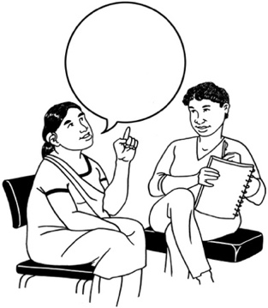
by meeting with you in person.

At the first meeting the researcher will:
answer any questions that you have about the researech
make sure you still want to take part
talk about what sort of things you want to share about your experience.

The sorts of things you might want to talk about with the researcher include:
What happened when you had your experience with the Police?
How did this experience make you feel?
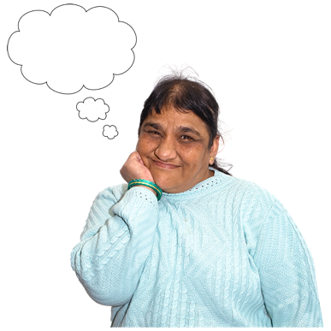
What ideas do you have about how the Police should work with / support disabled people?

The researcher will not talk about anything with you that you do not want to talk about.

You can choose how you want to tell your story.

Some of the ways you could tell your story include:
having a friendly / relaxed chat
taking a walk through a place that is important to you and talking about your experience

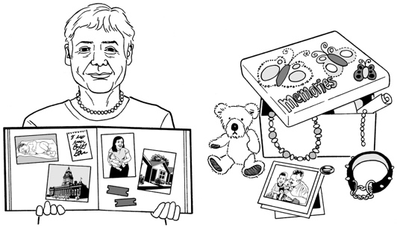
- sharing things that support you to remember / tell your story like:
- photos / drawings
- other things

- telling your story in a creative way like using:
- art
- poetry
- song.

What you can expect if you are Māori and want to take part in the research

It is important that stories from Māori are a part of the research.

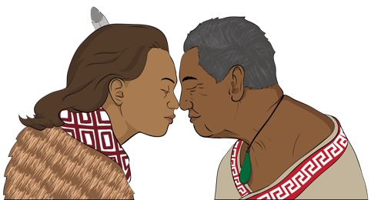
People who take part in the research who are Māori can work with a researcher who is Māori.

Dr Kelly Tikao can:
speak te reo Māori
make sure you get any support you may need if you want to tell your story by speaking / writing in te reo Māori.

Writing and sharing your story

You will work together with the researcher to write your story.

Only the things you want other people to know will go into your story.

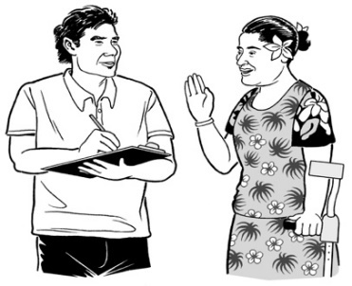
The researcher will make sure your story is written using your words only.

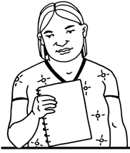
We will make sure that you can always:
see what your story says
change things that are not right about your story.

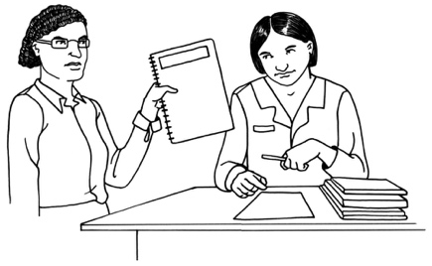
We will give you a copy of your story when it is written.

We will not use your story until you:
are happy with it
think it is finished.

No one else can change your story when it is finished.

The researchers will look at all 20 stories to write a report about the research.

What will happen with the information
you tell us?

We will keep all your information private.
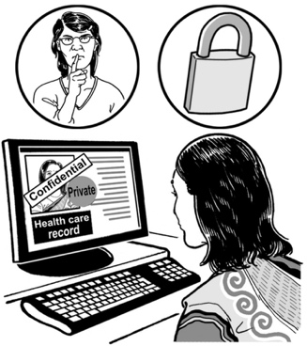

Private means that we will not share what you tell us with anyone.

The researcher will not talk to anyone else about you / things you said unless you say it is okay.

Sometimes the researcher might have to talk to someone else about things you said because:
you might not be safe
someone else might not be safe.
Sometimes the researcher might have to talk to someone else about things you said because the law says we have to tell someone about these things.

We might have to share what you have told us with someone else if:
you are being hurt
you are hurting someone else.

We will talk to you about this before we talk with anyone else.
We might use some of the things you tell us in:
- a report about the research
- other documents like articles.
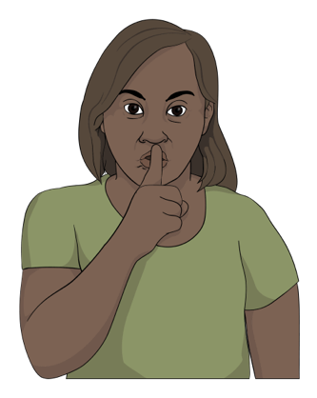
If we write about what you have said we will make sure no one knows it was you who said it.

Everything you tell us for this research will be:
kept safely at the Donald Beasley Institute for 10 years

destroyed after 10 years.

This means after 10 years no one will be able to read it.

When you meet with the researcher they will ask you if it is okay to record what you tell them.

You can ask to have the recorder turned off at any time.
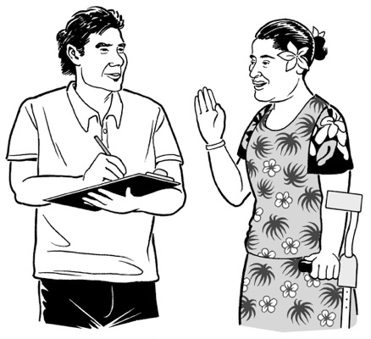
The researcher might also write down some notes:
- while you are telling your story
- when you have finished telling your story.

Only people who are part of the DBI research team will be able to see the information you give us.

We will record the information in a way that means no one can tell who it was who gave the information.

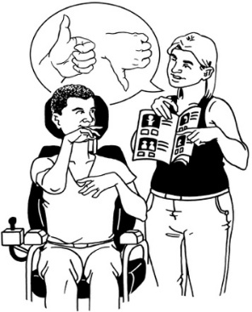
We will make sure you get any supports you might need to take part in the research.

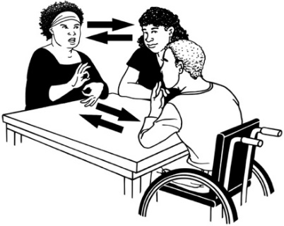
The supports you might need could be things like:
- having a New Zealand Sign Language interpreter
- meeting at a place that is easy for you to get to / move around in
- having someone with you that you trust like a friend / family member.

There might be some time between:
taking part in the research
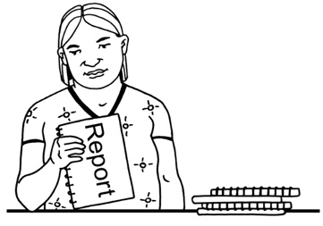
getting the final report about the research.

We may also contact you in the future to:
- confirm / check your interview date and time
- ask if we can talk with you further about the things you have told us
- update you on this study
- tell you about more ways to be part of the research in this study.

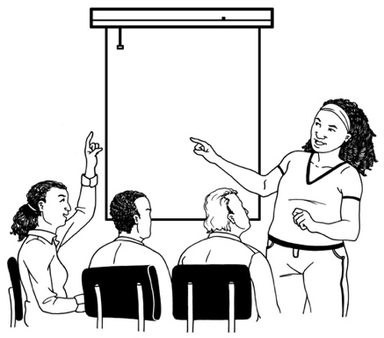
There are some people / groups who will use the final report to think about how the Police services can be made better.

The final research report might be used by:
the people who are working on the study called:
Understanding Policing Delivery
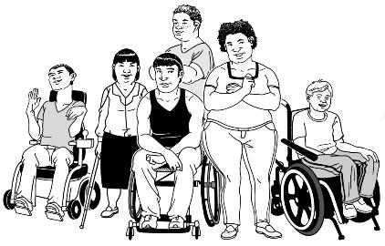
the New Zealand Police
- Disabled Peoples Organisations
- community health services
- disability support services
- the New Zealand government.

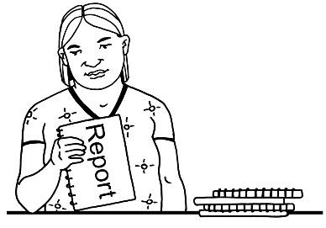
Any information you give will be used for this research only.

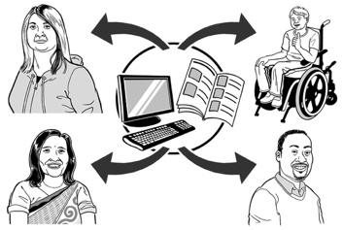
It will not be used for anything else.

Other questions you might have

There are some questions we get asked a lot.

We have answered some of those questions on the next few pages.

What if I do not want to take part in the research?

It is up to you if you want to take part in the research.

You do not have to take part in the research.

No one can tell you that you have to take part.

What happens if I take part in the research but I change my mind?

You can choose to stop taking part in the research:
- at any time
- before the final report is written.

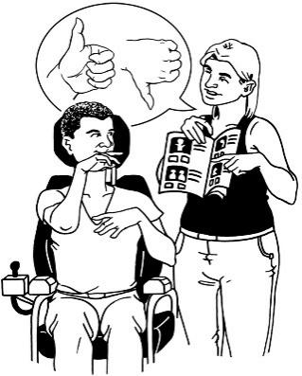
If you stop being a part of the research you can also choose if the researcher can use the information you have told them.

You can tell us if you still want to know about any more research we do in the future.

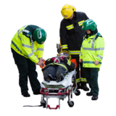
What happens if I get hurt when I take part in the research?

You are not likely to get hurt during the research.

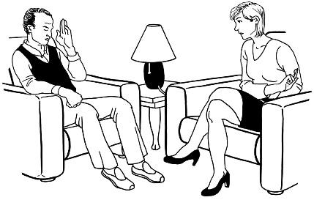
If something in the research is upsetting you can talk with us about:
- how to access support
- where to access support.

How to take part in the research

If you want to take part in the research you must tell us by filling in the Participant Interest Form.

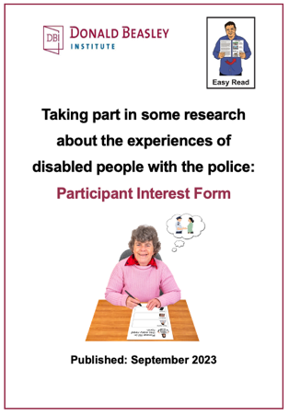
You can find an Easy Read version of the Participant Interest Form at:

www.donaldbeasley.org.nz/projects/understanding-policing-delivery

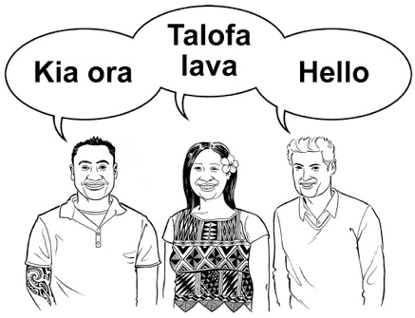
It is up to you if you want to fill in the form in:
English
te reo Māori.

You can also fill in the Participant Interest Form online at:

https://tinyurl.com/4fz2c5h9

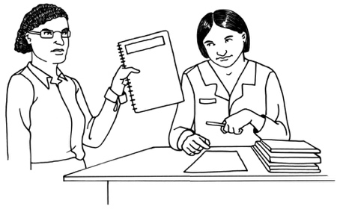
If you fill in the form online your answers will be sent to the DBI research team straight away.

You can also download the form as a Word document from our website at:

www.donaldbeasley.org.nz/projects/understanding-policing-delivery
You can fill in the form then email it to Lydie Schmidt at:
lschmidt@donaldbeasley.org.nz

You can also print out the Word document of the form to fill in then send it to us by post to:
Donald Beasley Institute

Suite 4, Level 2

248 Cumberland Street

Dunedin 9016

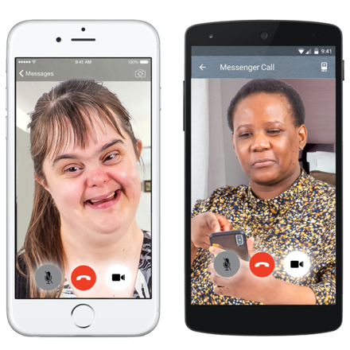
You can also email us a recording of your answers like as a:
video
voice recording.

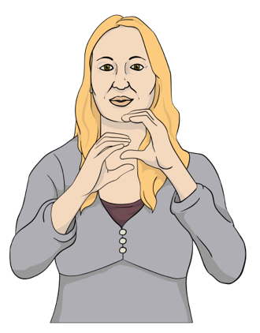
If you use New Zealand Sign Language you can email us with a video of what you want to tell us.

You can also:
- Go to the SeeFlow Direct website:

https://seeflow.co.nz/direct
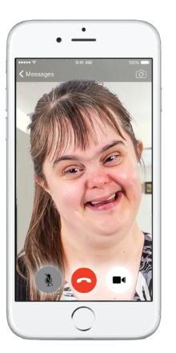
- Video record your answers on the website.

- Your answers will be sent to us.

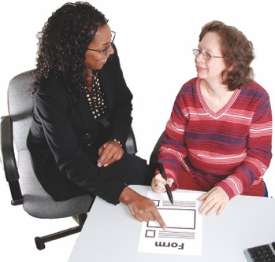
If you need support to fill out the form you can:
- talk to the DBI research team by calling:

0800 878 839
send an email to Lydie Schmidt to arrange a time to fill it out together at:
lschmidt@donaldbeasley.org.nz

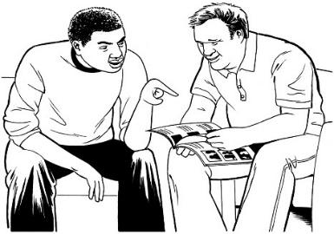
- ask someone else to support you to fill out the form like a:
- friend
- family member
- support worker.

We will get in touch with you after we have got your Participant Interest Form to:
talk to you about the research
make sure you really want to take part.

If a lot of people want to take part in the research we may not be able to talk to everyone.

You can still let us know if you want us to tell you about how the research is going.

How to contact us

You can contact us if you need:

- more information about the research
- Māori cultural support with our Kairangahau Māori Research Associate Dr Kelly Tikao.

You can contact Dr Brigit Mirfin-Veitch for more information by:
phone on:

027 479 2021
email at:

bmirfin-veitch@donaldbeasley.org.nz

You can contact Dr Kelly Tikao for Māori cultural support by:
phone on:
027 482 6324
email at:
ktikao@donaldbeasley.org.nz

You can contact the Donald Beasley Institute:
by phone on:
0800 878 839
by email at:

admin@donaldbeasley.org.nz

It will not cost you any money to call this phone number.

Other people you can contact

You can find out more the study called:

Understanding Policing Delivery
You can find out more by going to the New Zealand Police website at:

https://tinyurl.com/yc4skkvf

You can contact Paul Spoonley with any questions about the study by:
phone on:
06 350 5701
email at:
P.Spoonley@massey.ac.nz
If you want to talk to someone about this research who is not part of the research team you can talk to a Health and Disability Consumer Advocate by:

- phone on:

0800 555 050

- email at:
advocacy@advocacy.org.nz

It will not cost you any money to call this phone number.
You can also send them a message through the form on their website at:

https://advocacy.org.nz/contact/

2 groups of people have checked to make sure our research is ethical.

Ethical means that:
our research is safe
we will work with people in a respectful way that means we:
- will think about how people feel
- not do anything that might upset the people we work with.

The 2 groups are the:
Understanding Policing Delivery Ethics Panel
Northern A Health and Disability Ethics Committee.
If you are worried about any ethical issues to do with this research you can contact the Northern A Health and Disability Ethics Committee by:
- phone on:
0800 4 38442
- email at:
hdecs@moh.govt.nz

This information has been written by the Donald Beasley Institute.

It has been translated into Easy Read by the Make it Easy Kia Māmā Mai service of People First New Zealand Ngā Tāngata Tuatahi.

The ideas in this document are not the ideas of People First New Zealand Ngā Tāngata Tuatahi.

Make it Easy uses images from:

- Changepeople.org

- Photosymbols.com

- SGC Image Works

- Huriana Kopeke-Te Aho
- T.Wood.
All images used in this Easy Read document are subject to copyright rules and cannot be used without permission.

